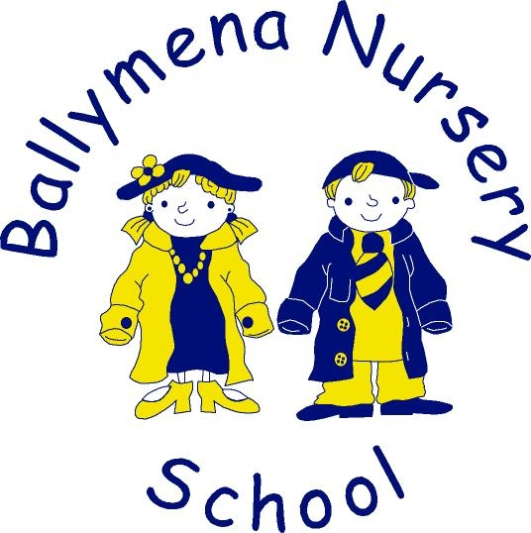
Online Home Learning Policy

Presented and adopted by Board of Governors
Signed _____________________________
Date _______________________________
Review cycle: ________________________

Ballymena Nursery School – Online Home Learning Policy

Introduction

This policy was created as a result of school closures as we, the staff at Ballymena Nursery School, are committed to providing continuity of learning to children and will do so through a process of remote (online home) learning.

“Online Home Learning” has now been adopted as part of our full nursery experience as we use our online learning journal, Tapestry, on a regular basis to enhance learning opportunities and increase home-school communications.

Learning from home

Extensive online home learning applies when school is closed for an extended period of time but a high proportion of children and teachers are healthy, and able to work from home.

Remote learning may also be provided when children, in agreement with the pre-school, have am extended period of absence but are able to work at home. This may apply in cases such as long-term illness where the child is able to complete activities at home when isolating following an infectious disease outbreak for example.

Through the implementation of this policy, we aim to address the key concerns associated with remote working, such as online safety, access to educational resources, data protection and safeguarding.

All the principles from our ICT policy also apply to online home learning.

This policy aims to:

- minimise disruption to children’s learning and the delivery of the curriculum
- ensure provision is in place for all children to access high quality learning resources
- protect children from the risks associated with using the internet
- ensure data remains secure and is not lost or misused
- ensure robust safeguarding measures continue to be in effect
- ensure all children have the provision they need to complete their work to the best of their ability, and to remain happy, healthy and supported.

The online resource nursery will use is Tapestry. It is available on the web or through the app on all smart devices. More information can be found in our ICT policy.

The school will provide continuity of learning in the following ways:

- a survey will be carried out at the beginning of each school year to ensure all children have access to an online device at home
  - for children who do not have access to any online device, we will endeavour to loan equipment in order to facilitate their participation
  - at the very least, paper copies of activities and resources will be provided.
    - We realise that the circumstances that cause our pre-school to close will affect families in different ways. In our planning, we will take individual needs into account.
- regular direct instruction from staff, with the opportunity for children and parents/carers to ask questions and make comments in response to activities
- teaching staff will deliver pre-recorded content for the whole school
- staff will make use of a range of online websites including but not limited to YouTube, CBeebies GRtL, EA, Libraires NI and Twinkl
- children can respond to online home learning in a variety of ways
  - recorded voice messages
  - writing in comments
  - creating new posts
  - video of them completing activities
  - photographs of themselves, their work, drawings, models etc

We will be flexible with regards to:

- adults working from home so access to technology as a family may be limited
- families who have two or more children trying to access technology
- staff who may be managing their own families’ requirements
- ICT systems may not always function as they should
- equipment that is available in the home, for example, staff will not assume that all children have access to a printer, and will therefore provide alternative ideas
- Providing timely and helpful feedback is a cornerstone of good learning. Whilst this may be more challenging with remote learning, staff will endeavour to provide regular feedback to children as soon as possible.

Roles and responsibilities

Ballymena Nursery staff will be working their normal hours, either at home or in pre-school. If they are unable to work for any reason during this time, for example, due to sickness or caring for a dependent, they should report this using the normal absence procedure. Other staff will cover the member of staff who is unwell to ensure that activities are uploaded and shared with parents/carers.
Staff will be expected to take regular breaks away from the computer or i-Pad.
If they have any questions or concerns about remote learning, they should speak to the principal. The pre-school’s ICT and Child Protection Policies still applies to all interactions between children, staff and parents/carers.

The teaching staff are responsible for:
- providing activities to support all areas of learning
  - Communication, Language and Literacy,
  - Personal, Social and Emotional Development,
  - Physical Development,
  - Early Mathematical Development,
  - Understanding the World around Us
  - The Arts
- setting regular activities that will be uploaded to Tapestry
- setting tasks which maximise everyday family experiences - counting the shoes by the front door, drawing their view from a window etc.
- awareness of their surroundings when recording lessons at home
- working together to plan activities and coordinate online home learning
- contacting parents/carers who are having difficulty accessing materials
  - The ICT coordinator is responsible for helping staff and parents/carers with any technical issues where possible.
- contacting the parents/carers of children in their class, who are considered vulnerable or have IEP’s, if these children are not in nursery
  - The principal is responsible for coordinating staffing and pupil contact, while the SENCO will advise and support all activities for these pupils.

All staff are responsible for:
- responding to parents/carers and children through the comments section
- the correct use and care of devices they are using
- coordinating the remote learning
- monitoring the effectiveness of the remote learning activities through regular contact with one another
- overseeing the on-going wellbeing of staff
- helping staff and parents/carers with any technical issues; where possible.

DATA PROTECTION

Accessing personal data
When accessing personal data for remote learning purposes, all staff will immediately delete it from devices that have been used. Personal data will not be kept on paper so that there is limited risk of loss.

Processing personal data
Staff will need to collect and/or share personal data (e.g. email addresses) as part of the online home learning system. As long as this processing is necessary for the pre-school’s official functions, individuals will not need to give permission for this to happen. However, staff are reminded to collect and share as little personal data as possible online.
Keeping nursery devices secure is of upmost importance in order to protect personal data and for child protection. Staff will therefore take all appropriate steps to ensure their devices remain secure. This includes, but is not limited to:
- keeping devices locked with pre-set PIN
- keeping Tapestry accounts locked with strong personal passwords and PIN
- making sure the device locks if left inactive for a period of time
- not sharing the device among family and friends
- installing antivirus and anti-spyware software regularly
- keeping operating systems up to date (always install the latest updates).

This policy has taken relevant legislation and statutory guidance into account. It needs to be read in association with the following school policies:
- Acceptable behaviour
- Children as active learners
- ICT
- Language and communication
- Learning and teaching
- Monitoring and evaluating
- PRSD and personal development
- SEN and disability
- Well-being

The staff and principal monitor this policy regularly. It will be reviewed by the Board of Governors when necessary and kept in mind when changes are made to the ICT policy.

