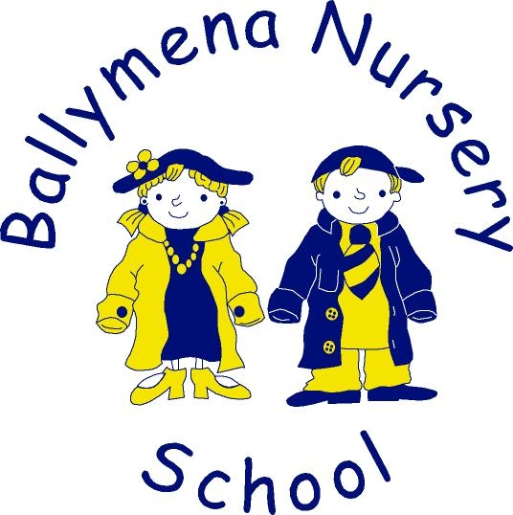
Acceptable Behaviour
and Anti-bullying Policy

Presented and adopted by Board of Governors
Signed _____________________________
Date _______________________________
Review cycle: 2 years

Ballymena Nursery School –
Acceptable behaviour and anti-bullying policy

What is bullying…

We understand bullying to be a deliberate and persistent attempt to hurt, be cruel to or humiliate someone. The bully acts in the knowledge that what s/he is saying or doing will hurt or frighten someone else, resulting in an imbalance of power, making it hard for the victim to defend himself or herself. It is not accidental or a sudden outburst of temper.
However, it is important to remember that young children can be cruel without really understanding what they are doing. Staff and parents are aware that some young children have a tendency to dominate to achieve their wishes. One-off incidents are dealt with as they occur and, while always taken seriously, do not fall within the definition of bullying.

Identifiable types of bullying

Physical
➢ Hitting, punching, kicking
➢ Pushing, jostling, prodding, spitting
➢ Hair pulling
➢ Interference with personal property

Psychological
➢ Name calling eg ”smelly”
➢ Reference to body image eg ”fatty”
➢ Threatening eg “I’m going to get you”
➢ Teasing
➢ Exclusion from the group
➢ Use of body language eg threatening looks
➢ Deliberately refusing to share

Racial
➢ Racial taunts
➢ Negative stereotyping
➢ Gestures

Sexual
➢ Inappropriate physical contact
➢ Use of sexist language
➢ Negative stereotyping

SEN/Disability
➢ Name calling based on disability or Special Educational Needs
➢ Mimicking speech impediment ie Stuttering/stammering

Main Aims

Bullying is wrong and causes damage. We strongly believe that our school should be a happy ‘Safe place’ for children and adults and that no one should have their time with us spoilt by the words or actions of another.

Through our policy and practice we intend to ensure that all members of our school community of children, staff, parents, visitors, governors understand that –

➢ Bullying is not acceptable in any form
➢ Everyone should report incidents of bullying, including witnesses
➢ We will support victims of bullying
➢ We will confront bullies with the consequences of their actions and help them to modify their behaviour
➢ We respond to incidents calmly without aggression to avoid reinforcing the message that it is alright to bully if you have power.
➢ We seek staff, parental and peer group support to counter bullying at all times
➢ We will always listen.

Preventing Bullying

All staff including substitute staff, volunteers and students will be made aware of our policy, of the procedures to follow, the need for vigilance in all areas of the nursery school throughout the session. In addition to this all members of our school community are encouraged to speak out against bullying, including reporting all incidents they may overhear or witness.

Supporting Victims

Any victim of bullying needs to be supported in developing skills to cope with future situations through our curriculum. They may display some/all of the following characteristics: sensitivity, low self-esteem, passivity, timidity/withdrawn. In offering support we :
- Always listen
- Give support through helping them to develop coping strategies eg by knowing it’s ok to say “Stop it” “I don’t like it”
- Encourage children to speak out, and to tell an adult what has happened
- Encourage co-operative/turn taking activities with other children
- Aim to develop self-esteem and confidence
- Following an incident, reassure the child that they have our support and that it is not their fault
- Inform/involve other staff and/or parents/carers

Managing and Investigating Incidents

All nursery adults are vigilant. We take reports or incidents of bullying seriously, responding calmly and taking action as quickly as possible to establish exactly what has happened by listening to and talking with those involved, including witnesses. Depending on the severity of the incident, we may use some/all of the following strategies:

➢ Comfort, support and reassure the victim
➢ Encourage empathy with the victim from the bully
➢ Share concerns with other members of staff
➢ Make it clear to the bully what was wrong with the behaviour and why
➢ Encourage the bully to try to make amends
➢ Inform the staff involved with both children about the incident
➢ Record specific, dated incidents in children’s records
➢ Involve parents/carers in discussing a plan of action
➢ Share concerns at a whole staff meeting
➢ Involve SENCO
Curriculum Links

Our curriculum is used to support our anti bullying policy. Jenny Mosley’s ‘Golden rules’ and ‘Our Hands are For rules’ are taught in the first term and re-enforced with the children regularly. Related issues may be tackled during whole class circle time eg through a focus on exploring feelings/Social Stories. Drama, puppets, story sacks and imaginative role-play activities are also used to explore relationships and to encourage co-operative interaction. For example, Media Initiative; Oh Lila; and NSPCC. We inform parents of our anti bullying programmes and initiatives, through our parent information sessions; newsletters; special prompt notes; stickers; posters; leaflets; slide show of digital photographs and our nursery Web site. We are proactive and maximise every opportunity to build self-esteem and develop a positive sense of worth.

Online resources available –
Safer Schools
BBC Online Safety
Aware NI
Parenting NI

The Role of the Board of Governors

The Board of Governors support the Principal in all attempts to eliminate bullying from the nursery school. Any incidents of bullying that do occur are treated seriously and dealt with appropriately.

The Role of the Principal

➢ To ensure that all staff members receive sufficient training to equip them to deal with all incidents of bullying.
➢ To implement the policy and ensure that all staff are aware of the policy and deal appropriately with incidents that may arise.
➢ To decrease incidents of bullying by establishing an ethos of good Community Relations, Inclusion and Diversity (CRED) and Zero tolerance of bullying.

The Role of Parents

Parents are informed about the aims of the school.

All parents have a responsibility:
➢ To support the school’s anti-bullying policy
➢ To discuss Jenny Mosley’s ‘Golden Rules’ and ‘our hands are for’ nursery rules with their child
➢ To complete the Behaviour management parental confirmation sheet.
(Appendix 1 – to be sent through Google Forms)

Monitoring and Review

The staff and principal monitor this policy regularly. It will be reviewed by the Board of Governors every two years.

APPENDIX 1.

Procedures for dealing with unacceptable behaviour

All parents and persons with parental responsibility will be made aware of the procedures for dealing with unacceptable behaviour early in the first term. A copy of the policy will also be emailed to each parent when their child starts nursery school and made available online. Unacceptable behaviour within this context includes hitting or smacking, biting, spitting, hair pulling, verbal or physical bullying, destructive/disruptive behaviour, swearing or any form of racist comments.

Nursery staff will deal with any form of unacceptable behaviour by a child in the following way:

➢ An immediate verbal response to the action
➢ A gentle explanation to the child as to why the behaviour was unacceptable.
➢ If unacceptable behaviour persists, the child will be withdrawn from the activity/group for a short period.
➢ If necessary a child may be taken to another area of the nursery school to calm down.
➢ Parents will be informed if we feel that a child’s behaviour is particularly worrying.
➢ Nursery school staff and parents will work together to promote desired behaviour.
➢ All nursery school staff will be consistent in their approach to behaviour management.
➢ If a child’s behaviour shows no sign of improving, advice will be sought from an external source eg Early Years Inclusion Service (EYIS)
➢ Take reasonable steps to ensure a child’s inclusion is compatible with:

(a) the efficient education of the other children.
(b) the health and safety of children, staff and students.

➢ Strategies will be put in place to support the child and if necessary, reduction in their length of session may be introduced, in accordance with “Curricular Guidance for Pre-School Education”

https://www.education-ni.gov.uk/publications/curricular-guidance-pre-school-education

➢ The Board of Governors will be kept informed by regular SENCO reports.

We will follow these procedures in a way that is appropriate to the maturity of the child and the misdemeanour, in order to protect other children in the class and staff members from any threat to their health, safety or emotional well-being.

Parents and those adults with parental responsibility have an obligation to strive to instil positive behaviour with their child/children at all times.

PLEASE SIGN TO CONFIRM YOUR UNDERSTANDING AND RETURN THIS TO THE SCHOOL OFFICE.

PARENT/GUARDIAN OF: ________________________________________
(please print name of child)

SIGNED: ________________________________ DATE: ______________

