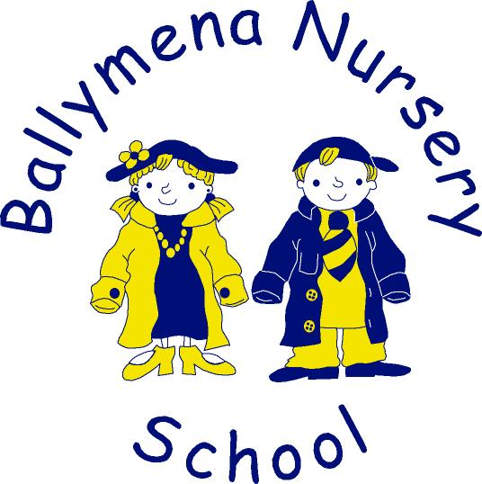

BALLYMENA NURSERY SCHOOL

HOLIDAYS 2024-2025

AUTUMN TERM commences Tuesday 27th August 2024

Staff Development Days: - Monday, 28th and Tuesday, 29th October (no children)
Half-Term Holiday: - Wednesday, 30th October – Friday, 1st November (inclusive)

Christmas Holiday: - Monday, 23rd December – Thursday, 2nd January 2025 (inclusive)
Staff Development Day: - Friday, 3rd January 2025 (no children)

SPRING TERM commences on Monday 6th January 2025

Staff Development Days: - Monday, 10th and Tuesday, 11th February (no children)
Half-term Holiday: - Wednesday, 12th February – Friday, 14th February (inclusive)

St. Patrick’s Day: - Monday, 17th March

Easter Holiday: - Monday, 14th April - Friday, 25th April (inclusive)

SUMMER TERM commences on Monday,28th April 2025

Bank Holiday: - Monday, 5th May

Spring Bank Holiday: - Monday, 26th May

School finishes for Summer holidays: - Friday, 27th June.

There will be 1 additional exceptional closure for staff training – date yet to be decided and not included in the above.

