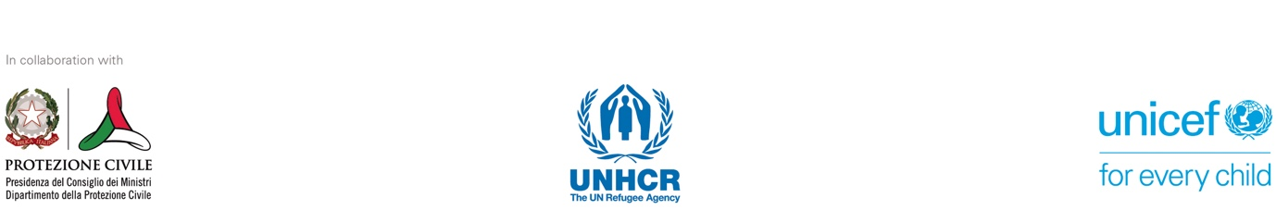
CODE OF CONDUCT - PROTECTION AND SAFEGUARD OF THE DIGNITY AND RIGHTS OF THE BENEFICIARIES OF THE COMMUNITY-BASED RECEPTION
This document understands "exploitation" as meaning any actual or attempted abuse of a position of vulnerability, power, or trust, including but not limited to profiting monetarily, socially, or politically from the exploitation, including sexual exploitation, of another person. "Sexual abuse" is the actual or threatened physical intrusion of a sexual nature with the use of force or under conditions of inequality or coercion. This includes exploitation and sexual abuse perpetrated without physical contact and/or online.³⁰ "Child abuse" is any act, or failure to perform an act of care, committed by a person who has a relationship of trust, responsibility, or power with a minor, who physically or psychologically hurts them, directly or indirectly causes harm or precludes the prospects of a healthy and safe development into adulthood. The World Health Organization defines the main categories of abuse as being physical violence, emotional violence, neglect and negligent treatment, and sexual abuse and exploitation. We intend to include in these categories also that of witnessing violence.³¹
[Organization] declares that any act of abuse and exploitation committed against persons receiving support services violates universally recognized national and international legal norms and standards and constitutes unacceptable behavior and prohibited conduct for all practitioners, including employees of [Organization] and related personnel (consultants, interns, volunteers, casual contractors, etc.).
It is further declared that all employees of [Organization] and related personnel are expected to maintain the highest standards of personal and professional conduct at all times and to provide support and services that respect and promote the rights of beneficiaries with particular attention given to at-risk groups.

EXPECTED BEHAVIOR OF ON-DUTY AND OFF-DUTY PERSONNEL
Each [Organization] staff member is committed to abiding, in their professional and private life, by the standard of behavior developed in international and European policies to prevent and counter all forms of exploitation and abuse, by following these basic principles of conduct:
- All people who receive support services within the framework of our activities have the right to be treated with a spirit of understanding and equal respect and consideration and not to be unfairly discriminated against, directly or indirectly, because of one or more factors, including religion, gender, sexual orientation, conscience and beliefs, physical appearance and color of skin, language, ethnic or social origins, citizenship, personal and health conditions, family choices, and age.
- No member of [Organization] shall be permitted to use, directly or indirectly, the authority of their position or office for the purpose of forcing persons receiving support services to perform tasks or services benefitting the former, unless such service is a legal obligation of the latter.
- Each staff member must provide an environment that protects and ensures safety for all migrant and refugee persons and encourages the participation of women, children and other at-risk groups to help develop their capacity for self-protection and self-determination.
- No member of [Organization] shall be permitted to inflict any physical or psychological violence on migrant and refugee persons or engage in any behavior aimed at humiliating and denigrating them or any other behavior that may cause moral harm, including attitudes toward children that - even from a psychological standpoint - may adversely affect their harmonious and socio-relational development.
- Each staff member must avoid engaging children in work or activities that are inappropriate for their age and/or maturity, or that may be detrimental to their physical and mental health and/or act in ways that may be abusive, or that may place the children at risk of exploitation or abuse.
- Each staff member must commit not to disclose personal information concerning migrant and refugee persons to third parties except in cases their informed consent is given or if included in the legal obligations and responsibilities of the staff members.
- Exploitation and sexual abuse perpetrated by staff constitute gross misconduct and are therefore grounds for dismissal. In addition, if such acts involve children they must be reported to the appropriate authority.
- Any sexual act on children (persons under the age of 18) is prohibited and constitutes a crime. Misconception about the age of a child is not a valid defense.
- Giving money, labor, goods, or services in exchange for sex, including sexual favors or other forms of humiliation, degradation, or exploitation is prohibited. This includes the exchange of de facto assistance owed to the recipient(s).
- Any sexual relationship between those who provide humanitarian services and protection and those who benefit from such services and protection, which involves the misuse of authority or position, is prohibited. Such relationships undermine the credibility and integrity of humanitarian aid.
- Any staff member who has concerns or suspicions about sexual abuse or exploitation by a colleague, regardless of whether the colleague works for their own organization, is required to report such concerns using the reporting mechanisms established by [Organization].
- Each staff member is obligated to create and maintain an environment that prevents exploitation and abuse and promotes the enforcement of this code of conduct. Managers and supervisors at all levels have specific responsibilities for supporting and developing systems that protect this environment.

DISCIPLINARY SANCTIONS
Violation of these rules will result in the application of administrative and disciplinary sanctions in line with the current regulations on the obligation of public employees and private individuals to report (Articles 331 and 334 of the Criminal Code) in accordance with the internal regulations of [Organization] and in line with the policy of 'zero tolerance' toward sexual offenses.

The undersigned ________________________ as _______________________ declares that he/she has read the Code of Conduct of [Organization], acknowledging its guiding principles and (committing to abide by) its fundamental principles of conduct.
Signature

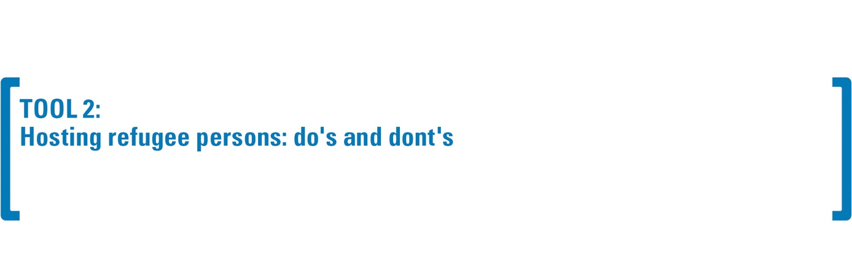
FOREWORD
Those who host refugees need to be aware that women, adolescent girls, and children may have experienced various forms of gender-based violence before leaving Ukraine or while traveling and may therefore need support in accessing available response services.
In order to best provide support and receive appropriate guidance and resources, it is recommended that all people hosting refugees join governmental or non-governmental reception programs where available.

Recognizing power imbalances and boundaries that are not to be crossed
People housed in private homes are in a vulnerable condition. This does not mean that they are helpless or unable to make decisions and choices on their own, but rather that they may find it difficult to communicate their needs or what makes them uncomfortable. This could be because they are likely to feel indebted to their hosts for taking them in and worried about the consequences of a possible "no" (e.g. losing a safe place to stay, ruining daily relations, jeopardizing opportunities to receive further support, etc.). This sense of insecurity may be exacerbated by other factors such as class differences, proficiency in the local language, gender, presence of children, sexual orientation, gender identity, mental health issues, and disability. Being aware of the power imbalance that exists between the homeowner(s) and the housed refugee(s) is a critical first step to building a supportive relationship that helps refugee(s) feel safe in their new home.

Facilitating a clear and transparent conversation about accepted behaviors
At the beginning of the hosting period, it is appropriate for the organization and the host family to promote a conversation with the hosted family to explicitly define the commitment that all participants in the program are expected to undertake and the accepted behaviors that the families agree to. This is an essential step that ensures, for each family (host and hosted), several positive effects from a risk mitigation and protection perspective: (i) it explicitly defines the goals that families share; (ii) it outlines the outcomes that participants expect from the community-based widespread reception; (iii) it details the actions that families can and wish to concretely implement in support of their own and others' well-being, including on the basis of specific needs; and (iv) it ensures that participants are provided with the necessary framework of protection and safeguard, also clarifying the support arrangements and contact persons to be involved in critical situations. The following pointers can facilitate the sharing moment:

DO’S | DONT’S
Provide a friendly and welcoming environment where everyone and especially women, children, and adolescent girls can feel safe. | DO NOT attempt or have sexual relations with the hosted persons, which is inappropriate behavior and constitutes an offense under the Criminal Code³² if it involves children.
Reserve a private space for guests with doors and windows that can be locked from the inside. Ensure that they can spend time alone in a space available to them if they wish. | DO NOT establish business or financial relationships with refugee persons (e.g. lending money, hiring them in your company, etc.).³³
Use automatic translation services, such as Google Translator, if you speak a language other than the guest language. | DO NOT expect guests to learn the local language right away.
Establish clear expectations and limits regarding the use of common areas. Creating a simple welcome package can be helpful to avoid overloading guests upon arrival with too much information to remember.³⁴ | DO NOT demand or require that the host(s) take care of the children, do housekeeping, or take on other support roles for the host family (beyond what may be considered their contribution of caring for their own space as roommates).
Agree with the host(s) on rules of living together that suit both families (host/refugee) and take into account the different needs of all members. | DON'T impose your own rules and don't expect your guests to already know the rules of living together. "Good manners" may vary from one community to another, even within the same country.
Maintain confidentiality regarding information and stories that women, and children share, except in situations that present an imminent risk to themselves or others in which case, contact the relevant authorities. | DO NOT require guests to share their personal history and past experiences.
Provide housed people with the necessary information about the area in which they live, available services, local legislation, and so on so that they are able to make decisions for themselves. | DON'T make decisions on behalf of refugee women, adolescents, and children and don't tell them what to do.
Help refugee people translate what they need to understand "how things work" in the new context. | DO NOT always take over the tasks that refugee people should do (e.g. filling out residence permit forms, contacting support services) just "because it's easier or faster."
Provide accurate information about available support services. | DO NOT replace health or psychological support services, even if you have the necessary expertise.
Seek support from the host network and program should living together prove problematic for hosts and/or refugee persons (this can happen in any host setting; no one should feel responsible). | DO NOT evict refugee persons or ask them to leave their homes without ensuring that they have adequate and safe alternative housing.
Provide emotional support to settle in and cope with the newness and difficulties that the process of adapting to the new reality might entail. | DO NOT underestimate individual coping strategies and resilience. DO NOT assume that a certain event, no matter how destabilizing and dramatic it may appear, automatically generates 'trauma' in the person, since each person reacts differently.
Recognize the person's ability, however bewildered and upset by events, to make informed decisions about their life. Do not try to replace the person in decision-making processes. | DO NOT, under any circumstances, solicit the persons hosted to recount sensitive and potentially painful and violent episodes they may have experienced. Instead, demonstrate willingness and readiness to listen if and when the person wishes.
Respect the priorities of the hosted persons, even if they may seem unusual. Some women may prioritize financial independence and job search, others may be concerned with providing education for their children, and others may need emotional support and social networking before they can focus on their new life in another country. | DO NOT judge or be influenced by personal beliefs with respect to the choices of the people hosted and do not force them to do otherwise.
Provide people with information about services available in the area, including support services against sexual violence, domestic abuse, human trafficking, or other forms of exploitation. Do not wait until they need a particular service to share information about it. | DO NOT force adult housed women to report any abuse to the police or other authorities if they do not wish to do so. It is up to them to decide whether and when to report.
Discuss the critical issues and specific needs of the host family and what strategies can be used to offer direct support or through the territorial network. | DO NOT assume that refugee persons have free access to all the services they need. They may, in fact, face barriers (psychological, linguistic, cultural, technological) that are not necessarily visible to host families or hosting organizations.

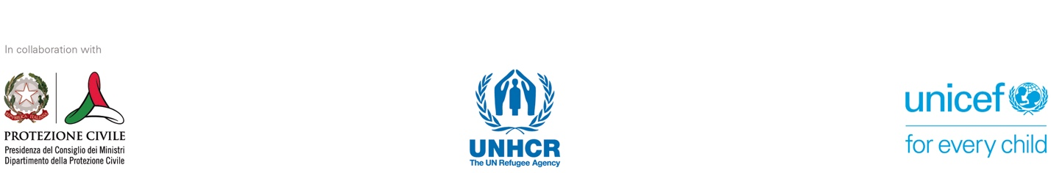
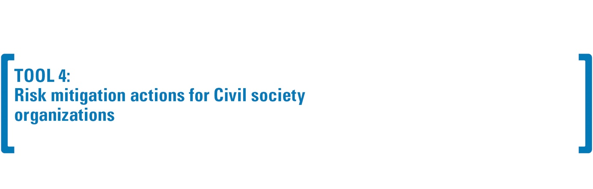
This illustrative and non-exhaustive list is intended to provide some checklist criteria to ensure compliance with gender-based violence risk mitigation and safeguarding policies, especially during staff recruitment and service provision by CSOs:

- Conducting background checks (e.g. a certificate from the Judicial Records Register in case of activities to be carried out in contact with children³⁵ ) and references of candidates/applicants
- Require applicants to self-report any sanctions and/or convictions such as, for example, termination of previous employment, criminal records, and reports to government authorities regarding contact with children, and to consent to the disclosure of such information by their former employers during reference checking ³⁶
- Conduct background checks (e.g. criminal records, Google searches) and check with references for previous incidents of violations of labor, privacy, and data protection laws in force
- Ensure that the hiring process is managed by a gender-balanced team and that interviews are conducted from a gender-neutral perspective³⁷
- During the interview, ask candidates questions about ethics and ethical dilemmas (e.g. what is your idea of an ethical organization? Tell me about a time when you faced an ethical challenge)
- Require candidates to review and sign the code of conduct prior to the start of the contract, which outlines possible disciplinary sanctions
- Integrate a safeguard clause³⁸ in contractual agreements and conventions with CSOs, including when subcontracting
- Promote training and updating courses on risk mitigation and safeguarding policies at regular intervals
- Block the professional advancement/employment opportunities of individuals under investigation and/or the continuation of a contract following reports from a CSOs
- In cases of verified negligent conduct, implement robust disciplinary action (such as dismissal, suspension, official written reprimands or other administrative/corrective measures) and, where this involves possible criminal conduct, consider reporting the incident to local authorities³⁹

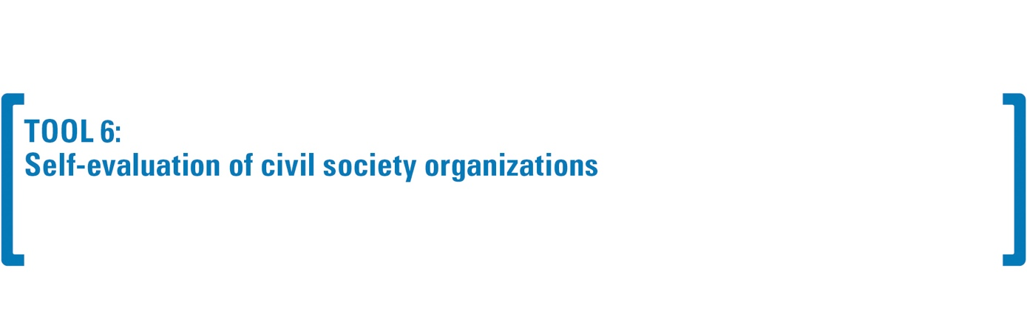
The table below provides (a) the fundamental standards on organizational procedures on GBV risk mitigation and child safeguarding, which constitute the minimum requirement and (b) indicators to support each organizations’ fulfillment of the minimum requirements of each core standard.

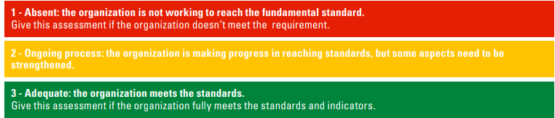

After reviewing and scoring the organizations's compliance based on the standards, each organization must add up the totals for each standard to get the total score. The total score indicates the organizations’ current capabilities in GBV risk mitigation and child safeguarding and the relative level of risk.

Total score | Capacity of the organization | Risk level in gender-based violence risk mitigation and child safeguarding
7 or lower | Low | High
8 - 14 | Needs improvement | Moderate
15 - 18 | Adequate | Low

Standards and indicators | 1 | 2 | 3 |  | Supporting evidence/documentation
Core Standard 1: Procedures of the organization  The organization already has in place a procedure related to GBV risk mitigation and child safeguarding that describes appropriate standards of conduct, preventive measures, reporting, monitoring, investigation and corrective measures.  Indicator 1: The organization's policies and/or procedures include (a) a definition of gender-based violence, abuse and exploitation; (b) a description of the behavior expected of on-duty and off-duty staff; and (c) an explicit statement of zero tolerance toward sexual abuse and exploitation (in other words, such acts should be considered grounds for disciplinary action, which may result in dismissal).  Indicator 2: The code of conduct is signed by all staff, including employees, consultants, volunteers, contractors, and others.  Indicator 3: The organization displays, in its offices and project locations, information regarding the content of the code of conduct, including the code of conduct and details of reporting channels. | ο | ο | ο |  |  | - Code of Conduct  - Procedures and policies on risk mitigation and protection  - Documentation of standard procedures put in place for all staff to receive/sign the policy the code of conduct  - Other (specify):
 | Comments:

Standards and indicators | 1 | 2 | 3 | Supporting evidence/documentation
Core Standard 2: Management and human resources systems of the organization  The organization's management and human resources systems take into account the GBV risk mitigation and child safeguarding Indicator 1: The organization's contracts and partnership agreements include a standard clause requiring contractors, suppliers, consultants, and partners to commit to a zero-tolerance policy toward sexual abuse and exploitation and to take steps to prevent and respond to it.  Indicator 2: There is a systematic preparatory screening procedure for new hires that complies with local regulations, including checks to exclude previous involvement in gender-based violence, abuse and exploitation.  Indicator 3: Standard contracts and partnership agreements include clauses to prohibit gender-based violence, abuse, and exploitation and require the partner or contractor to take measures to prevent them and respond if reported  Indicator 4: Templates for reference checking include a request for confirmation that there are no previous allegations of violence, abuse, and exploitation. | ο | ο | ο | - Terms of reference (e.g. with clear responsibilities in this matter)  - Partnership contracts/agreements  - Hiring procedure (e.g. reference check)  - Other (specify)______
 | Comments:

Standards and indicators | 1 | 2 | 3 | Supporting evidence/documentation
Core Standard 3: Mandatory training  The organization organizes mandatory training sessions for all staff on procedures in the area of GBV risk mitigation and child safeguarding . The training includes 1) a definition of gender-based violence, abuse, exploitation, child safeguarding 2) the prohibition of all forms of abuse and exploitation; 3) the actions that staff are required to take; and 4) how to support survivors of violence.  Indicator 1: The organization has a formal, documented training package on GBV risk mitigation and child safeguarding mechanisms.  Indicator 2: The organization requires all staff to attend training on a recurring basis and maintains an internal attendance record (with names of participants, date of training, type of training) | ο | ο | ο | - Annual training plan  - Training program  - Attendance records  - Other (specify):  _________________
 | Comments:

Standards and indicators | 1 | 2 | 3 | Supporting evidence/documentation
Fundamental Standard 4: Reporting  The organization has mechanisms and procedures that meet basic standards for reporting (i.e., security, confidentiality, transparency, and accessibility) for staff, beneficiaries, and communities, including children, to report allegations of abuse and/or exploitation committed by its staff, and ensures that beneficiaries are aware of these mechanisms.  Indicator 1: The organization has informative material and reporting channels available in locally relevant languages and presented in a manner that is understandable to all groups, including children.  Indicator 2: The organization has a template for staff and beneficiaries to report allegations of abuse and exploitation committed by its staff and the organization's procedures for handling such allegations, including those involving staff of other organizations.  Indicator 3: The organization limits the number of people who have access to the information provided and removes information that could lead to the identification of the individual when sharing information. | ο | ο | ο | - Outreach material  - Awareness plan on GBV risk mitigation and child safeguarding  - Description of the reporting mechanism(s)  - Other (specify):_______
 | Comments:

Standards and indicators | 1 | 2 | 3 | Supporting evidence/documentation
Core Standard 5: Support and referral to support services  The organization has a system in place to ensure that survivors of gender-based violence and other forms of violence, abuse, and exploitation, including child survivors, receive immediate professional support and are referred to the appropriate services if they wish so.  Indicator 1: The organization has an updated list of local service providers and/or is in contact with local gender-based violence response coordination mechanisms for all places/areas where the program is active.  Indicator 2: The organization has a procedure in place to guide staff through the referral process. It outlines the steps that staff, particularly those involved in receiving complaints, are required to take, including following-up on referrals. | ο | ο | ο | - List of service providers  - Description of the referral process for survivors of gender-based violence  - Other (specify):  _________________
 | Comments:

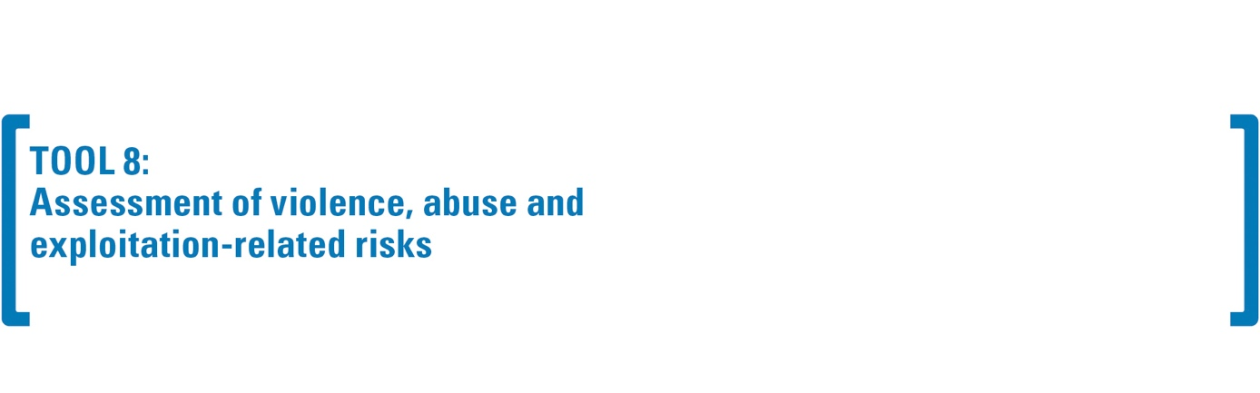

Area | Questions to consider for risk assessment | Possible mitigation actions
Profile of the beneficiaries | - What is the demographic profile of the population in the target areas (e.g. gender, age, education level, income level, household size, single-parent households, legal status, etc.)?  - What are some population characteristics that may make individuals more susceptible to incidents of gender-based violence, abuse, and exploitation?  - Is there a high number of children or other vulnerable groups among the beneficiaries? Is there information available with respect to incidents of violence in transit areas?  - What is the data related to gender-based violence or violence against children in the community of origin?  - Do vulnerable groups have adequate access to information regarding their rights and the system of community-based widespread reception? | - Adapt outreach activities to meet the specific needs of the beneficiaries  - Conduct targeted communication campaigns for the most vulnerable groups  - Collaborate with other organizations working on GBV/child protection Engage vulnerable groups to make sure they know their rights and whom to turn to in case of need, and to discuss together what are the best channels to share information
Staff Profile | - Is there a gender balance among staff involved in the program, particularly among staff directly in contact with beneficiaries?  - Have staff credentials been sufficiently checked and have staff been adequately trained on the subject?  - Have staff signed and been trained on the contents of the Code of Conduct?  - Do staff wear visible identification items (e.g. caps, undershirts, T-shirts) while conducting program activities? | - Restore the gender balance of staff involved  - Involve other female resources in the program or those of different sexual orientation and/or nationality, if necessary  - Hold one or more training/refresher courses  - Review staff HR records and conduct additional audits to detect past misconduct, if necessary  - Ensure that staff wear visible identification items (e.g. caps, undershirts, T-shirts)
Profile of the institution | - Has the institution conducted a self-assessment against standards related to GBV risk mitigation and child safeguarding?  - Has the institution demonstrated that it has assessed its risks and developed an Action Plan that includes measures to improve its internal systems?  - Does the contracted organization directly carry out the activities of the community-based widespread reception or does it operate through other local organizations and facilities and/or use other organizations to manage some support activities? | - Proceed with the joint self-assessment of the institution using Tool 6  - Jointly develop and monitor an action plan for the institution to implement the risk mitigation measures identified in Tool 7
Programmatic activities of the community-based widespread reception | - Does the program create or exacerbate power imbalances among staff, institutions, host families, and beneficiaries?  - Does the program involve direct interaction between staff, host families, and beneficiaries, especially children, or other adults in vulnerable situations?  - How do staff provide goods and services (i.e. privately/publicly, working in pairs/autonomously, with staff of different genders)?  - Can outside visitors participate in program activities unaccompanied? Who is in charge of making these decisions?  - Do program beneficiaries have access to all necessary program-related information, including reporting mechanisms in a language and manner they understand? | - Arrange periodic follow-up visits by members of management or program supervisors  - Change/modify some activities of partner organizations, families and host facilities, and some locations to make them safer  - Limit the participation of outside visitors in program activities as much as possible  - Regularly inform participants of programmatic activities related to their rights, expected behavior of staff, and how to report any concerns/criticisms appropriately and according to their gender and age  - Develop programmatic actions related to the safer programming approach under Tool 10  - Limit all those actions that increase the vulnerability of the beneficiary/(ies)
Context of the program | - Where do program activities take place (remote and marginalized areas, rural towns, urban centers, etc.)? What are the specific risks associated with this particular location (e.g. lack of available services)?  - What is the attitude of the beneficiaries toward issues related to gender-based violence or violence against children?  - How comfortable would beneficiaries feel in reporting any fears and suspicions of violence, abuse, and exploitation?  - Is there a mechanism to handle feedback/reports? | - Create a safer environment and programming also using Tool 10  - Work with beneficiaries, families, and shelter microstructures to identify or update reporting mechanisms where necessary  - Adapt awareness initiatives on the topic to meet the specific needs of beneficiaries  - Conduct targeted communication campaigns  - Increase monitoring visits

INTRODUCTION
The modalities of community-based widespread reception (places, size of houses, structuring and management modalities of spaces and times of service provision, staff involved in activities and other operators in contact with groups at risk) constitute a risk factor for hosted people as they may expose them to potential episodes of violence, exploitation, and abuse. It is necessary, therefore, that the reception facility is, as far as possible, appropriate and at the same time welcoming, decent, and dignified and that it allows people, particularly women and children, to be and feel safe. For these reasons, it is necessary to conduct safety audits on a regular basis in these settings to assess the standards of safety and protection for women, girls, and children with a family or other forms of community-based care.
The safety audit is a monitoring tool that relies on a combination of methodologies that combine visual and direct observation consultation with people housed with a family or in a facility, organizations, and services on the ground.

GENERAL INFORMATION

Name and type of reception facility/family: _____________________
Date and place of compilation____________
People/organizations conducting the audit: _____________________________________________
Organization: _______________________________ (name and legal status)

Information to be collected before the audit

 | Newly placed in family/facility | Already present in the family/facility | Date of arrival | Notes
Girls < 18
Boys < 18
Women
Men
TOT

PART I. DIRECT OBSERVATION

# | Arrangement of accommodation | YES | NO | Notes
1 | Is the house or facility overcrowded?
2 | Are women housed separately from men or by family?
3 | Do unaccompanied children stay in separate areas or rooms?
4 | Can rooms be locked from the inside?
5 | Is there sufficient privacy even to store one's personal belongings?
6 | Are the house or facility and other common areas accessible to people with disabilities?
Sanitation facilities
7 | Are men's and women's showers separate?
8 | Can toilets be locked from the inside?
9 | Are the toilets and bathrooms for unaccompanied children separate from those for adults and are they divided by gender?
10 | Is sanitary material, including sanitary napkins, available?
Security
11 | Is the facility located in an area/neighborhood that is easily accessible and safe for all hosted persons?
12 | Are there public or facility-provided transportation services for guests?
13 | Are there mechanisms to monitor the safety of guests, especially children?
Participation and safeguarding
14 | Are there dedicated spaces that hosted persons have access to that ensure privacy based on their age/gender specific needs?
15 | Are the rules of conduct related to the various activities of the community-based widespread reception visible or have they been disseminated?
16 | Is the mechanism for reporting cases of abuse and exploitation available in different languages (posters or the like)?
17 | Is there a notice board with emergency numbers and contacts and other important information (services, contacts, etc.) in various languages?
Services
18 | Are there adequately and sufficiently trained operators or staff present at the time of the visit?
19 | If yes, is/are the person/s female?
20 | If yes, are there cultural mediators?
21 | If yes, are there any health workers?
22 | If yes, are there dedicated operators for children?
23 | Are there spaces dedicated to the specific needs of hosted persons?  Which ones?____________________
24 | Are there services in proximity or within easy reach by foot or public transportation?
25 | Are there social and recreational activities at the time of the visit?
26 | Is there access to free WIFI for all housed people?

PART II. FAMILY MONITORING
This tool can be used to facilitate separate monitoring of host and/or hosted families or through shared conversations among families.
Roles and responsibilities:  Indicate one of the decisions that had been made at the time of the discussion of rules and standards (Tool 2) |  | Has the decision and commitment been kept?  □ YES □ NO □ PARTLY  Briefly describe the reasons for the answer
Roles and responsibilities:  Indicate one of the decisions that had been made at the time of the discussion of rules and standards (Tool 2) |  | Has the decision and commitment been kept?  □ YES □ NO □ PARTLY  Briefly describe the reasons for the answer
Specific needs  (Indicate one of the support modalities that have been identified with respect to the specific needs discussed) |  | Has the support been provided?  □ YES □ NO □ PARTLY  Briefly describe the reasons for the answer
Specific needs  (Indicate one of the support modalities that have been identified with respect to the specific needs discussed) |  | Has the support been provided?  □ YES □ NO □ PARTLY  Briefly describe the reasons for the answer
ON-GOING FOLLOW-UP MEETINGS WITH FAMILIES

Meeting date:

Participants:

Main themes:

Decisions made:

USEFUL INFORMATION ON THE PROGRESS OF THE COMMUNITY-BASED WIDESPREAD RECEPTION

Quality of relations between families

Quality of relations with the organization

Positive resources mentioned by families

Any critical issues or difficulties encountered along the way

Other general considerations on the progress of the pathway

FILLED OUT BY.

Name of Organization | Contact person- Host Family |  | Contact person - Refugee family | Date and place

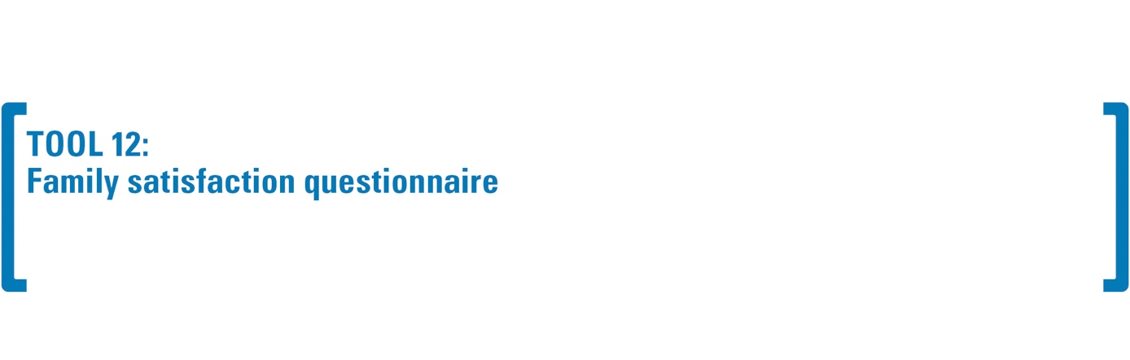
This instrument is used to assess the perception and satisfaction with respect to the progress of the reception process, in relation to several dimensions:

QUESTIONNAIRE FOR ADULTS
Personal Data
Family _________________ | First and Last Name of the person completing the Questionnaire.  _______________________________________  _______________________________________ | Role in the family  ☐ Mother  ☐ Father  ☐ Other: ______________________________________
Date of compilation

Satisfaction of families
Personal satisfaction  Are you satisfied with community-based widespread reception? | ☐ not at all ☐ a little ☐ fairly ☐ a lot ☐ completely  Why?  _______________________________________________________________________________  _______________________________________________________________________________
Consistency of actions  Were the support and reception actions relevant to what was agreed upon? | ☐ not at all ☐ a little ☐ fairly ☐ a lot ☐ completely  Why?  _______________________________________________________________________________  _______________________________________________________________________________
Criticality  Along the way, did you feel you were struggling? | ☐ not at all ☐ a little ☐ fairly ☐ a lot ☐ completely  If you encountered any, what difficulties did you face along the way? _______________________________________________________________________________  _______________________________________________________________________________
Strengths  What did you like most/worked best in this process? | _______________________________________________________________________________  _______________________________________________________________________________  _______________________________________________________________________________
Weaknesses  What did you like least or thought did not work? | _______________________________________________________________________________  _______________________________________________________________________________  ______________________________________________________________________________
Perception of change
Consistency with initial expectations  Was the reception consistent with your initial expectations? | ☐ not at all ☐ a little ☐ fairly ☐ a lot ☐ completely  Why? _______________________________________________________________________________  _______________________________________________________________________________
Changes in the family  Have there been changes in the family that are related to the reception process? | ☐ not at all ☐ a little ☐ fairly ☐ a lot ☐ completely  What changes have there been in the family? _______________________________________________________________________________  _______________________________________________________________________________
Perception of relations with the CSOs
Report  Are you satisfied with the support you received along the way from the organization’s staff? | ☐ not at all ☐ a little ☐ fairly ☐ a lot ☐ completely  Why? _______________________________________________________________________________  _______________________________________________________________________________
Communication  Are you satisfied with the way you communicate with the organization? | ☐ not at all ☐ a little ☐ fairly ☐ a lot ☐ completely  Why? _______________________________________________________________________________
Feedback
Feedback and suggestions  Do you have any feedback or suggestions to give to the staff? | _______________________________________________________________________________  _______________________________________________________________________________  _______________________________________________________________________________
Thank you for your participation!

