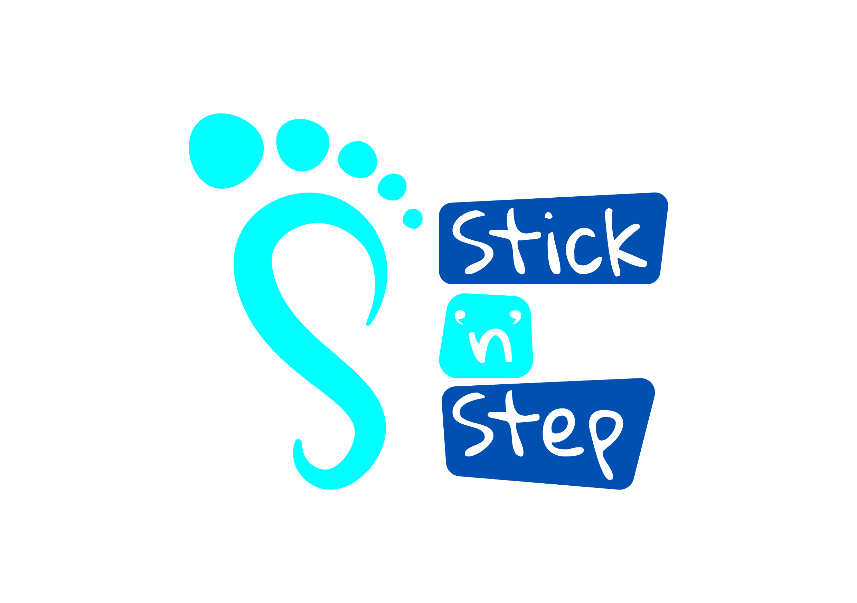
Gift Aid Declaration Form

Boost your donation by 25p of Gift Aid for every £1 you donate

Gift Aid is reclaimed by the charity from the tax you pay for the current tax year. Your address is needed to identify you as a current UK taxpayer.


In order to Gift Aid your donation you must tick the box below
□ I want to Gift Aid my donation today and all donations I make in the future or have made in the past 4 years to Stick ‘n’ Step.

I am a UK taxpayer and understand that if I pay less Income Tax and/or Capital Gains Tax than the amount of Gift Aid claimed on all my donations in that tax year it is my responsibility to pay any difference.

My details:

Title ............................. First name ……………...........................................................................

Surname ......................................................................................................................................

Full home address .....................................................................................................................

.....................................................................................................................................................

Postcode ...........................................................................

Email …………………………………………………………………………………………………

Signed ………………………………………….. Date.................................................................

Please notify Stick ‘n’ Step if you:

• Want to cancel this declaration
• Change your name or home address
• No longer pay sufficient tax on your income and/or capital gains.

If you pay Income Tax at the higher or additional rate and want to receive the additional tax
relief due to you, you must include all your Gift Aid donations on your Self Assessment tax
return or ask HM Revenue and Customs to adjust your tax code.
We could not deliver the services we offer without your support and donations.
We would like to keep you informed about developments at our centres and demonstrate to you how your contribution is making an impact every day.

Please tick this box to provide consent to receive quarterly Fundraising newsletters by email.

