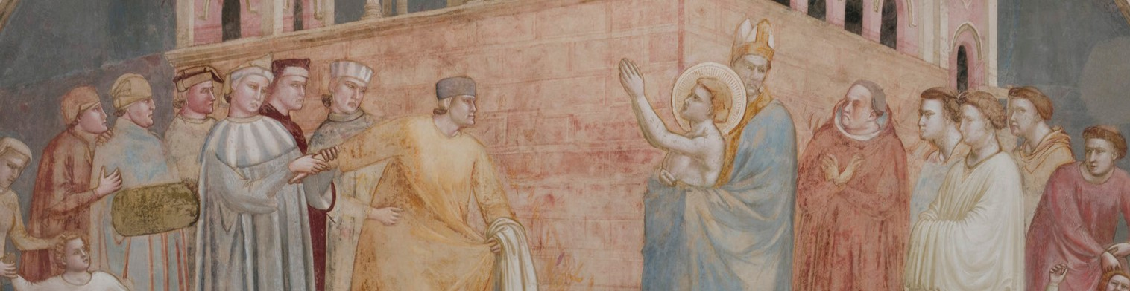
G I O T T O
AT SANTA CROCE
RESTORATION OF THE STORIES OF

SAINT FRANCIS
F
E
I
L
D
L
’
E
I
O
N
D
T
N
E
O
R
F
N
O
M
I
O
N
T
I
L
S
U
T
C
E
R
I
D
O
I
C
D
I

Giotto for Saint Francis: one genius and a team of artists
In the Bardi Chapel, restoration serves a powerful narrative, bringing Giotto’s spatial invention back to the fore
Florence, 11 September 2026 - By caring for a masterpiece, the restoration of the Stories of Saint Francis in the Bardi Chapel at Santa Croce provides a clearer reading of Giotto’s painting, highlighting its vibrant richness, expressive intensity and revolutionary conception of painted space and its relationship with real space.
Presenting this major intervention today are Alessandro Tortorella, Director of the Fondo Edifici di Culto of the Ministry of the Interior, together with Irene Sanesi, President of the Opera di Santa Croce, Giovanni Bettarini, Councillor for Culture of the City of Florence, Emanuela Daffra, Superintendent of the Opificio delle Pietre Dure, Father Franco Buonamano, Rector of the Basilica, Carlo Sisi, member of the Board of Directors of Fondazione CR Firenze, and Dominique Marzotto, President of ARPAI (Associazione per il Restauro del Patrimonio Artistico Italiano).
After four years of intensive work, Giotto’s wall paintings, a seminal work of the first quarter of the fourteenth century and a reference point for subsequent artists, are thus once again visible to visitors from around the world. The programme of in-depth study and subsequent restoration was promoted by the Opera di Santa Croce with the Opificio delle Pietre Dure, which designed and carried it out. Alongside the Ministry of Culture, support came from Fondazione CR Firenze, ARPAI and a group of passionate and generous private donors, including Veronica and Dominque Marzotto and William von Mueffling. The Giving4 Giotto campaign accompanied the restoration, inspiring the generosity of people around the world.
In the year marking the eight hundredth anniversary of the Transitus of Francis of Assisi, the chapel’s six scenes, based on Bonaventura da Bagnoregio’s Legenda maior, in which Francis is presented as the alter Christus, recount crucial moments in Francis’s life: the renunciation of his father’s wealth, the approval of the Rule, the apparition at the Chapter of Arles, the trial by fire before the Sultan, his death, and the apparition to Brother Augustine and Bishop Guido.
It is well known that several other painters worked alongside Giotto on the scaffolding under his direction, particularly at this mature stage of his career. The restoration now brings technical and stylistic differences into sharper focus, confirming that the Bardi Chapel was an incubator for innovations which, building on Giotto’s pictorial language, would shape developments in the following decades. It also confirms Giotto’s ability to adapt techniques to his expressive and practical needs, working on a fresco base but then making extensive use of a secco techniques to draw on a wider range of pigments and thus vary the chromatic and spatial effects, while managing the timing of the work more flexibly.
The restored image offers a deeper understanding of Giotto’s extraordinary figurative and spatial invention, while keeping visible the changing fortunes that have marked the cycle over the centuries: the limewashing in the early decades of the eighteenth century, its rediscovery in 1851 and restoration by Gaetano Bianchi, followed by Leonetto Tintori’s intervention under the direction of Superintendent Ugo Procacci between 1957 and 1959.
For four years, scientific investigation, conservation, research and documentation proceeded hand in hand, pursuing essentially two objectives. The first was to resolve less visible but more insidious problems that might have compromised the cycle’s very physical integrity. Using the most advanced methods of analysis and treatment, the most fragile areas were consolidated (cracks in the side walls, areas at risk of plaster detachment, and lifting and losses of the paint layer); harmful deterioration processes were reduced (such as the widespread presence of soluble salts); deposits and altered materials were removed, and many of the old synthetic fills dating from the previous restoration were replaced with mixtures more compatible with the original plaster.
The second involved the complex task of determining the final appearance: the delicate integration of losses (the larger ones that so visibly and indelibly mark the paintings, the numerous small losses scattered across the entire surface — around five thousand — and widespread abrasions) was approached using different methods, with the aim of restoring continuity to the figurative composition wherever possible while respecting the traces of its difficult conservation history.
Giotto’s spatial invention thus emerges in all its power. The individual scenes are united by monumental painted architecture, superimposed on the chapel’s actual architecture, which transforms it in conception into a kind of great ciborium. Within this illusionistic framework, which must have been shared by the other transept chapels, the scenes take place mainly in enclosed settings shown frontally, like large boxes opening towards the viewer, which govern the arrangement of the figures. Even in episodes set outdoors, such as the Renunciation of His Father’s Wealth, the complex architecture plays a central role.
The restoration sought to bring out this aspect, re-establishing, through interventions that remain identifiable, the continuity of the spatial framework superimposed on the real one, thereby making a crucial element of the artist’s pictorial revolution immediately legible once more. Its central importance is underscored by the painstaking care with which these elements were constructed on the wall, using incisions in the plaster and lines marked by snapping pigment-soaked cords against it. For the first time, all these elements have been digitally mapped and can therefore be read as a whole, making it possible to follow, step by step, the design of a pictorial space astonishing in its complexity and precision.
Finally, the vault is revealed almost as a new discovery, having received the least attention in earlier interventions. Cleaning, carried out in this area with the additional aid of laser equipment, has recovered the inventive power and figurative quality of the allegories of the Franciscan Virtues, particularly Obedience and Chastity, bringing back to light details that were previously illegible or entirely misunderstood.
As with any restoration project undertaken methodically and carefully considered in all its aspects, the completion of the work in fact opens the way to the future. Its results and the vast amount of data collected will provide the basis for further studies that will inform new readings of a crucial moment in European art and culture, while detailed knowledge of the materials and their condition will provide precise guidance for monitoring future deterioration and planning targeted interventions. This is therefore no closing chapter, but the prologue to stories yet to come.

The press kit, containing press releases, photographs and details of the frescoes and restoration site, video footage and video statements, can be downloaded from www.santacroceopera.it (News and Events section)

