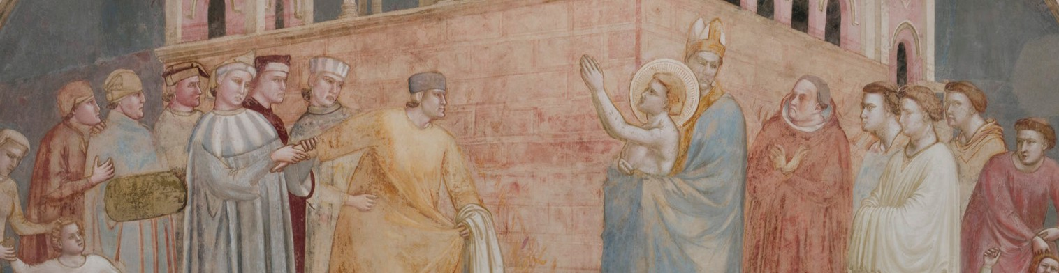
G I O T T O
AT SANTA CROCE
RESTORATION OF THE STORIES OF

SAINT FRANCIS
F
E
I
L
D
L
’
E
I
O
N
D
T
N
E
O
R
F
N
O
M
I
O
N
T
I
L
S
U
T
C
E
R
I
D
O
I
C
D
I

The painted cycle: from concealment to restoration

Florence, 11 September 2026 - The project to study and restore Giotto’s wall paintings in the Bardi Chapel grew out of a long process of research and preservation. Launched in July 2022, the intervention has its roots in Progetto Giotto, the innovative programme of investigations conducted by the Opificio delle Pietre Dure in 2010 in the Bardi and Peruzzi chapels. Those studies deepened understanding of the painting techniques of Giotto and his workshop and enabled a precise assessment of the condition of the two cycles.
Most probably commissioned by Ridolfo de’ Bardi, a member of the powerful family of Florentine bankers, the chapel has painted decoration covering approximately 180 square metres. On the side walls, Giotto and his workshop depicted crucial moments in the life of Saint Francis in six large scenes, complemented by the Stigmatisation painted above the entrance arch, the figures of saints on the rear wall and the allegories of the Franciscan virtues on the vault.
The dating of the cycle remains a subject of scholarly debate. The paintings were certainly executed after 1317, the year of the canonisation of Saint Louis of Toulouse, who is depicted on the rear wall of the chapel, and belong to the mature phase of Giotto’s career.
The conservation history of this masterpiece is particularly complex. The wall paintings were concealed beneath several coats of limewash at a date that has yet to be established, but certainly before 1730. This intervention probably spared at least part of the rear wall. In the early nineteenth century, the cenotaphs of two grand-ducal architects were also installed in the lower register of the side walls: Giuseppe Salvetti’s in 1812 and Niccolò Gaspero Maria Paoletti’s in 1818.
A chance discovery came in 1851: as preparations were being made for new decoration in the chapel, portions of the fourteenth-century paintings re-emerged beneath the layers of limewash. The uncovering of the cycle was entrusted to the painter and restorer Gaetano Bianchi. The mechanical removal of the limewash, known as descialbo, brought Giotto’s paintings to light, but also caused numerous abrasions, scratches and losses of the paint layer. The subsequent removal of the two cenotaphs also resulted in the permanent loss of the sections of fresco behind the monuments.
In keeping with nineteenth-century approaches to restoration, Bianchi reconstructed the missing areas and unified the surfaces with an extensive tempera patina. For around a century, the appearance of the Bardi cycle thus largely reflected this nineteenth-century interpretation of Giotto’s work. Between 1957 and 1959, Superintendent Ugo Procacci and restorer Leonetto Tintori addressed the problem according to radically different principles. Bianchi’s overpainting was removed to recover what remained of the original painting; the nineteenth-century additions were preserved separately for their documentary value. Tintori applied only light glazes to losses in the paint layer, leaving the approximately five thousand large and small gaps in the plaster in a neutral tone. This choice restored the authenticity of Giotto’s paintings, but inevitably left the cycle in a highly fragmentary state.
More than sixty years later, the restoration begun in 2022 addressed two needs together: ensuring the work’s preservation and improving its legibility, without erasing the traces of its history.

