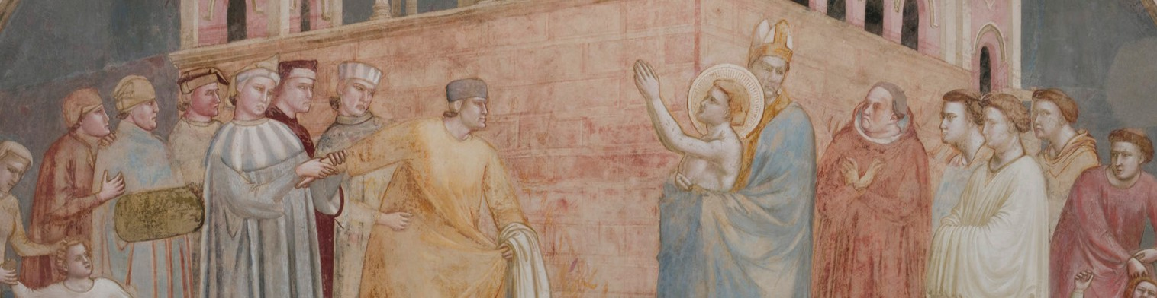
G I O T T O
AT SANTA CROCE
RESTORATION OF THE STORIES OF

SAINT FRANCIS
F
E
I
L
D
L
’
E
I
O
N
D
T
N
E
O
R
F
N
O
M
I
O
N
T
I
L
S
U
T
C
E
R
I
D
O
I
C
D
I

A shared restoration project, all together for Giotto
The decisive role of Fondazione CR Firenze and ARPAI
The #Giving4Giotto campaign engaged donors from around the world
A tu per tu con Giotto brought over 2,500 Florentines onto the scaffolding

Florence, 11 September 2026 - The restoration of the Bardi Chapel was a shared project, mobilising many different donors, all united by the same admiration and passion for Giotto’s genius. It was made possible by the essential support of Fondazione CR Firenze and the contribution of ARPAI (Associazione per il Restauro del Patrimonio Artistico Italiano), including through the Art Bonus scheme.
Contributions to this intervention, destined to take its place in the history of restoration, also came from Veronica and Dominique Marzotto, in memory of Countess Florence and Count Paolo Marzotto and Fabio Gori; Jon and Barbara Landau; and William von Mueffling. Also to be added to this list is Anne Farrell, who organised a generous fundraising effort in memory of her husband John, together with her family and his friends, with a special remembrance of Marina Marrelli.
In addition, the #Giving4Giotto fundraising campaign engaged people from around the world who, through their generosity, helped preserve one of Santa Croce’s most precious treasures and return it to the public, demonstrating the extent to which the heritage of this unique place is seen, in Italy and across the world, as belonging to everyone.
The A tu per tu con Giotto project, promoted and managed by Fondazione CR Firenze, brought over 2,500 Florentines onto the restoration scaffolding, offering them an unforgettable experience as they admired the details of this remarkable painted cycle and followed the various complex stages of the restoration.

