# 2020/21 Gender Pay Gap Reporting

Devon Doctors is required to report on its gender pay equality on an annual basis as the Organisation employs more than 250 individuals. This report reflects the pay position for the 2020/21 reporting period in line with the national guidance[1].

Once this report has been approved it will be uploaded to the Devon Doctors website so that it is publicly available.

For the purposes of this report, people who do not identify as Male or Female have not been included in the calculations; this is in line with the national guidance[2].

## Methodology

Data was obtained for the Group from the Sage-50 payroll system. This data included whether the individual was paid on a salaried or hourly basis, the rate of pay, the sex of the individual (where available), and the department that they work within.

This data was then reviewed to provide the six measures set out below:

1. Percentage of men and women in each hourly pay quarter
2. Mean (average) gender pay gap using hourly pay
3. Median gender pay gap using hourly pay
4. Percentage of men and women receiving bonus pay
5. Mean (average) gender pay gap using bonus pay
6. Median gender pay gap using bonus pay

In order to reflect the different roles and pay models within the Group, the data reported has been split between those paid on an hourly basis (Operational staff within Devon Doctors and Access Dental) and those on a salaried basis.

## Results

**Percentage of Men and Women working within Devon Doctors Group**

The workforce was sorted into order based on pay and then split in to four equal quarters. The proportion of male and female employees within each of those quarters was then calculated.



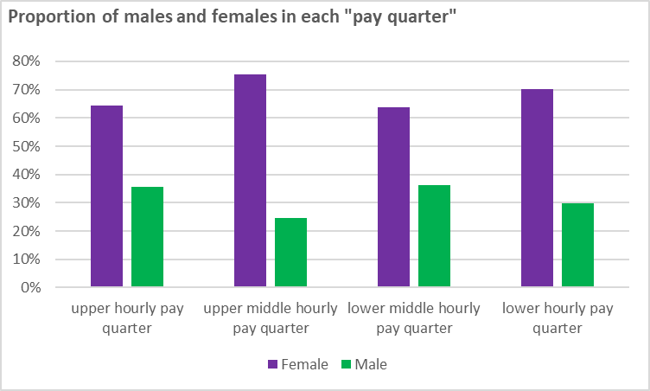

All four of the quarters have a greater proportion of women working within them, with the greatest differential being in the upper middle hourly pay quarter.

Overall, 68% of the workforce within the Organisation are female, with the remaining 32% being male. The graphs below show the male : female split for staff groups based on those in salaried positions and those who are paid on an hourly basis.

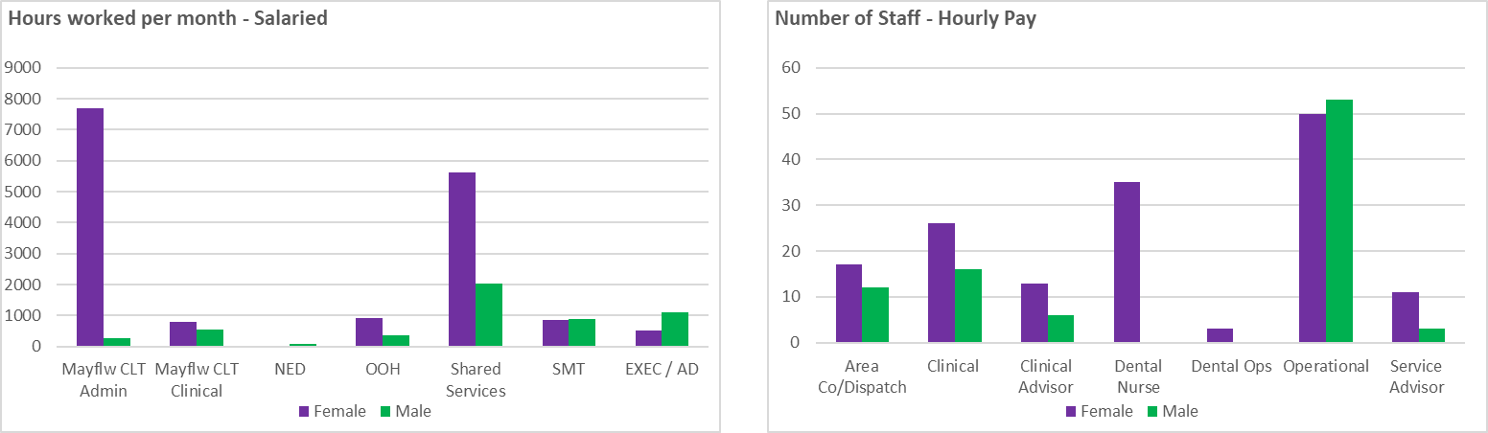

With the exception of the Executive / Associate Director and Non-Executive Director (NED) roles, all roles have a greater proportion of females working compared to males.

**Mean Gender Pay Gap**

The Graph below shows the average rate of pay for females (£14.87) and males (£16.85) based on the mean average.

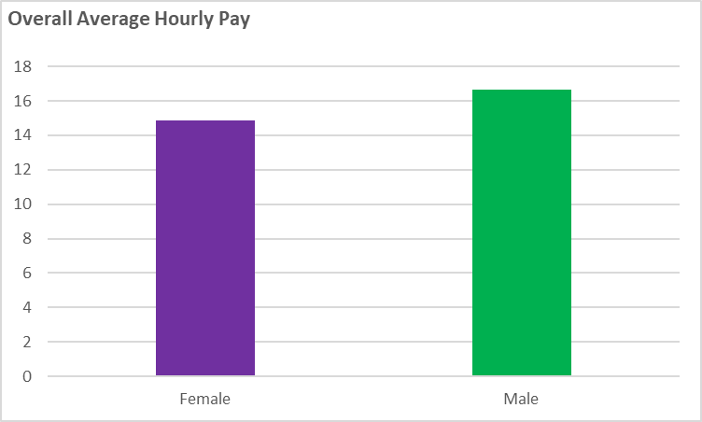

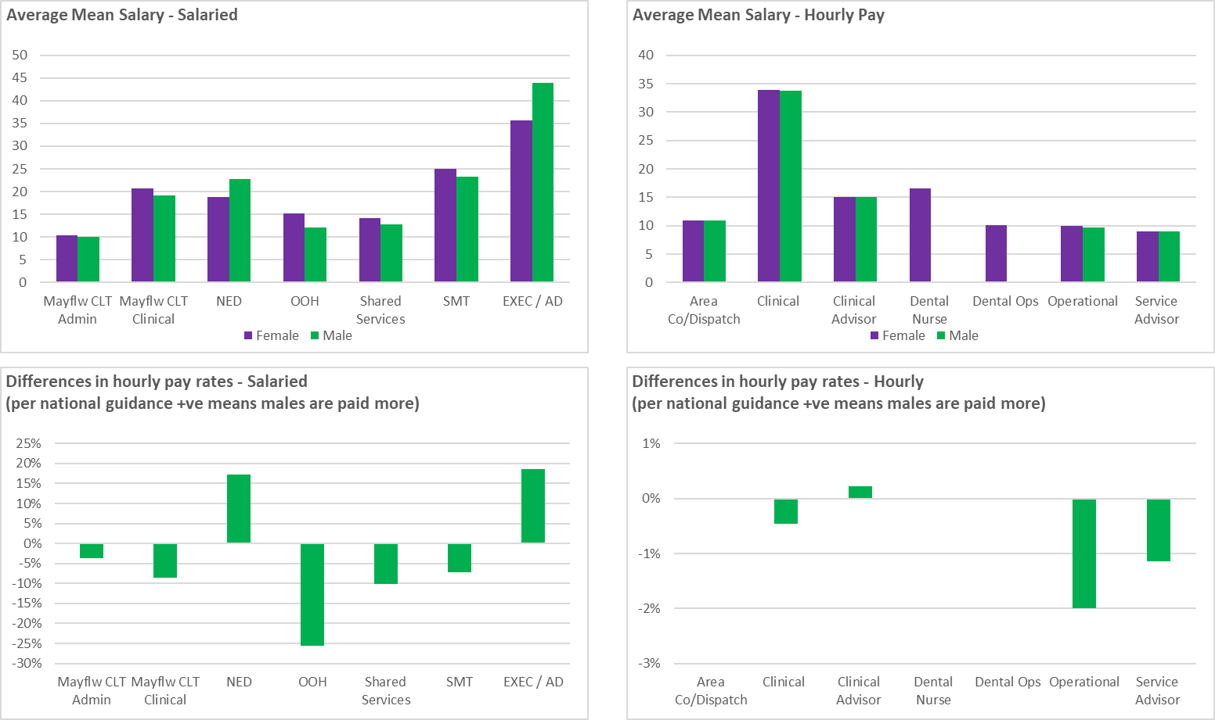

Overall, women are generally paid more in the staff groups except the Exec and Non-Exec Groups where the higher paid members of staff are male. Within the Non-Exec group, the Chair is paid more than the other NED’s due to having additional responsibilities within the Group. All other Non-Exec members are paid the same salary. The organisation has started to address this through appointing a female Chief Nurse at Executive Level and a female NED with a specialist interest in quality and governance. New NEDs are being onboarded before the end or 2021. Within the OOH (which includes 111) the senior managers are mainly female. Staff who are paid on an hourly basis are typically paid the same per role, with more females occupying senior roles within operations, particularly for Devon and Somerset IUCS (included as “Operational”).

**Median Gender Pay Gap**

The Median average pay shows that the median female (£11.84) is paid more than the median male (£11.19). The Median average removes the bias caused by the two extremes of the pay scale and is considered to be more representative of what the average employee is paid.

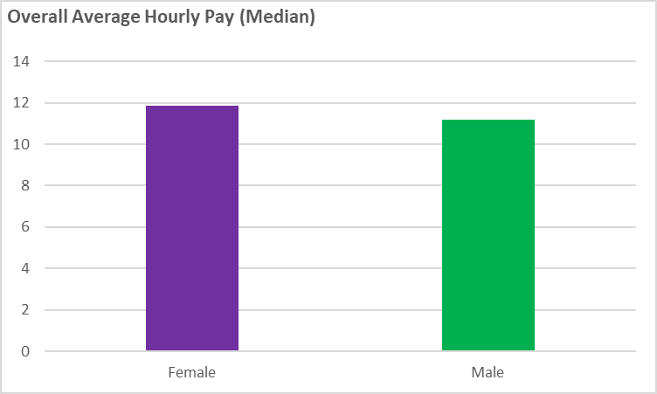

**Bonus Payments.**

During the year, 5% of females and 4% of males received a bonus payment

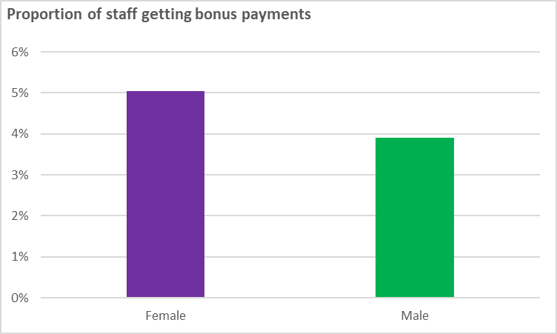

When reviewing bonus payments based on the average amount received, both Mean (57%) and Median (88%) methodologies show significant differences between male and female bonus payments. The proportion of staff receiving a bonus is higher for females. However, the maximum amount paid to a male was £5,000, this is the same as the maximum paid to a female member of staff.

## Next Steps and Commitments

Devon Doctors Group is committed to providing equal pay to members of staff irrespective of sex or any other protected characteristic. Hourly pay is, generally, balanced between males and females across all areas of the business. The prevalence of a greater number of males in senior management roles means that the mean salary is greater for men than women when considering the Group as a whole. The organisation seeks to address this through continued restructuring.

The Organisation provides opportunities throughout the Group for promotion to senior roles irrespective of protected characteristics. This has been seen throughout the Group during 2020/21 as more senior roles have been filled by women.

**Justin Geddes**

Chief Executive

1. <https://www.gov.uk/government/collections/gender-pay-gap-reporting>
2. [Who needs to report their gender pay gap - GOV.UK (www.gov.uk)](https://www.gov.uk/guidance/who-needs-to-report-their-gender-pay-gap#gender-identity)