Annual Surveillance Verification REPORT
This is a voluntary template that can aid in performing and documenting the annual surveillance procedure. Rules about this procedure is given in the General Programme Instructions, and the template should not be interpreted as introducing any new requirements to the procedure.
It is important for EPD Owners to be aware that they have the sole ownership, liability, and responsibility for the EPD.
The annual surveillance verification report (ASVR) is a review, conducted by the EPD Owner or LCA Consultant, to ensure that the EPD content and results are accurate and representative or whether any information in the EPD needs to be updated. If the EPD Verifier has been contracted to participate in the annual surveillance, he/she should be updated on the current validity of the EPD.
As outlined in the General Programme Instructions (GPI), during the validity period of the EPD it is not necessary to annually perform a full LCA, but monitoring of key parameters that were identified in the background LCA study is required. An EPD shall be updated and re-verified during its validity if changes in technology or other circumstances have led to:
- An increase of 10% or more of any of the environmental performance indicators ,
- Errors in the declared information, or
- Significant changes to the declared product information, content declaration, or additional environmental, social or economic information.
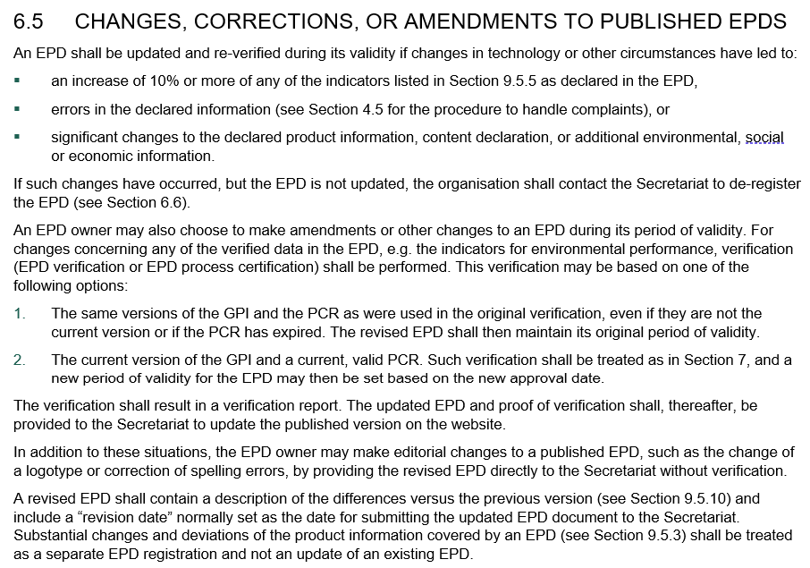

Suggested steps in the ANNUAL SURVEILLANCE VERIFICATION
These are four suggested steps introduced by the template:
- Identify hotspots and prepare questions
Interpretation of results of the environmental performance indicators from the EPD background report should identify the environmental ‘hotspots’ and the key data (LCI) or processes (e.g. product mix, electricity, gas, diesel consumption, etc.) that if changed could trigger a +10% deviation of EPD environmental impact indicator results. Based on these triggers specific yes/no questions should be developed.
- Prepare the ASVR template
The yes/no questions relating to the hotspots, key data, and other triggers should be added to the ASVR template at the end of the initial EPD verification process by the LCA Consultant/EPD Owner in coordination with the EPD Verifier (if applicable).
- Conduct AVSR checks
Annually the EPD Owner – or LCA consultants on their behalf – should review the key data and complete the ASVR checklist. Once complete, the AVS is signed by the EPD Owner and sent it to the Verifier for review.
- Annual Verification
The Verifier reviews the completed ASVR and, if the EPD does not have to undergo further checked or updates, the Verifier will complete and sign the AVSR and send a copy back to the EPD Owner (and/or LCA Consultant).

When do ASVR checks have to be conducted?
The ASVR checks don’t have to be conducted for initial EPD registration or the final year of validity but shall be completed annually according to the GPI, e.g. 12, 24, 36 and 48 months after initial registration of the EPD.

Annual Surveillance Verification Report TEMPLATE

EPD Information
Registration number of EPD(s): | Click to add text.
Product name(s): | Click to add text.
EPD Owner:  (organisation, name, position, email, phone) | Click to add text.
Product Category Rules (PCR):  Registration number, name and version  Complementary PCR(s) (c-PCR):  Registration number, name and version | Click to add text.
Publication date: | Click to add text.
Validity date: | Click to add text.
EPD programme operator: | Click to add text.
Title of the LCA report: | Click to add text.
Version of the LCA report: | Click to add text.
LCA practitioner:  (name, organisation, position, email, phone) | Click to add text.
If applicable, pre-verified LCA/EPD tool:  Name and version | Click to add text.
EPD Verifier:  (name, organisation, position, email, phone) | Click to add text.
Annual Surveillance Verification Report date (YYYY-MM-DD): | Click to add text.
Surveillance for the period: | ☐ year 1 ☐ year 2 ☐ year 3 ☐ year 4
EPD Scope | ☐ cradle-to-gate  ☐ cradle-to- gate with options  ☐ cradle-to-grave
If the EPD complies with EN15804 please indicate the life cycle stages included in the EPD below:
Product Stage |  |  | Construction stage |  | Use stage |  |  |  |  |  |  | End of Life |  |  |  |  | Resource recovery stage
A1 | A2 | A3 | A4 | A5 | B1 | B2 | B3 | B4 | B5 | B6 | B7 | C1 | C2 | C3 | C4 |  | D
Raw Material Supply | Transport | Manufacturing | Transport | Installation | Material emissions | Maintenance | Repair | Replacement | Refurbishment | Operational energy | Operational Water | Deconstruction/ Demolition | Transport | Waste Processing | Disposal |  | Reuse-Recovery-Recycling-potential
☐ |  |  | ☐ | ☐ | ☐ | ☐ | ☐ | ☐ | ☐ | ☐ | ☐ | ☐ | ☐ | ☐ | ☐ |  | ☐

surveillance verification questions
For each of the products listed in the EPD, please answer the questions below for the past 12-month period:
Question | Yes/No | Comments from the EPD Owner/LCA Consultant | Final Verifier Statement
- A1 Raw material supply
Have the raw material input quantities or types changed (design mix, formulation, components)? | Click to add text. | Click to add text. | Click to add text.
Have the manufacturers, suppliers, or source of raw materials changed? | Click to add text. | Click to add text. | Click to add text.
- A2 Transport
Have the locations of the manufacturers, suppliers, or source of raw materials changed? | Click to add text. | Click to add text. | Click to add text.
Have the transport distance or transport modes (e.g. truck, rail, ship) changed? | Click to add text. | Click to add text. | Click to add text.
- A3 Manufacturing
Have the manufacturing processes changed? | Click to add text. | Click to add text. | Click to add text.
Has the efficiency in the key manufacturing processes decreased? | Click to add text. | Click to add text. | Click to add text.
Has the source of energy changed (e.g. electricity, gases, or fuels) | Click to add text. | Click to add text. | Click to add text.
- General questions
Have any errors been identified in the EPD? | Click to add text. | Click to add text. | Click to add text.
Has there been any significant changes to the declared product information, content declaration, or additional environmental information? | Click to add text. | Click to add text. | Click to add text.

Additional questions | Yes/No | Comments from the EPD Owner/LCA Consultant | Final Verifier Statement
Click to add text. | Click to add text. | Click to add text. | Click to add text.
Click to add text. | Click to add text. | Click to add text. | Click to add text.
Click to add text. | Click to add text. | Click to add text. | Click to add text.
Click to add text. | Click to add text. | Click to add text. | Click to add text.
Click to add text. | Click to add text. | Click to add text. | Click to add text.
Click to add text. | Click to add text. | Click to add text. | Click to add text.
Click to add text. | Click to add text. | Click to add text. | Click to add text.
Click to add text. | Click to add text. | Click to add text. | Click to add text.
More rows can be added.
epd owner declaration
As the designated representative of the EPD Owner, I confirm that the annual surveillance has been conducted and there have been no:
- Changes identified that should lead to an increase of 10% or more of any of the environmental performance indicators in the EPD,
- Errors in the declared information in the EPD
- Significant changes to the declared product information, content declaration, or additional environmental, social or economic information,
- Changes to administrative information on the EPD (e.g., EPD Owner contact details).
EPD owner comments: | Click to add text.
Name: | Click to add text.
Signature:
Date (YYYY-MM-DD): | Click to add text.

Verifier declaration (IF APPLICABLE)
I confirm that the annual surveillance verification has been completed and no issues have been identified that require the EPD results to be updated.

The documentation reviewed as part of the annual surveillance verification include: | - Document name #1.  - Document name #2.  - Document name #3.
Verifier comments: | Click to add text.
Name: | Click to add text.
Signature:
Date (YYYY-MM-DD): | Click to add text.

General Programme Instructions (GPI)
Default list of environmental impact indicators is available on www.environdec.com
If the procedure for follow-up of data during EPD validity involved third-party verifier.

