INTERNAL follow-up REPORT
This is an example template that can aid in performing and documenting the mandatory internal follow-up procedure. Rules about this procedure is given in the General Programme Instructions (GPI), and the template should not be interpreted as introducing any new requirements to the procedure.
It is important for EPD Owners to be aware that they have the sole ownership, liability, and responsibility for the EPD (GPI 5.0.1 section 4.2.2).
The internal follow-up report (IFR) is a review, conducted by the EPD Owner or LCA Consultant, to ensure that the EPD content and results remain accurate and representative or whether any information in the EPD needs to be updated. The follow-up shall be done at least annually, based on last version date, and should be made with a frequency that will allow for an acceptable coverage of changes that might occur. If the EPD Verifier has been contracted to participate in the internal follow-up, the verifier should be updated on the current validity of the EPD and informed of any changes.
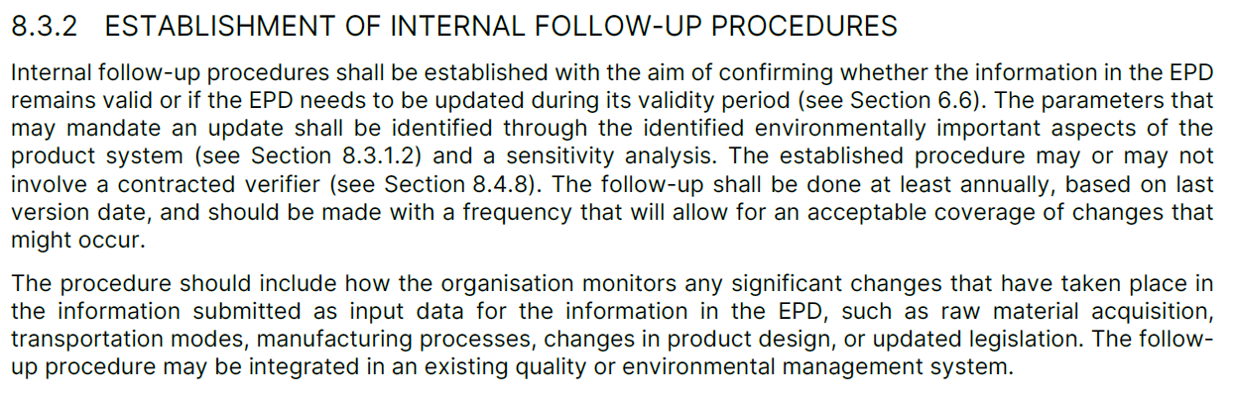
As outlined in the GPI, during the validity period of the EPD it is not necessary to annually perform a full LCA, but monitoring of key parameters that were identified in the background LCA study is required. An EPD shall be updated and re-verified during its validity if changes in technology or other circumstances have led to an increase in emissions or substantial changes to the declared information, as summarised in the GPI 5.0.1 section 6.8.1.
Additional examples of changes in technology and other circumstances include significant updates of applied datasets, changes in underlying data and information retrieved from suppliers, updates of EPDs used as a data source, or the release of more representative datasets applicable to the product system. Detailed requirements for data quality are specified in the PCR/c-PCR and GPI, and these requirements shall always take precedence.
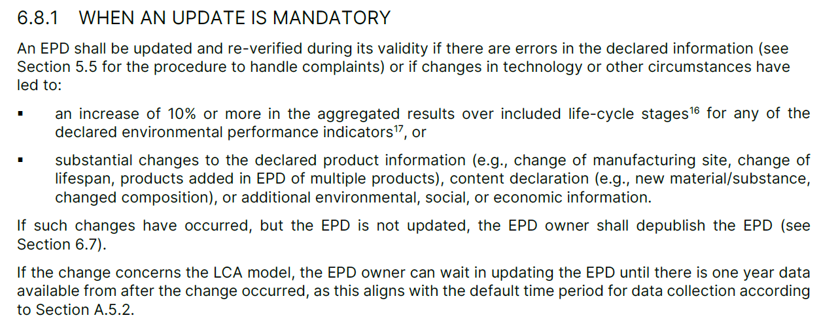
Suggested steps in the Internal FOLLOW-UP
These are four suggested steps introduced by the template:
- Identify hotspots and prepare questions
Interpretation of results of the environmental performance indicators from the EPD background report should identify the environmental ‘hotspots’ and the key data (LCI) or processes (e.g. product mix, electricity, gas, diesel consumption, etc.) that if changed could trigger a +10% deviation of EPD environmental impact indicator results. Based on these triggers specific yes/no questions should be developed.
- Prepare the IFR template
The yes/no questions relating to the hotspots, key data, and other triggers should be added to the IFR template at the end of the initial EPD verification process by the LCA Consultant/EPD Owner in coordination with the EPD Verifier (if applicable).
- Conduct IFR checks
Annually the EPD Owner – or LCA consultants on the EPD owner’s behalf – should review the key data and complete the IFR checklist. Once complete, the IFR is signed by the EPD Owner and sent to the Verifier for review¹.
- Annual Verification
The Verifier reviews the completed IFR to determine whether the EPD have to undergo further checks or updates. Once the review is completed, the Verifier will sign the IFR and send a copy back to the EPD Owner (and/or LCA Consultant).

When do IFR checks have to be conducted?
The IFR checks don’t have to be conducted for initial EPD registration or the final year of validity but shall be completed annually according to the GPI, e.g. 12, 24, 36 and 48 months after initial registration of the EPD.

INTERNAL FOLLOW-UP Report TEMPLATE

EPD Information
Registration number of EPD(s): | Click to add text.
Product name(s): | Click to add text.
EPD Owner:  (organisation, name, position, email, phone) | Click to add text.
Product Category Rules (PCR):  Registration number, name and version  Complementary PCR(s) (c-PCR):  Registration number, name and version | Click to add text.
Publication date: | Click to add text.
Validity date: | Click to add text.
EPD programme operator: | Click to add text.
Title of the LCA report: | Click to add text.
Version of the LCA report: | Click to add text.
LCA practitioner:  (name, organisation, position, email, phone) | Click to add text.
If applicable, pre-verified tool:  Name and version | Click to add text.
EPD Verifier:  (name, organisation, position, email, phone) | Click to add text.
Internal Follow-up Report date (YYYY-MM-DD): | Click to add text.
Follow-up for the period: | ☐ year 1 ☐ year 2 ☐ year 3 ☐ year 4
EPD Scope | ☐ cradle-to-gate  ☐ cradle-to- gate with options  ☐ cradle-to-grave

If the EPD complies with EN15804 please indicate the life cycle stages included in the EPD below:
Product Stage |  |  | Construction stage |  | Use stage |  |  |  |  |  |  | End of Life |  |  |  |  | Resource recovery stage
A1 | A2 | A3 | A4 | A5 | B1 | B2 | B3 | B4 | B5 | B6 | B7 | C1 | C2 | C3 | C4 |  | D
Raw Material Supply | Transport | Manufacturing | Transport | Installation | Material emissions | Maintenance | Repair | Replacement | Refurbishment | Operational energy | Operational Water | Deconstruction/ Demolition | Transport | Waste Processing | Disposal |  | Reuse-Recovery-Recycling-potential
☐ |  |  | ☐ | ☐ | ☐ | ☐ | ☐ | ☐ | ☐ | ☐ | ☐ | ☐ | ☐ | ☐ | ☐ |  | ☐

INTERNAL FOLLOW-UP questions
For each of the products listed in the EPD, please answer the questions below for the past 12-month period:
Question | Yes/No | Comments from the EPD Owner/LCA Consultant | Final Verifier Statement
- A1 Raw material supply
Have the raw material input quantities or types changed (design mix, formulation, components)? | Click to add text. | Click to add text. | Click to add text.
Have the manufacturers, suppliers, or source of raw materials changed? | Click to add text. | Click to add text. | Click to add text.
Have there been any updates to upstream EPDs? | Click to add text. | Click to add text. | Click to add text.
- A2 Transport
Have the locations of the manufacturers, suppliers, or source of raw materials changed? | Click to add text. | Click to add text. | Click to add text.
Have the transport distance or transport modes (e.g. truck, rail, ship) changed? | Click to add text. | Click to add text. | Click to add text.
- A3 Manufacturing
Have the manufacturing processes changed? | Click to add text. | Click to add text. | Click to add text.
Has the efficiency in the key manufacturing processes decreased? | Click to add text. | Click to add text. | Click to add text.
Has the source of energy changed (e.g. electricity, gases, or fuels) | Click to add text. | Click to add text. | Click to add text.
- General questions
Have any errors been identified in the EPD? | Click to add text. | Click to add text. | Click to add text.
Has there been any significant changes to the declared product information, content declaration, or additional environmental information? | Click to add text. | Click to add text. | Click to add text.
Have there been any significant updates of applied datasets? | Click to add text. | Click to add text. | Click to add text.
Is the EPD still following data quality requirements in accordance with applicable PCR and GPI? Are the used datasets still representative? | Click to add text. | Click to add text. | Click to add text.

Additional questions | Yes/No | Comments from the EPD Owner/LCA Consultant | Final Verifier Statement
Click to add text. | Click to add text. | Click to add text. | Click to add text.
Click to add text. | Click to add text. | Click to add text. | Click to add text.
Click to add text. | Click to add text. | Click to add text. | Click to add text.
Click to add text. | Click to add text. | Click to add text. | Click to add text.
Click to add text. | Click to add text. | Click to add text. | Click to add text.
Click to add text. | Click to add text. | Click to add text. | Click to add text.
Click to add text. | Click to add text. | Click to add text. | Click to add text.
Click to add text. | Click to add text. | Click to add text. | Click to add text.
More rows can be added.
epd owner declaration
As the designated representative of the EPD Owner, I confirm that the internal follow-up has been conducted and the following factors have been assessed:
- Changes identified that should lead to an increase of 10% or more of any of the environmental performance indicators in the EPD,
- Errors in the declared information in the EPD
- Significant changes to the declared product information, content declaration, or additional environmental, social or economic information,
- Changes to administrative information on the EPD (e.g., EPD Owner contact details).
Final decision on potential EPD update: | ☐ an update of the EPD is required due to identified changes  ☐ an update of the EPD is not required
EPD owner comments: | Click to add text.
Name: | Click to add text.
Signature: | 
Date (YYYY-MM-DD): | Click to add text.

Verifier declaration (IF APPLICABLE)
I confirm that the internal follow-up has been completed in accordance with GPI 5.
The documentation reviewed as part of the internal follow-up include: | - Document name #1.  - Document name #2.  - Document name #3.
Verifier comments: | Click to add text.
Name: | Click to add text.
Signature:
Date (YYYY-MM-DD): | Click to add text.

If the procedure for follow-up of data during EPD validity involved third-party verifier.

