



|  |  |  |  |  |
| --- | --- | --- | --- | --- |
| Gezien door | Instituut | Datum | Wat? | Goedkeuring? |
|  |  |  |  |  |
|  |  |  |  |  |
| Leo Posthuma | RIVM | 28 feb 2021 | Deltafact-stijl nog checken | Inhoud: Ja |
| Sanne van den Berg | WEnR | 16 Maart 2021 |  | Ja |

@@@Milo: het format “Deltafact” is sinds enige tijd aan strenge voorwaarden gebonden (ik had een Deltafact ter check ingezonden, en dit is wat ik hoorde). Wat ik gedaan heb is: het woord Deltafct vervangen door “KIWK-Toxiciteit Notitie”, en daar een stijl voor gebruiken, zie bv product S1. VOor het gemak kan je nu gewoon allee de woorden en logo’s van de Deltafacts verwijderen, en vervangen. PS Waarom engels? Ben benieuwd wat de mee-lezers daar van zeggen. Tenslotte: een plaatje (variatie van 170 k stoffen qua sorptie-eigenschappen, en qua bioassay-endpoints, kan helpen bij de lezer om alle keuzes te begrijpen. Wij moeten nog toewerken naar een keuze voor “Toestand&Trendmonitoring”, als basis. Het plaatje kan op de webpagina’s goed werken..

Environmental Sampling Techniques

Dit Deltafact geeft een overzicht van de verschillende bemonsteringstechnieken en de voorbewerking per techniek. Deze technieken kunnen ingezet worden bij het monsteren voor *effect-based measurements* (EBM) met behulp van bioassays.

1. INTRODUCTION

2. GRAB SAMPLING

3. PASSIVE SAMPLING

4. LARGE VOLUME SOLID PHASE EXTRACTION

5. SOURCES & LINKS

6. ACCOUNTABILITY

7. DISCLAIMER

8. REFERENCES

1. INTRODUCTION

A variety of environmental sampling techniques exist for extracting organic compounds from water. The used sampling technique should be considered at the start of a project proposal/design. The target organic compounds, frequency of sampling, water source, financial and temporal resources, and study objectives together determine the applied sampling technique(s) (table 1). Different types of sampling techniques exist: grab sampling, including single and composite sampling; passive sampling, which is the concentration of compounds in the water body of interest, (‘*in situ*’); and large volume extraction, which is the concentration and extraction of compounds in the field or in the lab, (‘ex situ’). Grab samples are samples taken at a discrete point in time and are representative of the water composition at only that point in time (snapshot samples). Grab samples are often concentrated and extracted prior to chemical- or bioassay analysis. Time-integrative composite samples are samples taken from a vessel in which water is collected for a specified amount of time. Passive sampling uses a solid or liquid phase to accumulate compounds from the water and can provide equilibrium or time-weighted average compound concentrations. Passive samplers concentrate substances in the field and can be extracted in the laboratory. Large volume solid phase extraction (LVSPE) offers a similar on-site concentration of samples, but uses a pump to provide precise extracted water volumes.

*Table 1. Summary of the different environmental sampling techniques, the sampled matrix, which compounds of interest are sampled and the advantages and limitations of the methods.*

|  |  |  |  |  |
| --- | --- | --- | --- | --- |
|  | **Sampled matrix** | **Compounds sampled** | **Advantages** | **Limitations** |
| Grab sampling | * Particle bound * DOC bound * Freely dissolved concentration | * Predominantly hydrophilic/polar compounds unless much suspended matter sampled | * Same day results possible from a single grab sample * Possible to do event-specific monitoring (e.g. after heavy rainfall, flooding, spills), though logistically difficult to implement * Inexpensive and simple to collect | * Labor intensive * Snapshot: concentrations only representative of the single point in time when sampled * Filtration needed to represent the dissolved/bioavailable concentration in a sample * Adequate sample storage is important as samples may not be stable over time * Large volumes required for nonpolar or low concentration compounds |
| Passive sampling | * Freely dissolved concentration | * Mainly polar (hydrophilic-less hydrophilic) compounds are concentrated (adsorption samplers) * Nonpolar (hydrophobic-super hydrophobic) compounds (equilibrium or partitioning samplers) | * Representative of the dissolved or bioavailable concentration in the water matrix * Relatively inexpensive, require little equipment for deployment or time investment while deployed * Gives a time-weighted average concentration, more accurately representing the concentrations in the water matrix than a grab sample * Very low concentrations of compounds can be detected due to sampling larger water volume (particularly for nonpolar compounds) * Uptake by samplers ensures limited degradation of samples in transport * No need to transport large volumes of water | * Lag time, potential interaction of compounds with membrane (adsorption samplers) * Not all compounds reach equilibrium simultaneously (absorption samplers) * Some samplers require additional calibration to calculate environmental concentrations * Concentrations of mixture constituents may not be representative of the actual composition of the mixture of compounds in water * Volumes of extracted water are unknown, so estimations need to be made for effect-based analyses |
| Large volume solid phase extraction | * DOC bound * Freely dissolved concertation | * Hydrophilic/polar compounds * Limited nonpolar compounds | * Time integrated (hours-days) sampling, ensuring representative water samples * SPE ensures limited degradation of samples in transport * Known extracted volume of water | * Onsite LVSPE requires electricity to operate, associated logistical difficulties * Off-site LVSPE requires transport of large volumes of water * More expensive and logistically difficult to implement than passive sampling |

2. GRAB SAMPLING

Grab sampling is the most straightforward and least expensive form of environmental sampling. A small water volume (usually 1 liter) is taken and brought to the lab for further analysis. Grab samples provide a snapshot representation of the water composition only at the time of sampling. Since the compound concentrations in the field can vary substantially, the time and location of sampling can strongly impact the concentrations in the grab samples. To overcome this, grab samples collected at regular intervals or flow volumes may be combined to form composite grab samples, representing the average water composition over the collection period (Kramer, 2018). When composing samples, the interval of sample collection is very important, as small peaks can be missed when the sampling interval is too long (Ort, Lawrence, Rieckermann, & Joss, 2010).

**Suitability of Single and Composite Grab Samples**

Single grab samples are particularly useful when the water body is relatively homogeneous in both time and space. When concentrations of compounds vary over time, composite grab samples can be more appropriate. The choice between grab samples and composite grab samples will depend on the compound(s) of interest, as well as the available financial and temporal resources. For example, composite sampling is unsuitable for unstable compound parameters like pH, dissolved oxygen or volatiles (which will evaporate due to the physical mixing process) (USEPA, 1995).

**Location and Frequency of Sampling**

The location, date-time, and frequency of sampling is very important when creating a sampling program. The concentrations of compounds may depend on the location (e.g. depth in the water column, distance from the shore) and time of sampling (e.g. high flow after spring melt or heavy rainfall event). The frequency of sampling is also important. If an average concentration is required, composite samples are more economical to analyze than discrete grab samples, but require personnel to be present on site for the sampling period. Passive sampling may be a good alternative if average concentrations are desired over longer periods (> 1 week deployment). Average water quality parameters may be required for certain types of analysis. In wastewater treatment plants (WWTPs), for example, the biological oxygen demand (BOD) is tested most often on composite samples, as the influent flow and water quality varies considerably throughout the day.

Composite grab samples may be time or flow proportional. Time proportional samples are samples of constant volume collected at regular time intervals, while flow proportional samples are constant volume samples taken at time intervals proportional to the flow. In systems where the flow and related water quality parameters vary substantially (e.g. WWTPs), flow averaged samples may be more appropriate than time averaged samples. Composite samples may be collected manually by mixing discrete grab samples, or through the use of automatic samplers with pumps.

**Sample treatment**

The compound(s) of interest and the study objectives will determine the sample treatment and analysis. Sample treatment prior to analysis may include concentration or extraction of the samples. Concentrating samples is required if the concentration of the compounds of interest in the original sample are below the detection limit of the analytical equipment. Extraction of the samples is necessary when, for example, the compounds cannot be analyzed in the aqueous phase directly or because of the presence of (suspended) solids onto which compounds may be adsorbed. Extraction and concentration techniques for samples include; liquid-liquid extraction (LLE), solid phase extraction (SPE), and solid phase microextraction (SPME).

*Table 2 Summary of the advantages, limitations and suitability of single and composite grab samples*

|  |  |  |  |
| --- | --- | --- | --- |
| **Method** | **Advantages** | **Limitations** | **Suitable For** |
| Single grab samples | * Same day results possible * Event specific monitoring possible (e.g. after heavy rainfall, flooding, spills) though logistically difficult to implement * Inexpensive and simple to collect | * Snapshot: concentrations only representative of the single point in time when sampled* * Filtration needed to represent the dissolved/bioavailable concentration in a sample * Large volumes required for nonpolar or low concentration compounds   *: May result in over- or underestimation of compounds of interest due to episodic or other form of temporal variation in system | * Single or event sampling * Unstable compound parameters (e.g. temperature, pH, dissolved oxygen, volatiles) with proper sample storage |
| Composite grab samples | * More economical to determine average concentrations than single grab samples * Representative of the time or flow proportional average concentration | * Cannot determine the maximum or minimum concentrations during the sampling period * Not suitable for compounds changing concentration over time (e.g. volatiles) * Flow proportional composite sampling requires accurate flow measurements * Time proportional samples may be inaccurate, especially for high/variable flow systems | * Stable or non-volatile compounds (e.g. BOD, total suspended solids, total nitrate) |

LLE is performed when compounds are extracted in a solvent that cannot be adequately mixed with water. It involves shaking the sample with an immiscible solvent to extract the compound(s) of interest to the solvent. The choice of solvent will depend on the compound(s)’s partitioning coefficient and polarity (Piri-Moghadam et al., 2016). LLE is able to concentrate large volumes of sample with dilute concentrations, however, LLE also requires substantial volumes of solvent, resulting in waste.

SPE is able to separate compound(s) of interest from a sample. SPE is particularly useful when a sample contains many compounds that require separate analysis or the removal of compounds which would otherwise interfere with the analysis (sample clean-up). SPE uses a suitable stationary phase to separate compounds of interest based on their physical and chemical characteristics (e.g., size and polarity), from which the compounds are subsequently extracted with a suitable solvent. SPE requires less solvent than LLE, however it is limited to small sample volumes and, therefore, cannot concentrate large samples as efficiently (Piri-Moghadam et al., 2016), unless multiple SPE columns are used.

3. PASSIVE SAMPLING

Passive sampling is a relatively simple technique in which a sorption material is exposed in the water for periods that can vary from several days to months. The uptake of compounds by passive samplers is based on diffusion and the samplers provide equilibrium- or time-integrated compound concentrations (Vrana, 2018). Passive samplers consist of a phase with a high affinity for dissolved compounds. The choice of passive sampler can be tailored to the particular compound(s) of interest, the environmental matrix and conditions, and the required exposure time. The uptake rate of compounds into samplers depends, among others, on the water flow; high water flow velocities with lots of turbulence lead to a faster uptake of compounds. Passive sampling is particularly useful for compounds with very low or varying water concentrations. The main advantages of passive sampling compared to grab sampling are:

* The measurement of freely-dissolved compound concentrations without any additional sample treatment;
* The *in situ* concentration of compounds in the sampler, resulting in lower detection limits and easy sample transportation and handling;
* The measurement of time-weighted average concentrations over the deployment period, and the integration of contamination peaks.

A variety of passive sampling devices exist with specialized features to target particular compounds of interest (De Weert & Smedes, 2014). The extracts of passive samplers can be used in target- and non-target chemical analysis and bioassays.

**Types of Passive Sampling Devices**

Passive samplers can be divided based on the two working principles:

1. Equilibrium (partitioning) samplers, such as silicone rubber, with a continuous uptake and release of compounds and absorption samplers where compounds diffuse into a polymer. Equilibrium samplers are commonly used to accumulate nonpolar (hydrophobic) compounds.
2. Adsorption (kinetic) samplers, such as Speedisk or POCIS samplers, which contain a sorbent or resin to which compounds adsorb. Adsorption samplers are applied for the sampling of more polar (hydrophilic) compounds.

The working principle of the two passive sampler types is discussed in short below. In a STOWA report of 2014 (*in Dutch*), a broader overview is given of the different passive samplers with a more detailed explanation about the working principle and the application possibilities of passive sampling (De Weert & Smedes, 2014).

**Equilibrium (partitioning) samplers**

*Silicone Rubbers / SPMD*

There are different types of partitioning samplers. The most commonly applied are: silicone rubber samplers, consisting of polydimethylsiloxane (PDMS) (Figure 1); LDPE samplers, consisting of a sheet of low density polyethylene; and the semipermeable membrane device (SPMD), consisting of two sheets of LPDE with the synthetic fat triolein in between (Figure 2). SPMDs are frequently used in the US, and silicone rubber and LDPE in Europe. In The Netherlands, mainly silicone rubber samplers are applied. The underlying compound-physical processes are comparable between these different samplers.

The uptake of compounds into partitioning samplers follows first–order kinetics. Because of this, the time weighted average concentration and the percentage of equilibrium can be calculated for each compound with a known passive sampler-water partition coefficient (Kpw) and a known sampled volume (see section on sampled volume estimation). Equilibrium samplers absorb the freely dissolved compounds of interest, which will diffuse into the polymer matrix. The uptake rate depends on the thickness of the water-boundary layer at the surface of the sampler. With more water movement, this layer is thinner and the uptake of the compounds faster.

As most polymers, except for SPMDs, are delivered in large sheets, these can be cut into sizes and shapes specifically for the tested system. After deployment and surface cleaning, the sheets could be theoretically directly applied as passive dosers in bioassays.

The range of compounds that an equilibrium sampler can effectively accumulate depends on the polymer composition. Equilibrium samplers are commonly applied for nonpolar compounds (logKow of 3 – 8) such as PAHs, PCBs, dioxins, furans, PBDEs, chlorinated pesticides and nonpolar contaminants related to wastewater effluents such as fragrances, triclosan, and phthalates (Alvarez, 2010). Polar compounds (logKow < 3) also diffuse into the sampler. However, the equilibrium time of polar compounds is short and the uptake capacity for these compounds is limited. This makes equilibrium samplers less appropriate for the monitoring of polar compound concentrations in water, either by chemical analysis or bioassays.

*Sampled volume estimation*

The estimation of sampled water volumes is crucial when translating chemical or bioassay analyses to surface water concentrations. Equilibrium samplers allow the use of performance reference compounds (PRCs) for sampled volume estimations. These samplers accumulate compounds until equilibrium is achieved between the sampler and the water matrix. The time to equilibrium is influenced by a number of site specific factors, e.g. hydrophobicity of the compounds of interest and flow rate.

PRCs are a suite of compounds spiked into the sheets prior to the deployment that dissipate from the samplers over time. The remaining concentrations of the PRCs after the deployment allow the calculation of the sampling rate and thereby the freely dissolved water concentration of the sampled compounds.

Performance reference compounds must fulfill three major criteria. They are:

1. a select group of compounds with a logKpw in the range of 4-8,
2. neutral and have reproducible and reliable uptake and release behavior,
3. not already present in the environment (e.g. non industrially used PCBs).

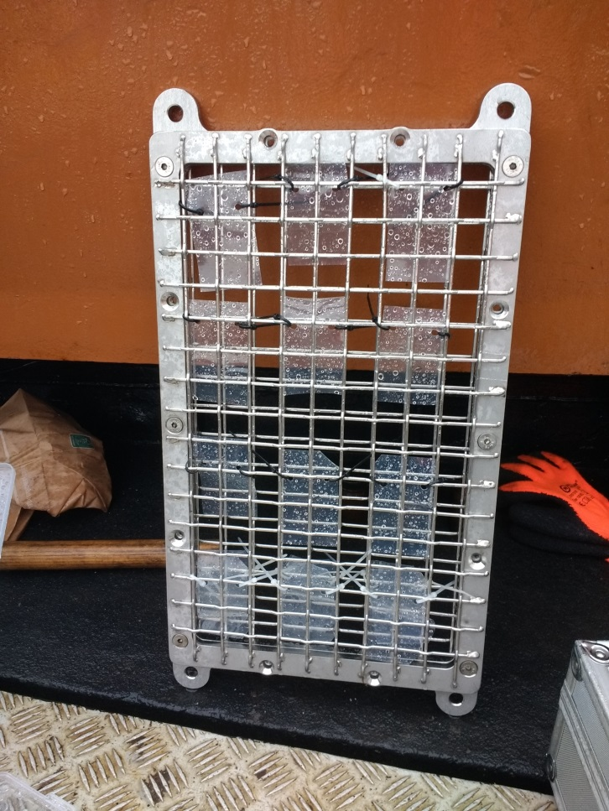*Figure 1 Equilibrium sampler silicone rubbers. Connected on a sampler holder designed for the sampling of oil pollution in surface water (Deltares 2019)*

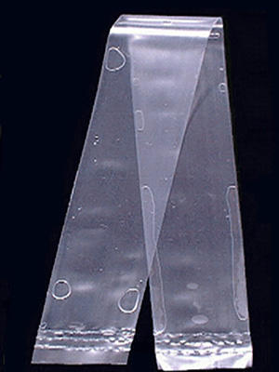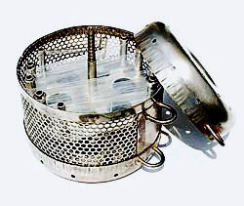

*Figure 2 Equilibrium SPMD sampler. Left: SPMD device, (Alvarez, 2010), Right: Example of field deployment of SPMD (Image source: Environmental Sampling Technologies)*

**Adsorption samplers**

*POCIS and Speedisks*

A variety of adsorption samplers is available, like POCIS, Chemcatcher, o-DGT, and Speedisk. Adsorption passive samplers are used in the linear or ‘kinetic’ uptake regime. POCIS and Speedisk are most commonly applied in The Netherlands. While POCIS (Polar Organic Compound Integrative Samplers) (Figure 3) and Speedisks (Figure 4) are different in their details, e.g. structure of the protective membrane and the composition of the sampling material, their respective working principle is the same and will be discussed together. Both samplers work with an adsorption material protected by a membrane. Speedisk samplers have one interaction surface while POCIS have two. Speedisk use glass fibre filter membranes while POCIS use polyethersulfone (PES) membranes. Adsorption samplers can be modified by using different sorption materials, e.g. polar- divinyl benzene (DVB), styrene, or hydrophilic-lipophilic balance (HLB) sorbents. This offers a higher flexibility for screenings by allowing the sampling of specific or a wide range of compounds. Moreover, alternative membrane materials can be used to improve the uptake of certain compounds.

POCIS are designed to sample polar organic compounds, such as pharmaceuticals, illicit drugs, polar pesticides, phosphate flame retardants, surfactants, metabolites and degradation products (Alvarez, 2010). The Oasis-HLB used in the standard POCIS configuration is a universal sorbent and is suitable for sampling a wide range of compounds. HLB materials can be amended with different functional group to preferentially sorb different compounds (Bäuerlein, et al., 2012). HLB materials with no additional functional groups are most suitable for neutral solutes, HLB with a MCX functional group is best for positively charged molecules, while a MAX functional group is best for negatively charged molecules (Table 3).

*Table 3 OASIS sorbent materials and the compounds the materials are suitable to sample*

|  |  |  |
| --- | --- | --- |
| **OASIS Sorbent** | | **Suitable for;** |
| **HLB** | Hydrophilic-Lipophilic-Balanced | Neutral (polar) solute |
| **WAX** | Weak Anion Exchange |  |
| **WCX** | Weak Cation Exchange |  |
| **MCX** | Mixed Cation Exchange | Positively charged molecules |
| **MAX** | Mixed Anion Exchange | Negatively charged molecules |

Membrane filters are applied to protect the sorbent and to limit the diffusion speed of compounds to extend the linear uptake phase of the samplers. The type of membrane that is used plays an important role in the uptake rate of compounds. The glass fibre filters used in Speedisks are inert (Smedes *et al*., 2013), while the PES membranes used in POCIS display sorption for more hydrophobic compounds (Vermeirssen et al. 2012). If this is undesireable, for example when POCIS are used to sample an as wide as possible range of compounds, a better alternative may be to replace the PES membranes by PTFE membranes that show little sorption, if any (Endo 2018). In short, the target compounds of POCIS and Speedisks range from polar to nonpolar (logKow -2 – 4) and can be further adjusted by using different sorbents and membranes.

Sampled volume estimations using PRCs is not suitable for adsorption samplers as compounds are strongly bound to the adsorption material and not readily released. Calculation of the sampled volume and thereby the freely dissolved water concentrations requires calibration of the samplers. However, during field deployments, the flowrate of the water can vary which affects the uptake rate and as a result the sampled volume. There are currently initiatives to develop field calibration systems for adsorptions samplers, however none are currently in regular use yet. This is a disadvantage of passive sampling when it is combined with (bio)analytical methods since the average sampled volume of the samplers has to be estimated.

|  |  |
| --- | --- |
|  |  |

*Figure 3 Diagram of POCIS sample, showing the layers of sorbent, membrane and ring. Image source:* [*https://www.affinisep.com/spe-kits-applications/passive-sampler/*](https://www.affinisep.com/spe-kits-applications/passive-sampler/)

|  |  |
| --- | --- |
|  |  |

*Figure 4 Speedisk sampler with it individual compartments (Deltares 2018)*

**Sampled Mixture**

No single sampler can give a complete representation of all contaminants in the water. For example, very polar compounds are difficult to sample due to the affinity for the aqueous phase compared with the sampler matrix, and the equilibration times for very nonpolar compounds with equilibrium samplers are very long. Equilibrium samplers have a larger capacity for nonpolar compounds and, as a result, accumulate more nonpolar than polar compounds. Similarly, nonpolar compounds are more concentrated in organisms than polar compounds.

Adsorption samplers are more representative of the compound composition of the water matrix, as polar compounds are present in higher dissolved concentrations than nonpolar compounds. Adsorption samplers concentrate polar and nonpolar compounds more or less equally. As a result, compounds which are present in higher concentration in the water (e.g. polar compounds) will also be present in higher concentrations on the adsorption material of the sampler compared to nonpolar compounds.

**Passive Sampler Selection for Subsequent (Bio)analysis**

The appropriate selection of passive sampler types depends on the monitoring goals. The type of water and pollution source, compounds of interest, and projected subsequent (bio)analyses determine which passive sampler(s) should be used.

Equilibrium samplers are commonly applied for the sampling of nonpolar compounds, while polar compounds are more effectively sampled by adsorption samplers. Specific sampler configurations have been developed to target specific compounds of interest (e.g. PFAS, neonicotinoid insecticides, pharmaceuticals, etc.), which can be considered when sampling particular pollution sources (e.g. WWTPs, agricultural areas, industry, etc.). However, when the goal is to have an as wide as possible scope on micropollutants, it is advised to used multiple passive sampler types simultaneously. A combination for a broad monitoring of organic micropollutants that is commonly applied in The Netherlands is silicone rubbers with either POCIS or Speedisk. The extracts of these samplers can subsequently be chemically analysed (LC- or GC-MS/MS) or applied in bioassays. Again, here the sampler type should be matched with the appropriate analysis. Nonpolar extracts are commonly analysed with GC, while polar extracts are better analysed with LC. Similarly, some bioassays are particularly responsive to nonpolar extracts, like aryl hydrocarbon receptor (AhR)-based bioassays, while others respond more strongly to polar extracts, like estrogen and androgen receptor-based bioassays. Whole-organism bioassays, like the Microtox bacterial inhibition assay, will respond to all bioactive compounds and can be exposed to extracts from all passive sampler types.

This means the type(s) of sampler used can be tailored to the specific needs of the monitoring campaign, and sampler selection should thus be an integral part of the design of the sampling strategy when passive sampling is desired.

**Deployment**

Passive samplers can be deployed from days to months depending on the research question(s) and compound(s) of interest. In the case of adsorption samplers, the minimum duration should be one week, because of the lag period of compound diffusion through the membrane filter. On the other hand, biofouling and the risk of damage/loss of the device will limit the deployment period. The number of sampling devices that is needed will be dictated by the detection limit of the chosen analytical method, the expected concentration of the compound(s) of interest in the environment, and the length of sampler deployment (Alvarez, 2010).

Partitioning samplers do not have a lag phase. Therefore, a deployment period of only a few days may be sufficient to sample more polar compounds, for which the sampler and water are more quickly in equilibrium. However, for more nonpolar compounds, that are commonly the target compounds of these samplers, the regular deployment period is several weeks. When sampling nonpolar compounds with a logKow >7, such as brominated flame retardants, the deployment time can even be several months to exceed the detection limit. Figure 5 gives an indication of the required deployment duration of equilibrium samplers based on the logKow of the compounds of interest.

Samplers should be installed in areas with flowing water - the stronger or more turbulent the flow, the higher the sampling rate. Knowledge of flow velocity can assist in the decision making of the deployment duration. Potential risks of losses can be circumvented by deploying multiple samplers units. Biofouling may occur and should be removed with local water during retrieval.

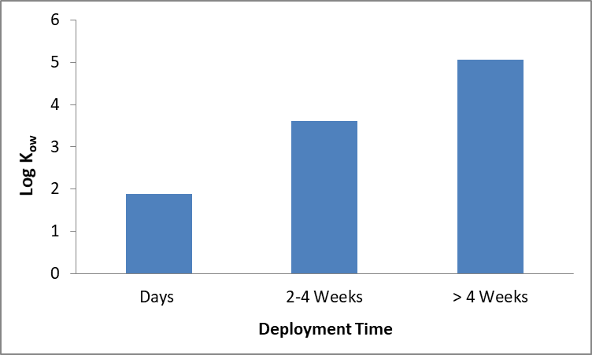

*Figure 5 Indication of the minimum required deployment of equilibrium samplers time based on when the samplers are in equilibrium according to the logKow.*

*Table 4 Summary of the advantages, limitations and suitability of adsorption and equilibrium passive samplers*

|  |  |  |  |
| --- | --- | --- | --- |
| **Device** | **Advantages** | **Limitation** | **Suitable for** |
| **Adsorption sampler** | * Accurately represents the dissolved or bioavailable concentration in the water matrix * Are relatively inexpensive, require little equipment for deployment or time investment * Give a time-averaged concentration, more accurately representing the average in the water matrix than a grab sample * Low concentrations of compounds can be detected, calculated from linear sorption behavior of PRC | * Act as non-releasing sink because of strong sorptive properties * No reliable PRC * Do not measure the sampled volume directly * Non-linear sorption behavior and competition after long exposure times affects sorption affinity, and complicated back calculation to aqueous concentrations | * Polar organic compounds * Neutral nonpolar * LogKow -2 - 4 |
| **Equilibrium sampler** | * The more polar the compounds the lower the sampled volume. * Few polar compounds have a good uptake and reliable Kow * For precise measurements, logKpw are required | * Neutral nonpolar compounds * Semi-polar compounds * logKow 2.5 - 8 |

**Extraction**

After deployment samplers must be extracted in the lab to determine the concentration of compounds of interest. Samplers are carefully cleaned of biofilm and other residues. For adsorption samplers, the filter/ membranes should be removed before extraction to avoid the coextraction of biofouled sampler housings.

The used extraction method and solvents depends on the type of sampler. Equilibrium samplers are mainly extracted with hot (soxhlet) extraction with hexane or cold extraction with acetonitrile. Depending on the logKow range of the compound(s) of interest, adsorption samplers may be extracted using a polar solvent like methanol and/or a non-polar organic solvent like dichloromethane. By using both, a broad range of compounds can be extracted. In the case of specific compounds, such as acidic herbicides, the solvent can be acidified to increase the extraction efficiency. Extracts can be subsequently analyzed, for example by GC-MSMS or HPLC-MSMS. Equilibrium samplers are reusable after cleaning procedures in the lab.

4. LARGE VOLUME SOLID PHASE EXTRACTION

**Large volume solid phase extraction**

**Introduction**

Large volume solid phase extraction (LVSPE) is a collection of techniques used to extract a range of compounds of interest from large volume water samples. LVSPE is particularly useful when sampling compounds present in the environment at very low concentrations, where compounds would otherwise not exceed the detection limit.

There are two methods for large volume solid phase extraction. The first is by active sampling (onsite LVSPE), where water is continuously pumped and compounds are directly captured by solid phase extraction (SPE) in the field. The second method is to collect a large volume of water (several liters) or to perform composite grab sampling of large volumes over periods of days to weeks (offsite LVSPE). Onsite LVSPE devices avoid the difficulties and error associated with sample transport and storage and degradation of the compounds of interest in the samples (Schulze et al., 2017). Onsite LVSPE uses interchangeable cartridges, which can be tailored to the particular compound(s) of interest. The devices have been developed to process large volumes of water (50-1000 L) and enrich samples for use in chemical analysis and bioassays (Shulze et al., 2017). Alternatively, for offsite LVSPE the compounds of interest can be extracted from the water by SPE in the lab. XAD-extraction is an example of this method. Depending on the type of XAD-resins, compounds within different logKow ranges can be extracted.

Onsite LVSPE devices can be set to automatically collect and extract samples. This allows for time-integrated (hours to days) concentration measurements, leading to more representative water samples. However, logistical preparation is needed since the device requires electricity to power the pump (Schulze et al., 2017). As opposed to passive samplers, with LVSPE the volume of extracted water is exactly known, allowing for more accurate ambient concentration measurements.

Offsite LVSPE does not require electricity in the field, however there is a practical limit on the volume of water which can be conserved and transported back to the lab, which may affect the eventual compound or bioassay analysis.

*Table 5 Summary of the advantages, limitations and suitable compounds which can be measured using large volume solid phase extraction*

|  |  |  |  |
| --- | --- | --- | --- |
|  | **Advantages** | **Limitations** | **Suitable For;** |
| Onsite LVSPE | * Time integrated (hours-days) sampling, ensuring representative water samples * SPE ensured limited degradation of samples in transport * Elimination of the transport of large volumes of water * Extracted volume of water known * Can detect even low concentrations in water source | * Requires electricity to operate pump onsite, associated logistical difficulties * More expensive and logistically difficult to implement than passive sampling * Clogging may occur when sampling large volumes of turbid water | * Pharmaceuticals * Pesticides * Contaminants of emerging concern * Compound and effect-based (e.g. bioassay) analysis * Detection of compounds in trace environmental concentrations |
| Offsite LVSPE | * Extracted volume of water known * Can detect even low concentrations in water source * Does not require electricity in the field | * Transport of large volumes of water and associated logistical challenges * Adequate sample storage is important as samples may not be stable over time |

**Analysis**

Both compound and effect-based analyses are possible on LVSPE samples. One major advantage of LVSPE is the enrichment of large and known volumes of water, and as a result the detection of compounds in trace concentrations (ng/L), covering a wide range of expected environmental concentrations (Schulze et al., 2017).

5. SOURCES & LINKS

The content of this Deltafact is based on international publications and research reports. All sources are mentioned in the text.

6. COLOPHON

This Deltafact is prepared in the context of the project ‘Kennis Impuls Water Kwaliteit’ by Alex Hockin (KWR), Daniel Giesen (Deltares), Patrick Bäuerlein (KWR), Jasperien De Weert (Deltares). Milou Dingemans (KWR), Milo de Baat (KWR), and Thomas ter Laak (KWR) contributed as well. This Deltafact was checked by experience expert Ron van der Oost (Waternet) and suggestions have been processed. Where possible, this Deltafact will be updated on the basis of newly acquired knowledge from the KIWK project Toxicity and (inter)national publications.

7. DISCLAIMER

The knowledge presented in this Deltafact is based on the most recent insights in the field. Nonetheless, when applying it, the results must be critically considered at all times. The author(s) and STOWA cannot be held liable for any damage caused by the application of the ideas in this publication.

8. REFERENCES

Bayen, S., et al. (2009). "Dynamic exposure of organisms and passive samplers to hydrophobic compounds." Environmental science & technology 43: 2206-2215

Kramer, K. (2018). Grab Sampling - Solutions for present and future emerging pollutants in land and water resources management. Retrieved from https://solutions.marvin.vito.be/docs/products_enduser/FS048.pdf

Ort, C., Lawrence, M. G., Rieckermann, J., & Joss, A. (2010). Sampling for pharmaceuticals and personal care products (PPCPs) and illicit drugs in wastewater systems: Are your conclusions valid? A critical review. Environmental Science and Technology, 44(16), 6024–6035. https://doi.org/10.1021/es100779n

U.S. Environmental Protection Agency. (2012). Guidelines for using passive samplers to monitor organic contaminants at superfund sediment sites. Sediment Assessment and Monitoring Sheet (SAMS). https://nepis.epa.gov/Exe/ZyPURL.cgi?Dockey=P100FRVF.TXT

Schulze, T., Ahel, M., Ahlheim, J., Aït-Aïssa, S., Brion, F., Di Paolo, C., … Brack, W. (2017). Assessment of a novel device for onsite integrative large-volume solid phase extraction of water samples to enable a comprehensive chemical and effect-based analysis. Science of the Total Environment, 581–582(December 2016), 350–358. https://doi.org/10.1016/j.scitotenv.2016.12.140

Schulze, T. (2018). Large-volume solid-phase extraction (LVSPE) - Solutions for present and future emerging pollutants in land and water resources management. Retrieved from https://solutions.marvin.vito.be/docs/products_enduser/FS049.pdf

De Weert, J. and Smedes, F. (2014) Overzicht toepassingsmogelijkheden van passive sampling. STOWA-rapport 2014-42

ter Laak, T. L., et al. (2005). "Sediment dilution method to determine sorption coefficients of hydrophobic organic compounds." Environmental Science and Technology 39: 4220-4225.

Vrana, B. (2018). Passive sampling for monitoring of trace organic chemicals in surface waters - - Solutions for present and future emerging pollutants in land and water resources management. Retrieved from https://solutions.marvin.vito.be/docs/products_enduser/FS039.pdf

Pawliszyn, J. (1997). Solid Phase Microextraction: Theory and Practice. New York, Wiley-VCH, Inc.

Piri-Moghadam, H., Ahmadi, F., & Pawliszyn, J. (2016). A critical review of solid phase microextraction for analysis of water samples. TrAC - Trends in Analytical Chemistry, 85, 133–143. https://doi.org/10.1016/j.trac.2016.05.029

Supelco. (1997). SPME Portable Field Sampler with Carboxen / PDMS Fiber. Retrieved from https://www.sigmaaldrich.com/content/dam/sigma-aldrich/docs/...Sheet/4798.pdf%0A%0A

United States Environmental Protection Agency. (1995). EPA Observational Economy Series Volume 1: Composite Sampling (Vol. 1). Retrieved from https://www.epa.gov/sites/production/files/2016-03/documents/comp-samp.pdf

United States Environmental Protection Agency. (1982). Handbook for Sampling and Sample Preservation of Water and Wastewater.

Alvarez, D. A. (2010). Guidelines for the Use of the Semipermeable Membrane Device (SPMD) and the Polar Organic Chemical Integrative Sampler (POCIS) in Environmental Monitoring Studies. In Collection of Water Data by Direct Measurement (p. 28). U.S. Geological Survey, Techniques and Methods. Retrieved from http://pubs.usgs.gov/tm/tm1d4

Bäuerlein, P. S., Mansell, J. E., Ter Laak, T. L., & De Voogt, P. (2012). Sorption behavior of charged and neutral polar organic compounds on solid phase extraction materials: Which functional group governs sorption? Environmental Science and Technology, 46(2), 954–961. https://doi.org/10.1021/es203404x

De Weert, J. and Smedes, F. (2014) Overzicht toepassingsmogelijkheden van passive sampling. STOWA-rapport 2014-42

Endo S, Matsuura Y. 2018. Characterizing sorption and permeation properties of membrane filters used for aquatic integrative passive samplers. Environ Sci Technol 52: 2118-2125.

Environmental Sampling Technologies- The Leader in Semipermeable Membrane Devices (SPMDs). (n.d.). Retrieved January 31, 2019, from http://www.est-lab.com/spmd.php

Smedes, F., Beeltje, H., Jonker, C. (2013) Onderzoek en veldpilot van passive sampling met partitie- en adsorptiesamplers. Deltaresrapport: 1206124-000, februari 2013.

Vermeirssen ELM, Dietschweiler C, Escher BI, Van der Voet J, Hollender J. 2012. Transfer Kinetics of Polar Organic Compounds over Polyethersulfone Membranes in the Passive Samplers Pocis and Chemcatcher. Environ Sci Technol 46:6759-6766

U.S. Environmental Protection Agency. (2012). Guidelines for using passive samplers to monitor organic contaminants at superfun sediment sites. Sediment Assessment and Monitoring Sheet (SAMS).

Schulze, T., Ahel, M., Ahlheim, J., Aït-Aïssa, S., Brion, F., Di Paolo, C., Brack, W. (2017). Assessment of a novel device for onsite integrative large-volume solid phase extraction of water samples to enable a comprehensive chemical and effect-based analysis. Science of the Total Environment, 581–582(December 2016), 350–358. https://doi.org/10.1016/j.scitotenv.2016.12.140

Schulze, T. (2018). Large-volume solid-phase extraction (LVSPE) - Solutions for present and future emerging pollutants in land and water resources management. Retrieved from https://solutions.marvin.vito.be/docs/products_enduser/FS049.pdf