User Manual

For

Registration of

Profession Tax

Steps to navigate through Single Window Portal to apply for Registration under Profession Tax.

- The investor needs to fill details like Username, First Name, Middle Name (optional), Last Name, Email, Country , Mobile No. and click Register button:
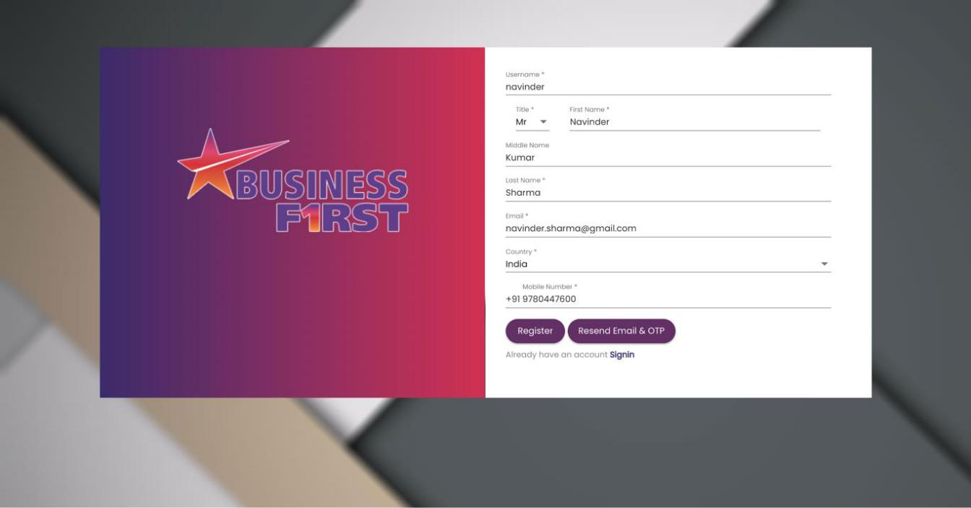

- The system will send a confirmation email and mobile OTP to email and mobile provided with above form. It will display screen as shown below, here click Ok button:
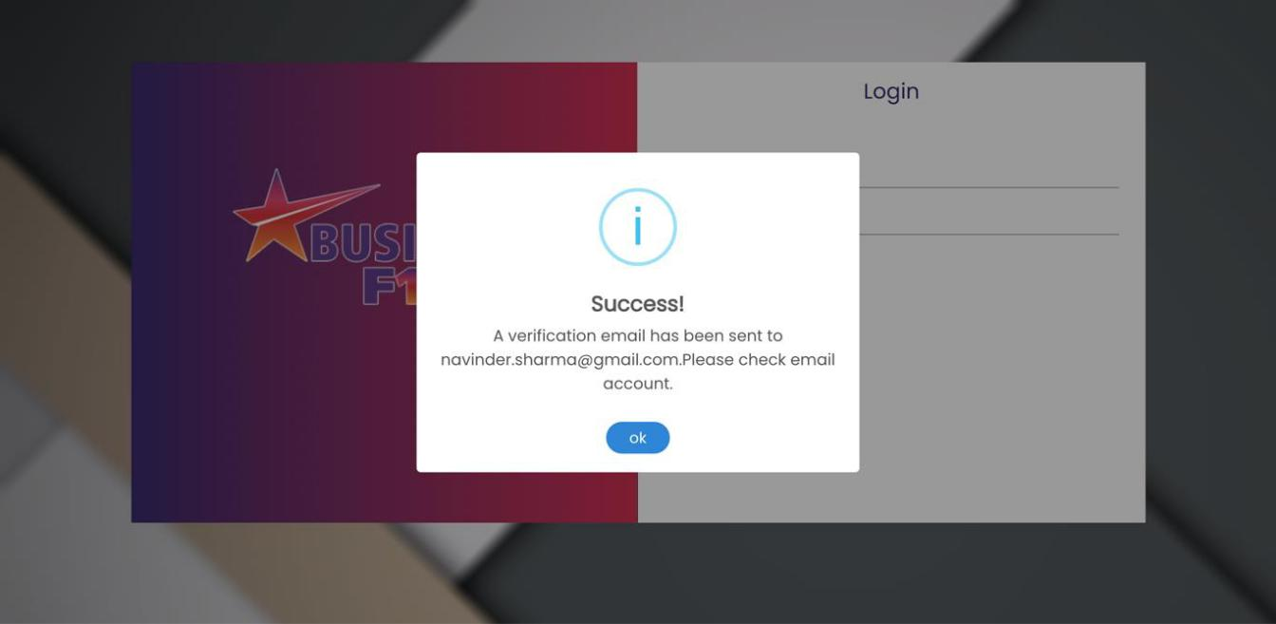

- Confirmation email will look like as shown below, click Click Here button for Email Verification at screen as shown below:
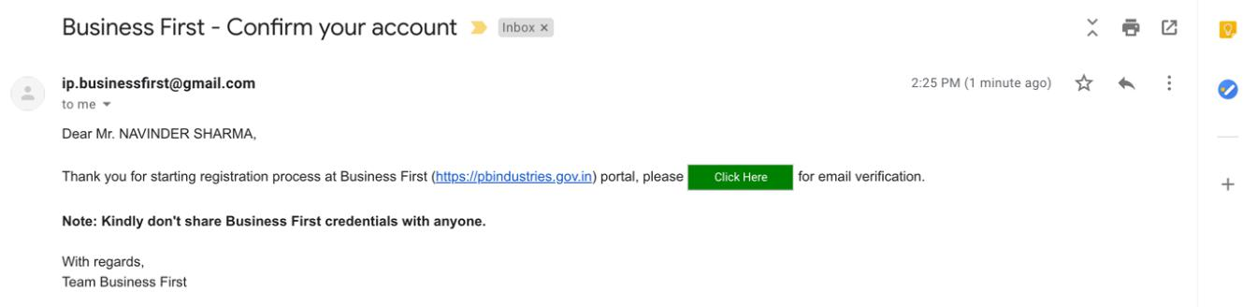

- Email confirmation message will look like as shown below, here click Ok button:
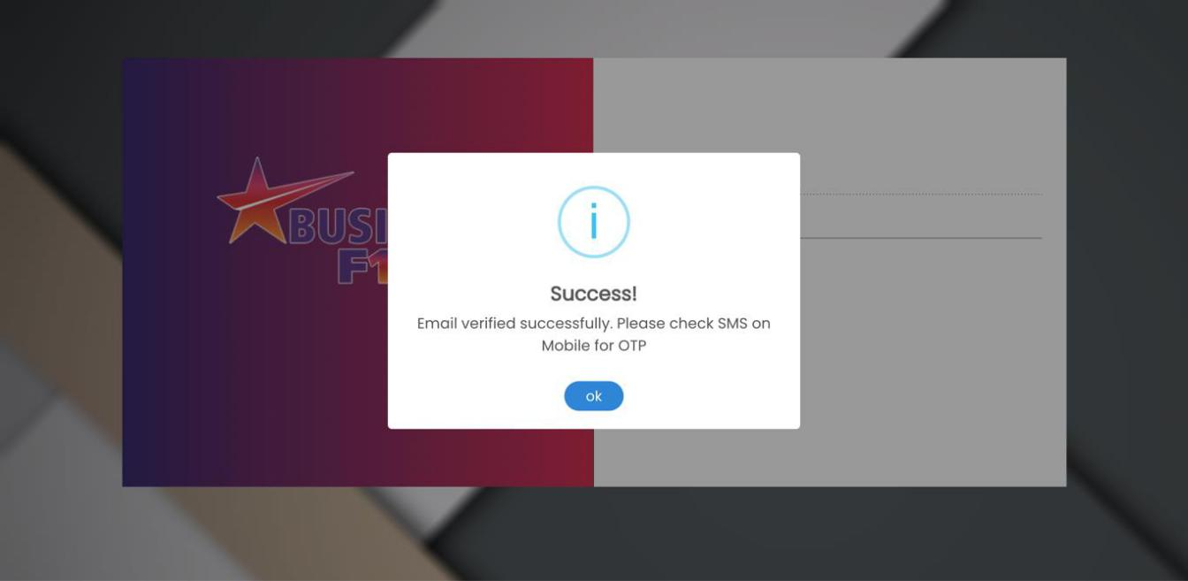

- In next step, the system will ask for Mobile OTP (sent on provided Mobile No.), enter Mobile OTP and click Verify Mobile No. button:

- Mobile No. will be confirmed with screen as shown below, here click Ok button:
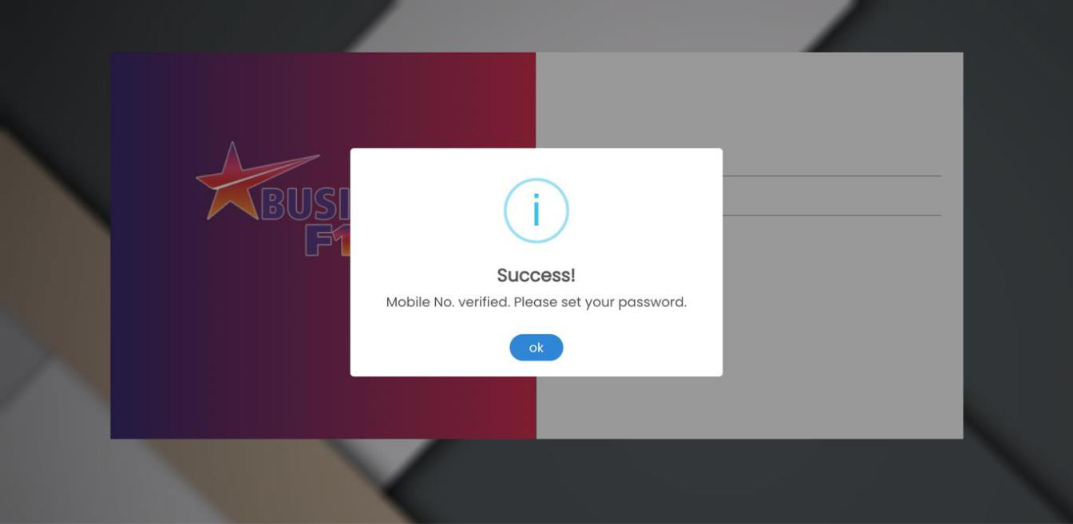

- At next step, investor can set his password by entering New Password, Confirm Password and clicking Set Password button:

- This will complete Investor Registration process and screen like shown below will come.
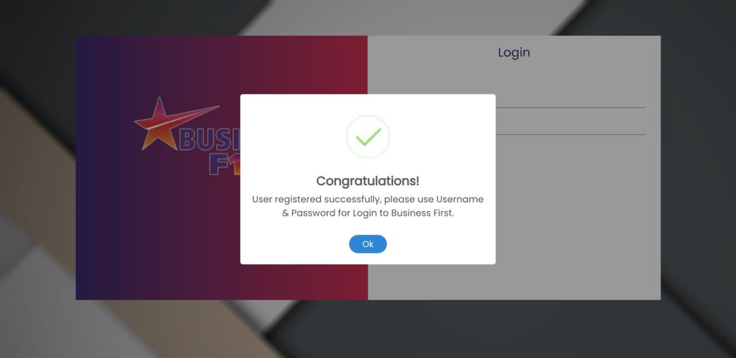

9. User login after successfully registered at web portal as shown below:

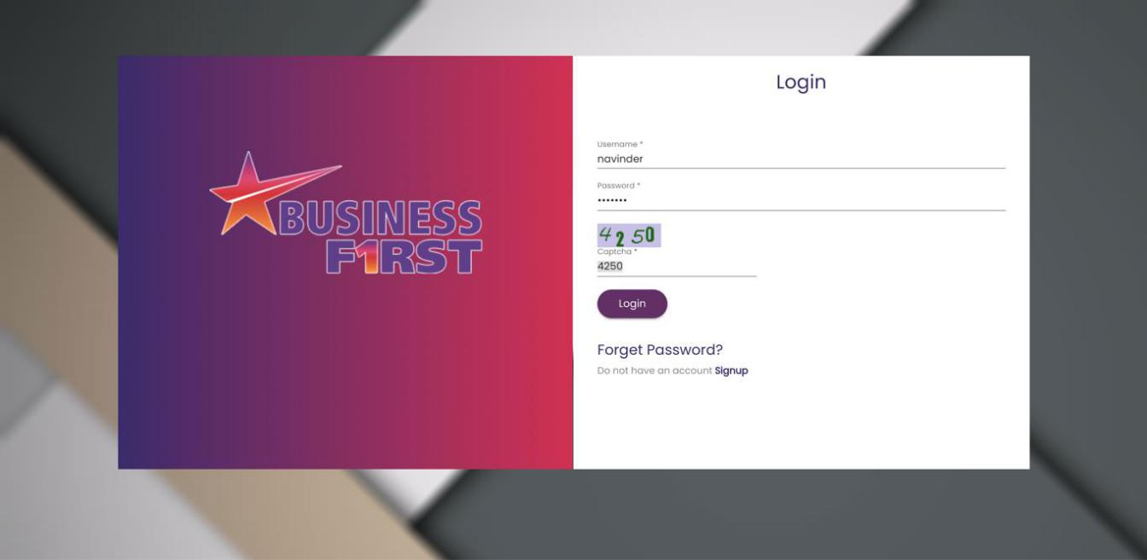

10. Click on Apply for New Services as shown below.

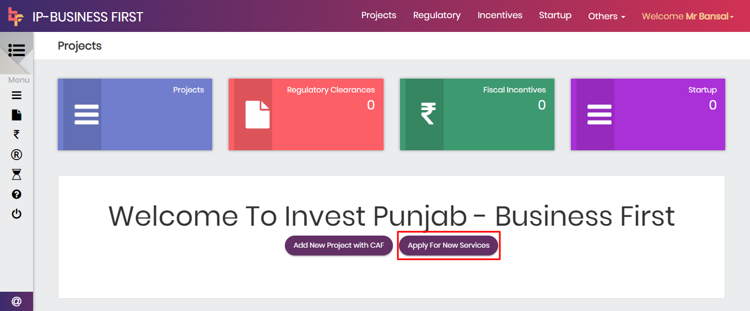

11. After Click on New button New Service Profile Page Open:

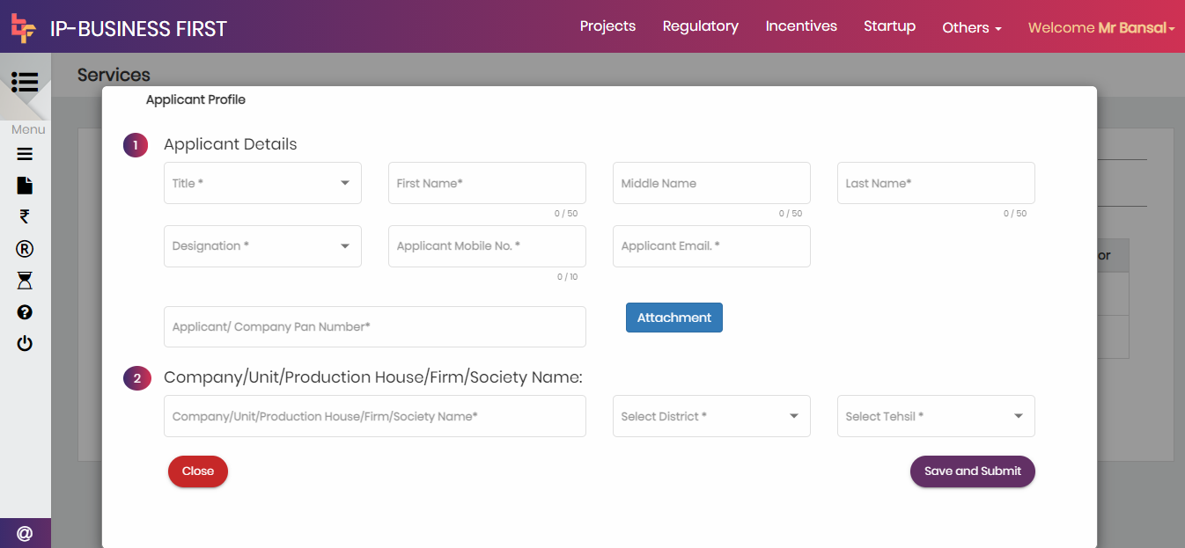

12. After submit Service Profile Page Dashboard Page is Open. Click on Details as it is highlight below:

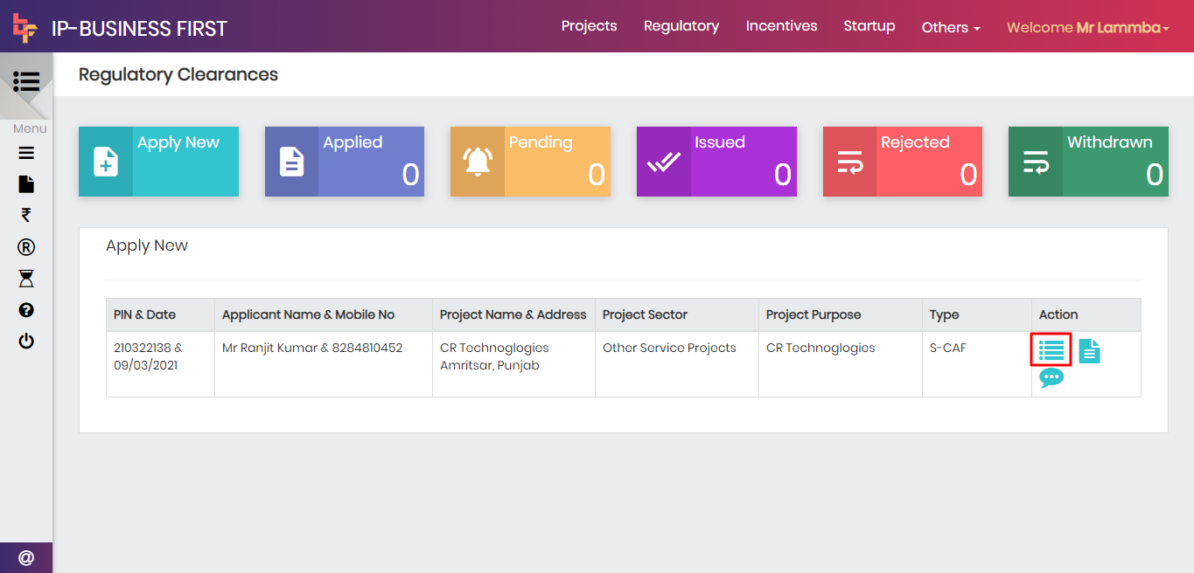

13. After click on details. Click on Apply for New Clearance, then list of forms is open:

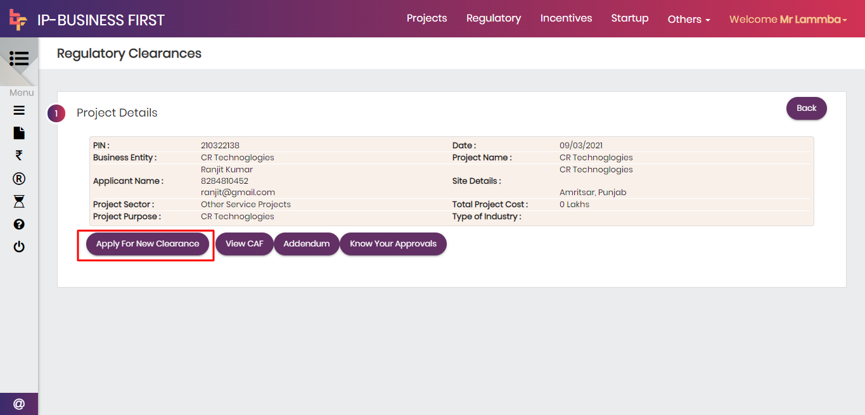

14. Search for registration of profession tax as shown below and press New. Please make sure before click on New Button that you have applied for “Organization” or an “Individual” :

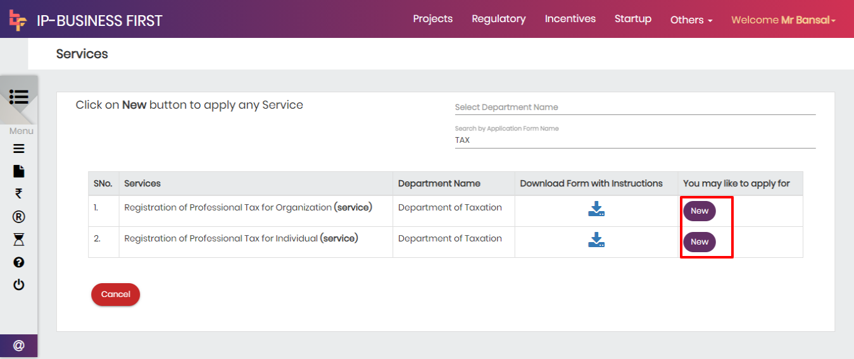

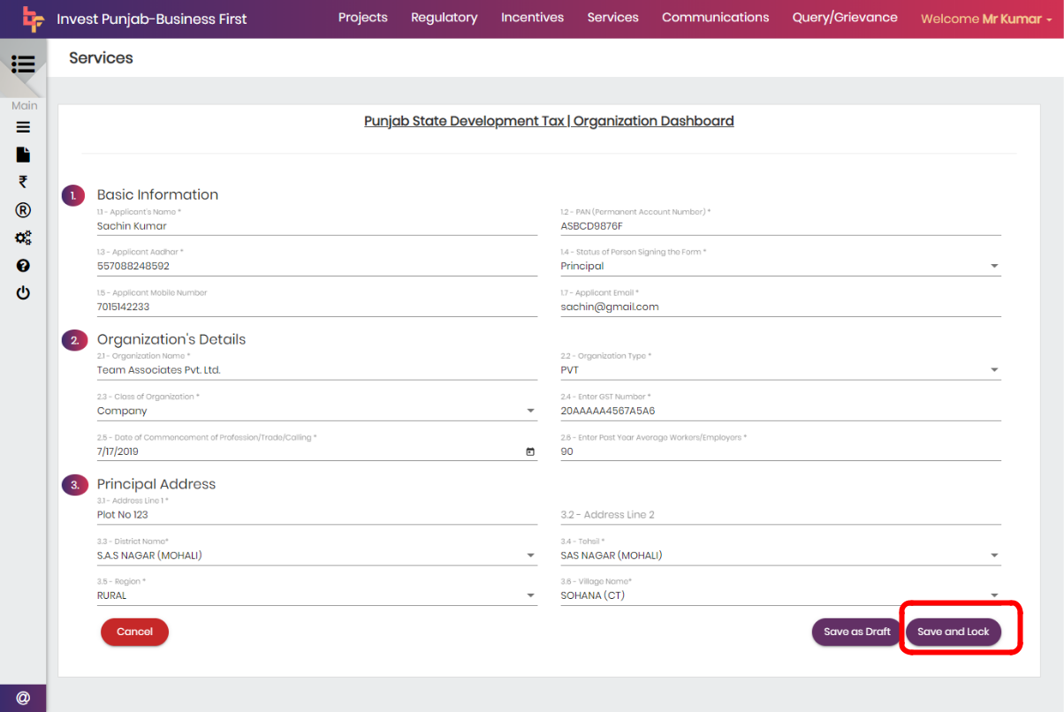
15 . Fill the required details and press save and lock. (Note: Please make sure you have applied for Organization or an Individual)
16. Press yes on the pop-up screen to save the details. It will complete the registration process.
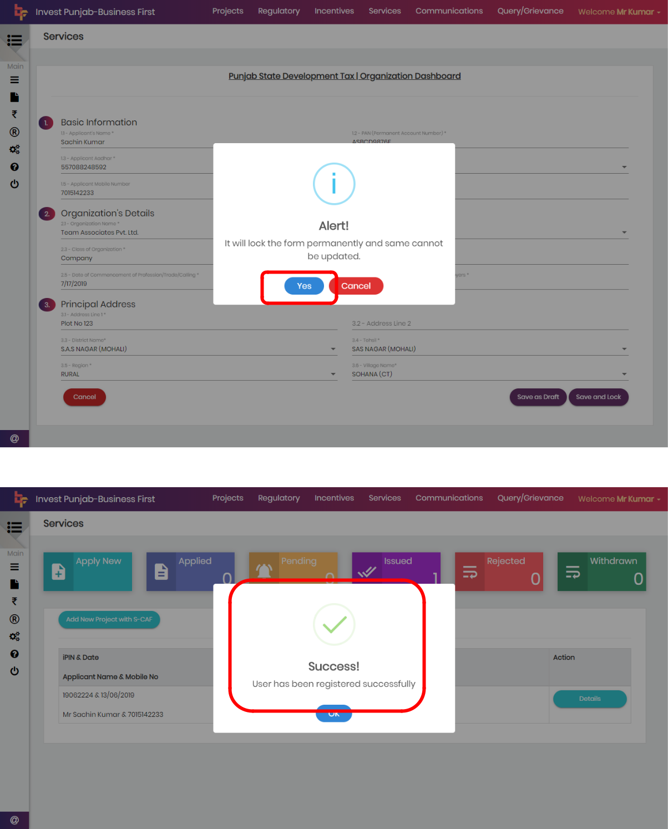

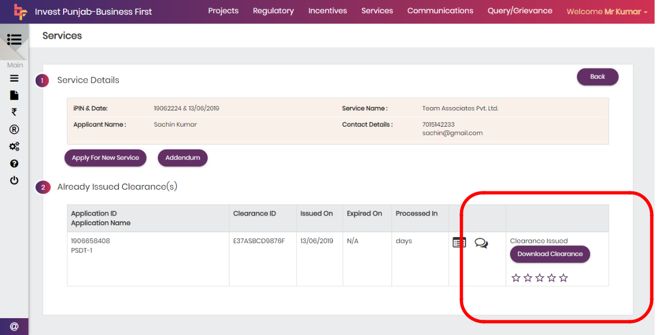
17. Users can download the certificate by pressing Download Clearance as shown below:
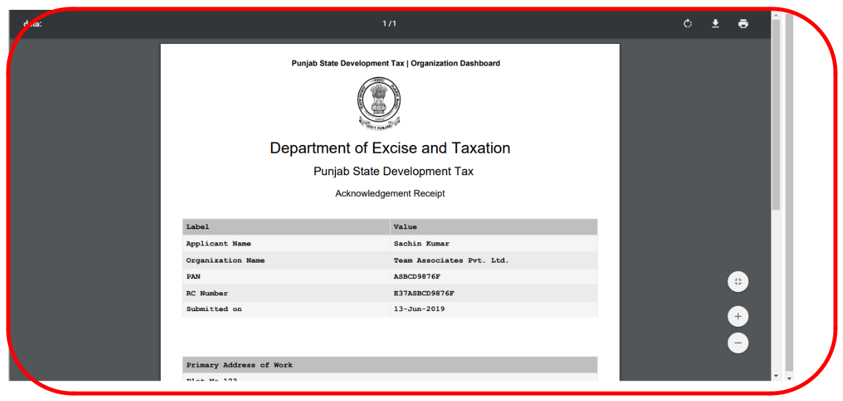
18. Users see the below clearance on downloading.

