Art Gallery of New South Wales Disability Inclusion Action Plan 2025–28
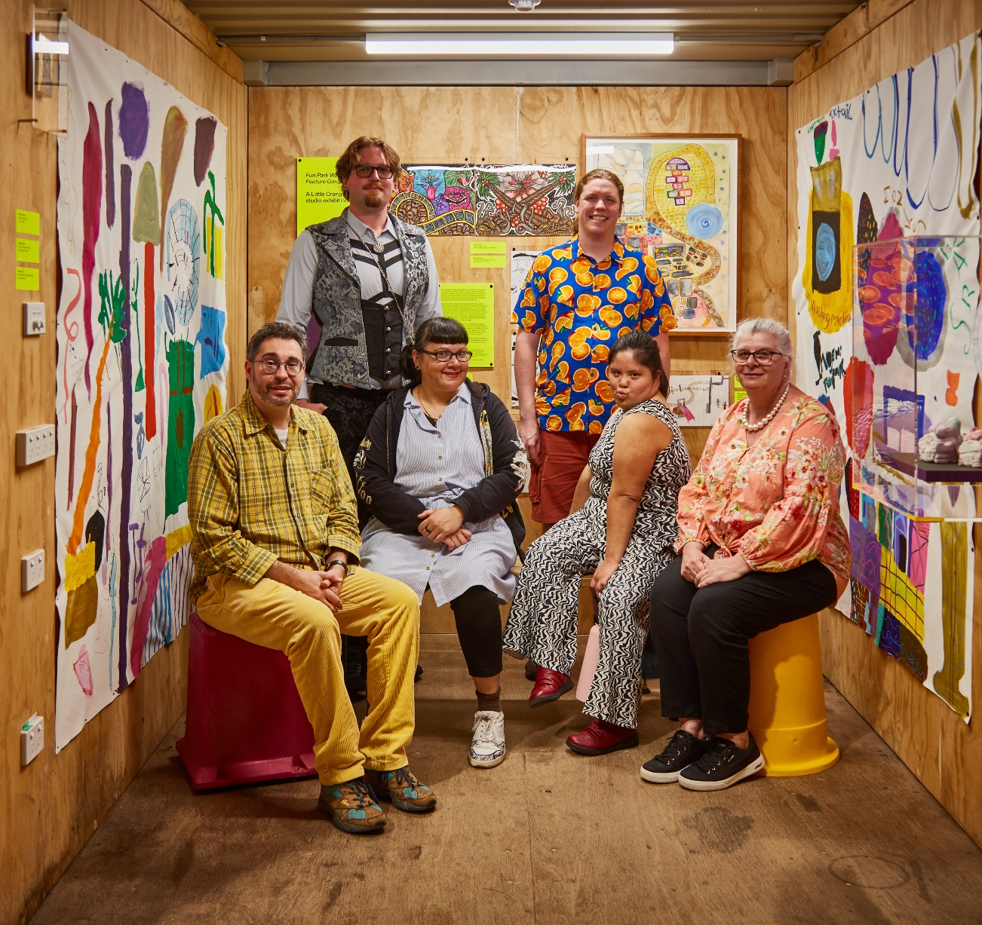
Inside Fun Park Water Feature Garden, an exhibition by artists from Campbelltown Arts Centre’s Little Orange studio in Bobby’s container, 3 December 2025 – 30 January 2026, as part of the exhibition Mike Hewson: The Key’s Under the Mat, Art Gallery of New South Wales, 2025, artworks © the artists. From left: David Capra, Adam Jones, Jezzy Fezzy, Joel Beers, Imogen Jade, Julie Finch
Contents

Director’s foreword
About the Art Gallery
Our commitment
Our context: disability in Australia, New South Wales and at the Art Gallery
Disability Employee Network
Access programming at the Art Gallery
Case studies
Attitudes and behaviours: increasing representation of artists with disability
Liveable communities: sensory-friendly Sunflower-branded events
Employment: embedding inclusive recruitment practices
Systems and processes: tactile accessible resources and regional engagement
Disability Inclusion Action Plan 2025–28
Attitudes and behaviours
Liveable communities
Employment
Systems and processes
Consultation process and key contributors
Monitoring and review
Acknowledgements
Contacts, publishing information and credits

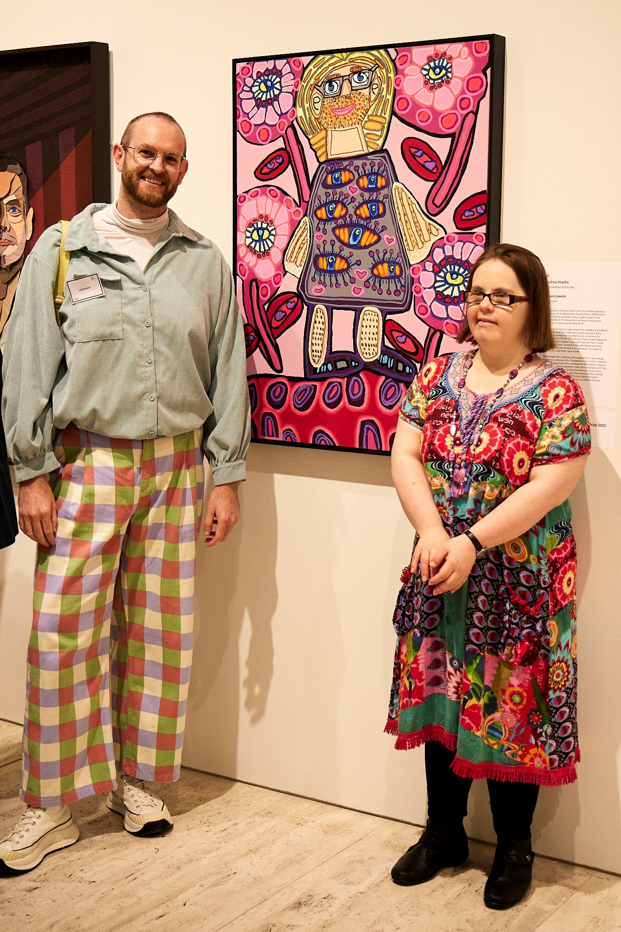
Emily Crockford, a Studio A artist, with Jeff’s pink daisy eyelash clash, her portrait of fellow artist Jeff McCann (also pictured) in the 2023 Archibald Prize exhibition

Director’s foreword
We are proud to present the Disability Inclusion Action Plan (DIAP) 2025–28 for the Art Gallery of New South Wales.
At the Art Gallery, we believe that art should be accessible to all. The arts play a vital role in society, fostering inclusive communities and reflecting diversity. Recognising creative expression as an essential component of personal wellbeing and social connection, we are committed to ensuring equitable access for all individuals to experience, participate in and contribute to the arts.
This third DIAP builds on our progress to date and aligns with both the Australian Government’s Creative Australia report Towards equity: a research overview of diversity in Australia’s arts and cultural sector (2020) and the NSW Government’s Creative communities: NSW arts, culture and creative industries policy (2023) framework. It introduces our objectives and planned actions to improve access for people with disability to our exhibitions, programs and services over the next three years. Through this plan, we strive to address barriers to participation and ensure equitable representation of people with disability in all facets of our work.
Since the implementation of our first DIAP in 2009, our commitment to creating an environment where people with disability feel represented, valued and included has led to tangible changes. These include the establishment of a Disability Employee Network for Art Gallery staff, physical access improvements for staff and visitors, inclusive programs, and increased visibility of artists with disability. Looking to the future, we have identified areas where we can make further improvements and lead in innovative and impactful ways.
The DIAP 2025–28 outlines specific actions to:
- ensure people with disability are consulted and represented in our exhibitions, programs and collection
- increase opportunities for people with disability to contribute as artists, audiences, volunteers and staff members
- enhance accessibility for both in-person and digital experiences.
We are deeply grateful to the individuals with disability who contributed to the development of this DIAP, whose insights, feedback and experiences have been invaluable. We also extend our thanks to the wider disability community, whose ongoing collaboration with the Art Gallery ensures our initiatives remain relevant and effective. We will continue to evaluate and improve our efforts to be a globally significant art museum that is inclusive and accessible – from here, for all.
Maud Page
Director, Art Gallery of New South Wales

About the Art Gallery
The Art Gallery of New South Wales is one of Australia’s flagship art museums and the state’s leading visual arts institution.
Situated on Gadigal Country in the multicultural city of Sydney, the Art Gallery boasts an exceptional collection of Australian and international art, with a special focus on Aboriginal and Torres Strait Islander art. As the state art museum, we champion artists and serve the widest possible audience as a centre of excellence for the collection, preservation, documentation, interpretation and display of art, and as a forum for scholarship, art education and the exchange of ideas. In 2024, we welcomed over 2.3 million local and international visitors.
Our Strategic Plan 2024–28 outlines our commitment to serving our diverse audiences and being an inclusive workplace, where everyone feels valued and respected. Our Diversity and Inclusion Strategic Framework 2022–25 further affirms our dedication to promoting and supporting a diverse arts and cultural sector, recognising our responsibility to provide a vibrant civic space that empowers many voices and views.
The Art Gallery takes a consolidated approach to ensure that our people and stakeholders feel welcome and included, irrespective of age, ability, cultural background, gender or sexual identification, or any other aspect of difference or personal circumstance.
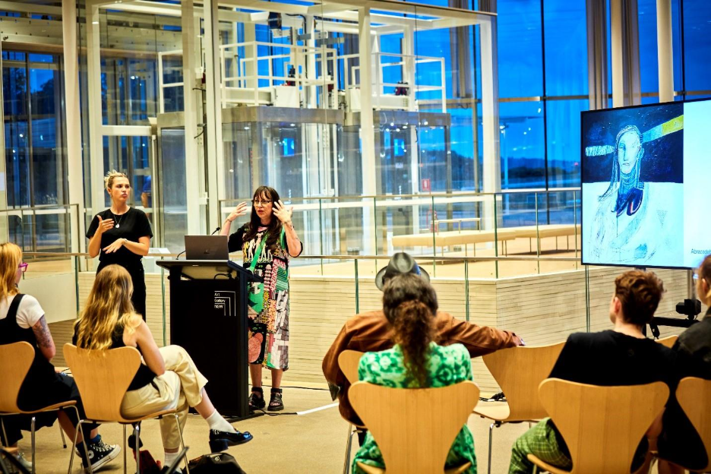
Celebrating International Day of People with Disability in 2023 with a talk by artist Angie Goto

Our commitment
We are aware of the continual barriers faced by artists and people with disability, and we understand our role in ensuring everyone has a fair chance to take part in the arts and cultural sector.
Disability includes long-term physical, mental health, intellectual, neurological or sensory differences which, in interaction with various attitudinal, procedural and environmental barriers, may hinder full and effective participation in society on a same or equal basis with others. At the Art Gallery, we extend this definition (based on the United Nations Convention on the Rights of Persons with Disabilities) to short-term conditions.
The Art Gallery subscribes to the social model of disability, focusing on removing barriers so that people with disability have the same opportunities of participation as others.
We believe that accessibility is key to being a truly welcoming institution. We are committed to ensuring the art experiences we offer resonate with all the people we serve.
This plan has been developed in consultation with our staff, volunteers, visitors, partners, the disability community and other stakeholders, including Accessible Arts. It has also been developed in line with the NSW Government’s Creative Communities policy and the Australian Government’s Equity: the Arts and Disability Associated Plan.
‘People with disability … may encounter multiple barriers to access and inclusion in everyday life, including the arts, and … these barriers can interact and overlap to make inequities worse. These can include ableism, racism and other forms of prejudice based on gender, sexuality, age, religion, cultural and linguistic diversity, and other kinds of identity. This is known as intersectionality.’
Source of quote: Equity: the Arts and Disability Associated Plan © Commonwealth of Australia 2024 licensed under CC BY 4.0, page 10
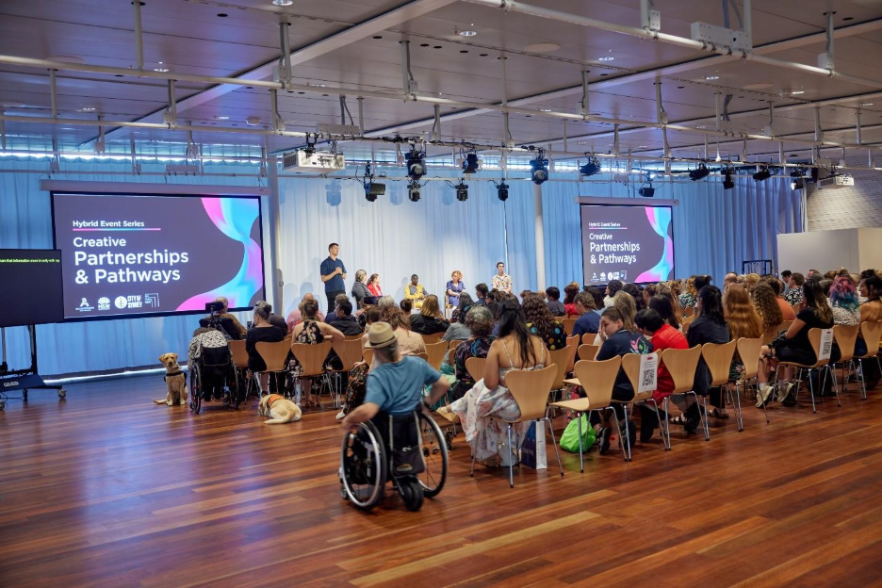
‘Access ideas and insights: creative partnerships and pathways’, a panel discussion on creative and career development opportunities for artists with disability or who are d/Deaf, presented in partnership with Accessible Arts, 2024

Our context: disability in Australia, New South Wales and at the Art Gallery
In Australia:
- 5.5 million people have a disability (21.4 per cent)¹
- 1.2 million people are primary carers; of these, around 44 per cent have disability themselves¹
- 3.6 million people live with hearing loss²
- 840,000 people live with vision loss; this number could exceed 1.04 million by 2030²
- 15 per cent of people age 0 to 64 years have a disability¹
- More than 50 per cent of people over 65 have a disability¹
- 7.9 per cent of people have a profound or severe disability¹
- Indigenous Australians are 1.9 times more likely to experience disability compared to non-Indigenous Australians³
In New South Wales:
- 1.35 million people experience disability (17 per cent)⁴
- 12 per cent of adults age 18 to 64 are people with disability⁵
- Nearly half of adults age 65 and over experience disability⁵
- 8% of children under 18 have disability⁵
Of people with disability age 0 to 64 in New South Wales:
- 22.9 per cent have a sensory and speech disability
- 20.9 per cent have an intellectual disability
- 57.8 per cent have a physical disability
- 31.3 per cent have a psychosocial disability.⁵
At the Art Gallery of New South Wales:
- 1.1 per cent of staff identified as having a disability in 2023–24, according to organisational data
- 12 per cent of staff identified as having a disability in the People Matter Employee Survey 2024, the annual survey of NSW public sector employees.
‘59 per cent of d/Deaf and disabled artists are women … Women with disability, including First Nations women and those from a range of diverse and intersectional backgrounds, are particularly vulnerable to multiple forms of discrimination which can actively limit equity in arts and cultural education, participation, career opportunities and leadership progression.’
Source of quote: Equity: the Arts and Disability Associated Plan © Commonwealth of Australia 2024 licensed under CC BY 4.0, page 10
The statistics given in this section are indicative. They present data from the period 2018 to 2022. References:
1 Australian Bureau of Statistics, Disability, ageing and carers, Australia: summary of findings, ABS, Canberra, 2022.
2 Richard Kha, Oonagh Macken, Paul Mitchell et al, ‘The Australian eye and ear health survey (AEEHS): study protocol for a population-based cross-sectional study’, PLOS One, vol 19, no 5, 2024.
3 The Australian Institute of Health and Welfare, ‘1.14 Disability’ in Aboriginal and Torres Strait Islander Health Performance Framework, Tier 1 – Health status and outcomes, AIHW, Canberra.
4 Australian Bureau of Statistics, Disability, ageing and carers, Australia: summary of findings, ABS, Canberra, 2018.
5 Data from the Australian Bureau of Statistics 2018, in NSW Disability Inclusion Plan 2021–2025 and Disability Inclusion Action Plan 2021–2025: Annual Progress Report 2022–2023 [PDF, 2.2MB], NSW Government Department of Communities and Justice.

Disability Employee Network
In 2024, the Art Gallery Disability Employee Network (DEN) was established to champion the inclusion, representation and wellbeing of people with disability within the Art Gallery. It is open to all employees, including those with lived experience of disability, as well as allies.
While fostering a supportive workplace culture, the purpose of the DEN is to raise awareness of and understandings about disability, promote accessibility and inclusion, and advocate on behalf of employees with disability and their community. The DEN also provides valuable input to the Art Gallery’s Diversity and Inclusion Steering Committee (an internal advisory group comprised of staff and management representatives) and the Art Gallery’s executive team, acting as a key stakeholder in shaping strategic diversity and inclusion priorities.
The quarterly meetings of the DEN ensure a safe space is available for employees to share experiences, ideas and solutions to improve accessibility across the Art Gallery, with the scope for additional gatherings and events to be held to mark key dates and foster connection. Through collaboration and open dialogue, the DEN supports the Art Gallery’s aim to be a workplace where all employees can participate fully, feel valued and thrive.
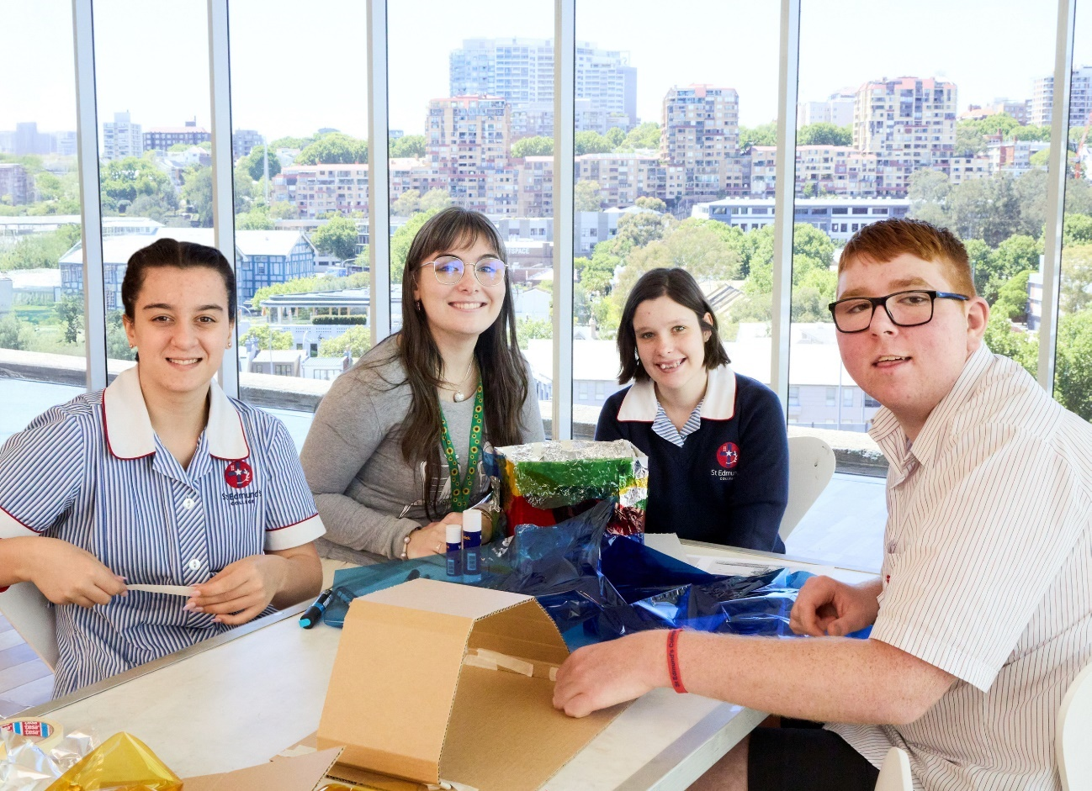
Art Gallery educator Amy Wright with students participating in the Starting with Art program, 2025

Access programming at the Art Gallery
The Art Gallery offers a range of free access programs designed to reduce barriers for people to engage with art and participate in creative activities. These programs have been developed in consultation with members of specific communities we serve, including d/Deaf and disability communities, carers and support workers, older adults, people in health and aged care settings, and people with refugee and migration backgrounds.
These scheduled and on-demand programs occur regularly throughout the year, including:
- monthly artist-led access tours and workshops for adults with disability or access requirements
- monthly Auslan tours led by invited artists from the d/Deaf community
- monthly Art and Dementia sessions for people living with dementia, their care partners and communities
- audio-description programs and tactile experiences accompanying major exhibitions for visitors who are blind or have low vision
- sensory-friendly early entry to temporary exhibitions for visitors who may benefit from a calmer, quieter environment
- quarterly kids access workshops designed for children with disability and access requirements, and their families
- sensory-friendly ‘Art After Hours’ evenings, including programming to commemorate the annual International Day of People with Disability
- our education program Starting with Art for primary and secondary students with disability or access requirements.
Our creative ageing programs are tailored to culturally and linguistically diverse communities. Together with our Art and Dementia program and on-request program for adults with access requirements, these programs align with the Mental Health Commission of NSW’s Living Well strategy.
Also addressing mental health and wellbeing, our Culture Dose programs use the Art Gallery’s collection to provide mindfulness-based experiences for adults and support for children with anxiety and their parents or guardians.
Begun as a pilot in 2021, the successful Regional Arts in Health Multipurpose Services (MPS) program provides aged care residents in regional New South Wales with access to professional and quality arts engagement experiences, and is delivered in partnership with Health Infrastructure NSW.
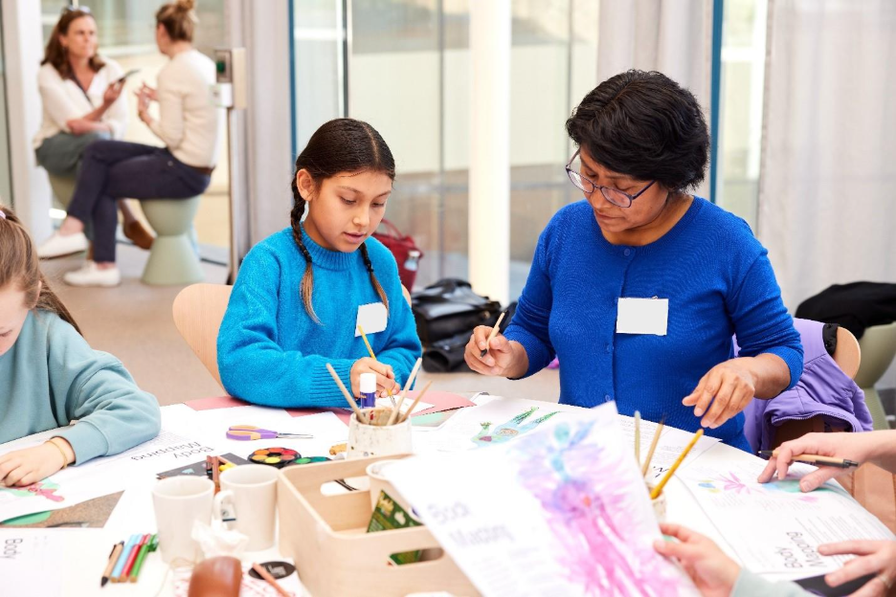
Culture Dose for Kids, 2023: our ongoing eight-week art program for children who are experiencing mild anxiety, developed and researched in partnership with the Black Dog Institute

Case studies
As we work towards the goals of the DIAP 2025–28, we celebrate outcomes of recent initiatives through selected case studies that address four key target areas:
- Attitudes and behaviours: increasing awareness and changing perceptions
- Liveable communities: making our offerings accessible to all
- Employment: our commitment to workplace equality and inclusion
- Systems and processes: continual improvement of processes to ensure better access to services, venues and support.

Attitudes and behaviours: increasing representation of artists with disability
Through exhibitions, commissions and acquisitions, the Art Gallery aims to increase the visibility of artists with a lived experience of disability, recognising their contributions and fostering a more inclusive and representative cultural landscape.
These outcomes are built on long-term engagement, as is the case with the Art Gallery’s relationship with Sydney-based Studio A and its artists. Studio A is a visual arts studio that creates pathways for artists with intellectual disability, ensuring their voices are represented within contemporary Australian culture.
In 2020, Studio A artists Mathew Calandra, Emily Crockford, Annette Galstaun, Lauren Kerjan, Jaycee Kim, Catherine McGuiness and Meagan Pelham were invited to create the largest mural ever painted at the Art Gallery. Love owls and mermaids singing in the rainbow pop 2020 expressed distinct personal stories of care and connection. Each artist portrayed a person or a being who supported and inspired them that year, including self-portraits with fellow artists and writers; pictures of friends, family and pets; and imaginative companions.
In 2022, the Art Gallery acquired Stations of the Cross 2021 by Mathew Calandra for the collection and included it in Making Worlds, the inaugural exhibition for the Sydney Modern Project, our north building now named Naala Badu.
Between 2020 and 2025, Victoria Atkinson, Mathew Calandra, Emily Crockford, Annette Galstaun, Daniel Kim, Catherine McGuiness, Meagan Pelham and Thom Roberts were all finalists in the Art Gallery’s flagship portraiture competition, the Archibald Prize. Several of these Studio A artists presented talks and workshops as part of the exhibition’s public and access programs, engaging directly with audiences, sharing their creative processes and contributing to the ongoing dialogue about contemporary art, identity, representation and accessibility within the arts.
The Archibald Prize exhibition travels to regional galleries interstate and throughout New South Wales, further amplifying the work of artists with disability and expanding their audiences. The exhibition celebrates a range of artistic voices and identities and fosters inclusive practices.
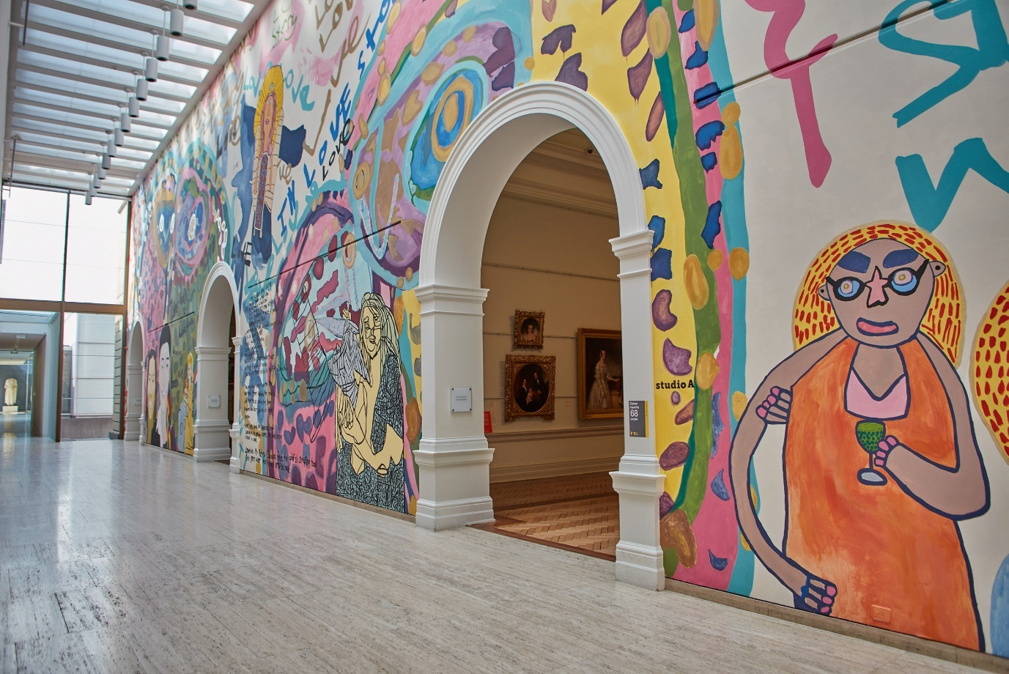
Love owls and mermaids singing in the rainbow pop, an epic mural created by Studio A artists Mathew Calandra, Emily Crockford, Annette Galstaun, Lauren Kerjan, Jaycee Kim, Catherine McGuiness and Meagan Pelham at the Art Gallery, 2020

Liveable communities: sensory-friendly Sunflower-branded events
The Art Gallery hosts sensory-friendly events creating an inclusive environment for audiences with hidden disabilities, particularly considering people with sensitivities to noise, amplified sound and bright lights. These events offer a relaxed and supportive environment for visitors who may feel overwhelmed in conventional gallery settings.
Since 2023, the Art Gallery has extended its sensory-friendly offerings across the calendar year. These include sensory-friendly Art After Hours evenings, early entry to exhibitions and dedicated sessions during Hive Festival, the Art Gallery’s festival for children and families.
To ensure these programs meet the needs of individuals with autism and sensory sensitivities, the Art Gallery partnered with Aspect Autism Australia. The partnership’s aims were to grow awareness in mainstream culture around hidden disability and provide training for Art Gallery staff and volunteers. Aspect Autism Australia conducted ‘lived experience audits’ and identified high- and low-sensory spaces within the Art Gallery. Staff and volunteers received training on the Hidden Disabilities Sunflower initiative, which helps front-of-house staff, gallery educators and volunteers identify visitors with hidden disabilities like autism, ensuring they can be easily recognised and assisted as needed.
These events also allow the Art Gallery to engage artists and creative practitioners with hidden disability as presenters.
Through the ongoing development of these events, and tools like Sunflower badges and lanyards, the Art Gallery signals its readiness to meet the needs of individuals with access needs and sensory sensitivities.
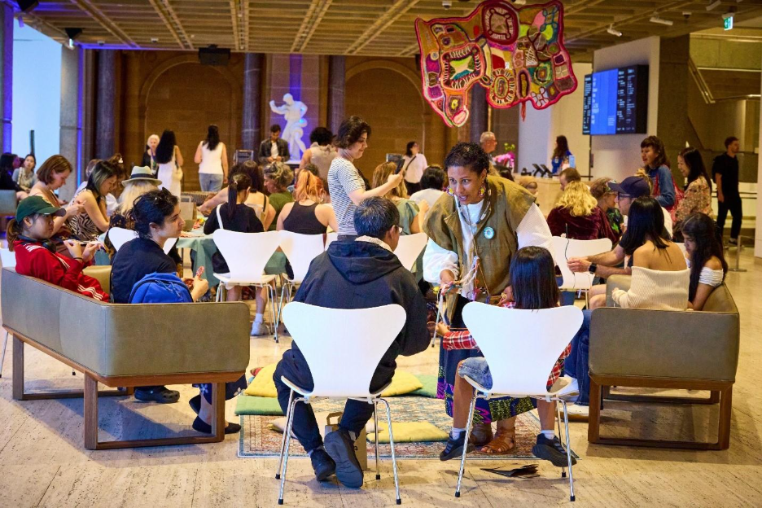
A workshop led by textile artist Paula do Prado during sensory-friendly Art After Hours at the Art Gallery, 2025

Employment: embedding inclusive recruitment practices
Guided by our Diversity and Inclusion Strategic Framework, the Art Gallery is dedicated to building an inclusive environment, supporting a diverse workplace and cultivating a positive culture that attracts a wide range of talent.
In 2025, the Art Gallery’s People and Culture team, in consultation with the Disability Employee Network (DEN), reviewed its recruitment policies and procedures and adopted more inclusive languages and practices. They also engaged JobAccess, the national hub for disability employment, to provide training in recruitment for hiring managers.
In 2023 and 2025, the Art Gallery participated in the Ripple: Disability and Culturally Diverse Internship Program, offering specialised industry training and part-time work experience to individuals who are d/Deaf or have a disability and also identify as culturally and linguistically diverse. The Ripple program is a collaboration between Accessible Arts and Diversity Arts Australia, designed to forge connections between underrepresented communities and the arts and cultural sector.
For the Ripple program, relevant Art Gallery staff were trained on the strategies, approaches and minor adjustments needed to ensure the access needs of the interns were met. The program created pathways for reciprocal learning and skills-exchange between Art Gallery staff and interns, and resulted in concrete changes to institutional processes. These included adjustments to recruitment processes, updated job descriptions, provision of accessible interview formats, and accommodations for candidates with access needs.
Through initiatives like the DEN and our participation in the Ripple program, the Art Gallery continually improves accessibility and inclusion of underrepresented peoples within the arts sector. By continuing to refine our recruitment strategies and promote access awareness within the workplace, the Art Gallery is paving the way for a more diverse and representative arts ecology.
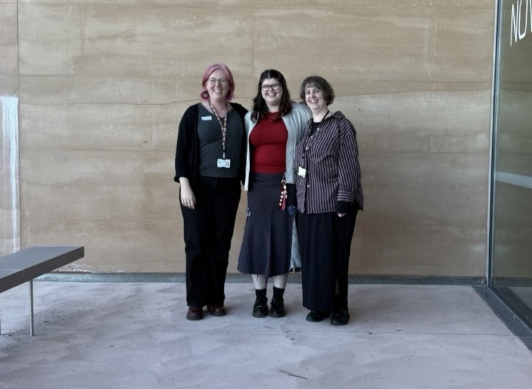
Art Gallery mentors Joanna Fleming and Claire Eggleston with artist Ava Lacoon (centre), a 2025 Ripple intern

Systems and processes: tactile accessible resources and regional engagement
An investment in tactile resources and audio-description skills has enabled the Art Gallery to provide a richer art experience for audiences who are blind or have low vision, both within the museum and in offsite settings.
In 2022, in partnership with Vision Australia and individuals from the blind and low vision community, the Art Gallery began developing tactile reliefs of Archibald Prize finalists’ works to complement the major exhibition’s audio-description programs. These resources provide a two-dimensional representation of selected portraits, enabling audiences to explore the composition and details of the works by feel. The print technology ensures that each relief accurately represents the textures, contours and likenesses of the portraits.
The tactile resources are used in conjunction with live audio descriptions of the works provided by tour guides onsite or via online portals. Braille labels are included on the back of the reliefs, and braille versions of the artwork’s interpretative texts on display within the exhibition are also created. Additional sensory and tactile elements provide further context and details about the artist, their subject’s appearance or objects depicted in onsite programs.
An essential part of this initiative has been the audio-description skills developed by the Art Gallery’s volunteer access guides and gallery educators to accompany the tactile resources and support visitors who are blind or have low vision. This holistic approach allows guides and audiences to engage in meaningful, two-way dialogues.
Since 2022, our tactile and audio-description programs have expanded to include an annual community day with Guide Dogs NSW and the provision of 2D tactile resources at venues for the regional tour of the annual Archibald Prize exhibition.
The success of the resources and guide training, as well as positive audience feedback, have meant that tactile resources are now also incorporated into broader access programming at the Art Gallery. These include access tours and workshops for adults and children, the Art and Dementia program and on-request programs tailored to specific community needs, such as the annual Down Syndrome NSW Community Day. The resources also accompany other touring exhibitions additional to the Archibald Prize regional tour.
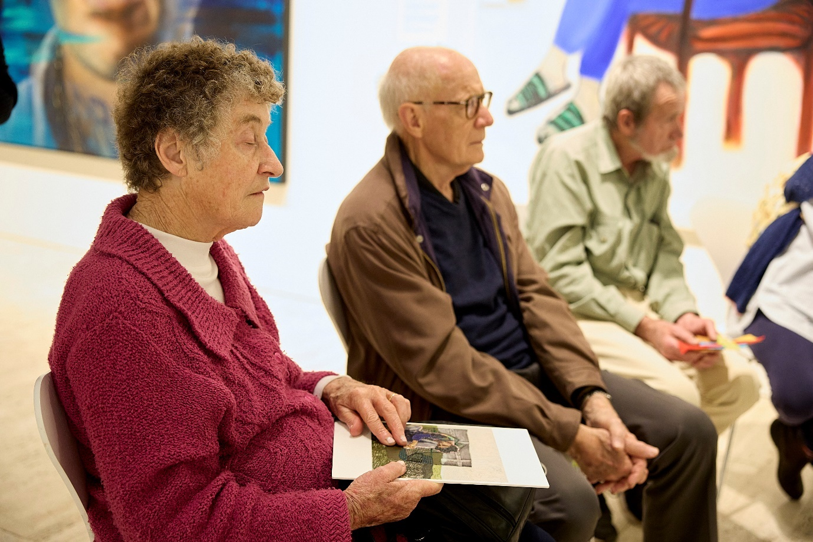
A tactile representation of the 2023 Archibald Prize–winning work by Julia Gutman, Head in the sky, feet on the ground, in use during an audio-description tour of the Archibald, Wynne and Sulman Prizes 2023 exhibition

Disability Inclusion Action Plan 2025–28
This new Disability Inclusion Action Plan for 2025–28 introduces the opportunities that we will pursue to improve access for people with disability to our exhibitions, programs and services across four key focus areas.

Attitudes and behaviours
Attitudes and behaviours towards people with disability are a barrier to full access and inclusion. We aim to support the development of positive attitudes through increasing awareness and revising policy and practice.
Actions:
- Integrate disability inclusion into both strategic and day-to-day aspects of Art Gallery culture and operations: from policies and procedures to programming, the website and human-resources processes, including training, recruitment and onboarding.
- Promote awareness of the DIAP and the Art Gallery’s Diversity and Inclusion Strategic Framework within the organisation.
- Expand partnerships with artists with disability, community organisations and peak bodies that support the various communities we serve.
- Provide ongoing disability awareness and disability confidence training to staff and volunteers.
- Include DIAP-awareness training in contractor inductions.
- Provide accessible exhibition design training to relevant staff.
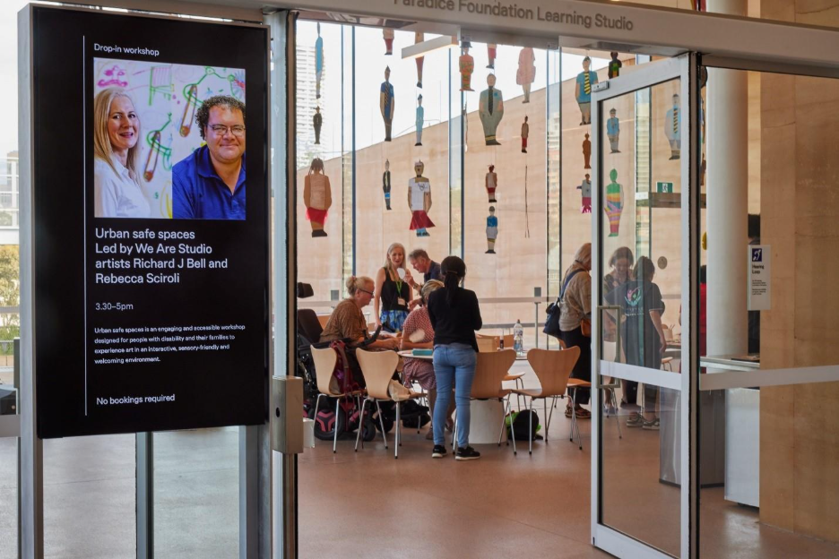
Hands-on art-making workshop led by We Are Studios artists Richard J Bell and Rebecca Sciroli in the Art Gallery’s Learning Studio, 2024

Liveable communities
Liveable communities deliver access to culture and social engagement for all, with physical and digital spaces that follow the principles of universal design.
Actions:
- Consult regularly with community members and organisations to ensure that our programs and services are current.
- Communicate our access programs and initiatives throughout the year, internally and externally, using a comprehensive and integrated approach.
- Increase access provisions in the delivery of exhibitions, programs and events onsite, offsite and online; for example, Auslan interpretation, audio description, captioning, large-print booklets, multisensory approaches.
- Expand sensory-friendly offerings; for example, sensory maps, visual stories, early openings, afternoon sessions, evening programming, Hidden Disability Sunflower program.
- Scope provision of a safe, designated quiet space for visitors during opening hours and special events, informed by community consultation.
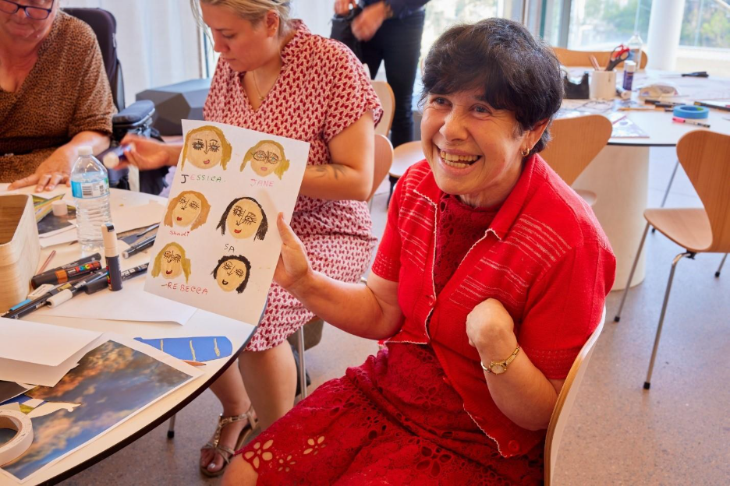
Artist Grazia Napoletano takes part in a hands-on art-making workshop led by fellow We Are Studios artists Richard J Bell and Rebecca Sciroli, 2024

Employment
Acknowledging the barriers that people with disability experience at all stages of the employment process, we aim to increase workplace equality, diversity and inclusion.
Actions:
- Review the accessibility of our recruitment processes, including advertising, interviews, assessment and workplace adjustments.
- Scope the introduction of identified positions for people with disability when budget or collaboration allows.
- Continue to seek opportunities to deliver paid internships for people with disability.
- Maintain and grow awareness of the staff-led Disability Employee Network, championed by a member of the executive.
- Include an access rider in all contracts with artists, performers and interns; train staff on access rider processes.
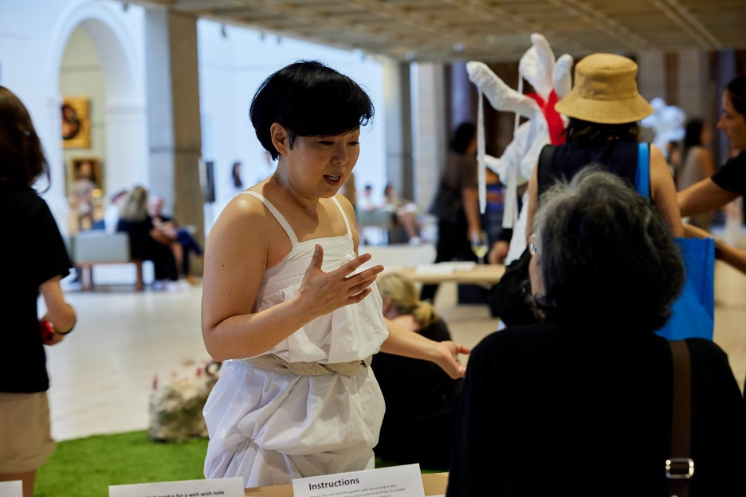
Participatory performance and workshop by artist Eugenie Lee during sensory-friendly Art After Hours, part of the Art Gallery’s celebrations for International Day of People with Disability, 2024

Systems and processes
Our goal is to enhance staff and visitor experience by continually evaluating the efficacy of our systems and processes in conversation with people with disability.
Actions:
- Maintain up-to-date PEEP (Personal Emergency Evacuation Plan) for staff.
- Coordinate regular internal and external audits of Art Gallery venues and processes from lived experience, exhibition design, risk management, wayfinding, transport and parking perspectives.
- Extend our Minimum Access and WHS Standards for Exhibitions checklist for onsite exhibitions to our touring exhibitions, including the option to consult with Art Gallery staff.
- Review and respond appropriately to feedback from the public, artists, stakeholders, partners and staff.
- Evaluate data collection mechanisms to ascertain diversity data is captured accurately.
- Include the DIAP in procurement and tender processes for goods and services.
- Review Art Gallery policies to ensure each aligns with DIAP commitments.
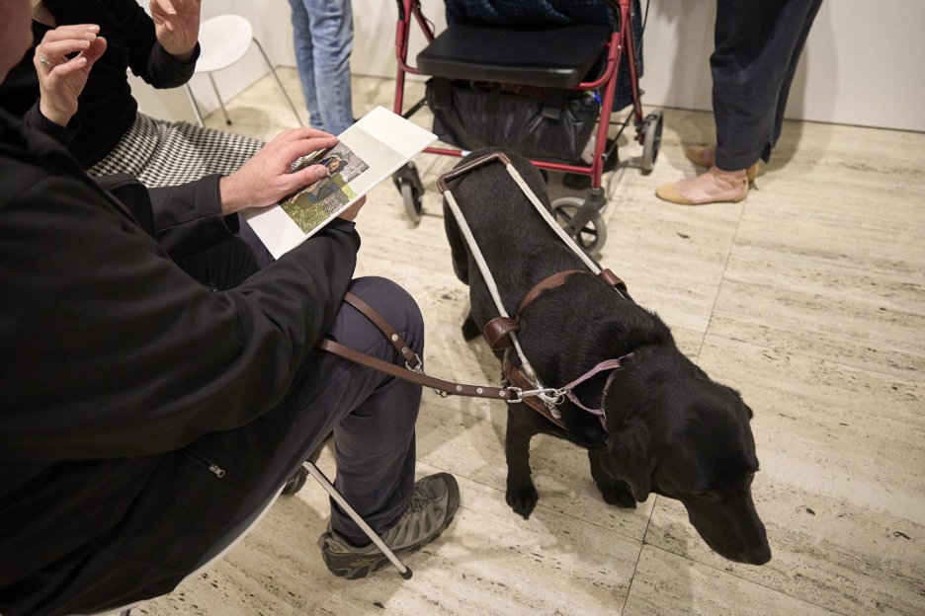
Visitors from Guide Dogs NSW using tactile resources developed with Vision Australia on an audio-description tour of the 2023 Archibald Prize

Consultation process and key contributors
The Art Gallery partnered with Accessible Arts, the peak arts and disability organisation in New South Wales, to undertake consultation processes that informed the development of this DIAP. This plan has also been shaped by insights gained through several disability-led initiatives, including three Access and Ideas panel discussions and two Wellbeing through Art programs developed in collaboration with Accessible Arts.
The DIAP 2025–28 has been informed by:
- external survey and focus-group consultations focused on the experiences and priorities of artists, audience members, visitors and disability support service-providers
- internal survey and focus-group consultations with Art Gallery trustees, staff, volunteers and contractors, including the DEN
- a review of internal and public information related to accessibility
- an accessibility ‘walk-through’ audit of the Art Gallery’s premises, conducted by Accessible Arts and Aspect (Autism Spectrum Australia)
- the Art Gallery’s Strategic Plan 2024–28
- the Art Gallery’s Diversity and Inclusion Strategic Framework 2022–25
- legislative requirements and government policy guidelines
- the Australian Network on Disability research and resources for disability inclusion in the workplace.
The Art Gallery sincerely thanks the team from Accessible Arts, as well as all individuals and organisations involved in the consultation process, for generously sharing their expertise and lived experience to improve access at the Art Gallery.
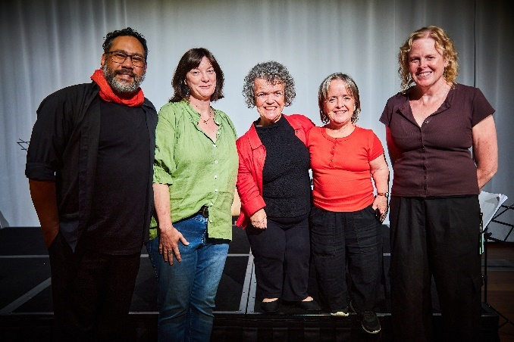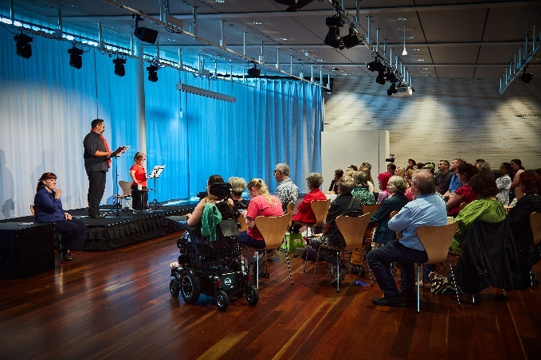
The creative team behind Who’s gonna love you?, a dramatic reading of a play by Debra Keenahan and a talk presented in the Meers Hall as part of the Art Gallery’s celebrations for International Day of People with Disability in 2025. Group photo (from left): Ray Chong Nee, Alison Rooke, Debra Keenahan, Leisa Prowd and Katrina Douglas

Monitoring and review
This DIAP is lodged with the Disability Council NSW and the Australian Human Rights Commission and is available to the public on the Art Gallery website. Accessible printed copies or other alternative formats are available on request.
The Art Gallery’s executive and staff will drive agency-wide implementation of the DIAP and ensure regular monitoring and progress reporting.
Updates on progress will be provided to the Art Gallery’s executive and the Art Gallery’s Board of Trustees on a regular basis, including formal reports that meet our statutory obligations for annual reporting.
Feedback from staff, artists, visitors with disability, carers and support workers, as well as arts and disability and community organisations, will be sought throughout the life of the DIAP to maintain a continuous improvement and feedback loop.
The success of the DIAP will also be monitored through:
- annual benchmarking of the number of people with disability attending bespoke programs and events in-person and online
- increased numbers and ongoing feedback from people with disability attending public programs as reflected in visitor-experience data
- increased numbers and ongoing feedback from artists with disability engaging with the Art Gallery in a professional capacity
- formal consultations/focus groups/surveys (at least once per year) exploring the quality of the Art Gallery experience from the perspectives of artists with disability, staff with disability, program partners/arts and disability organisations, audience members with disability, and disability support service providers
- the profile of the Art Gallery workforce and results from the People Matter Employee Survey
- positive public recognition of the Art Gallery’s disability, accessibility and equality initiatives in both mainstream and industry-specific media.
We value your feedback and encourage you to share your thoughts and experiences with us to support an accessible and inclusive Art Gallery of New South Wales. Our contact details are provided at the end of this document.
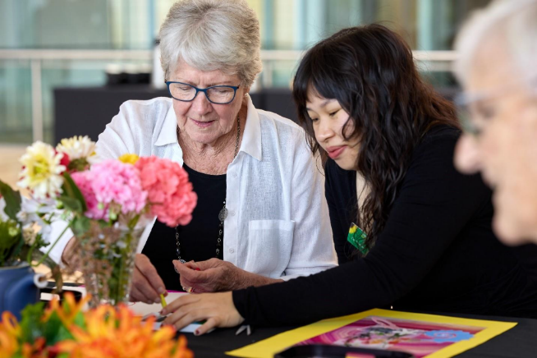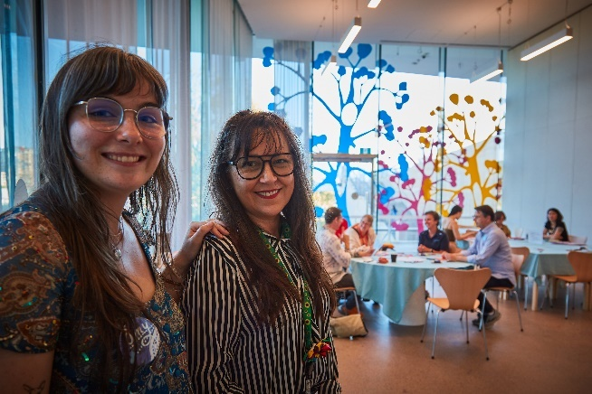
left: The Art and Dementia program, running since 2009 at the Art Gallery to support social inclusion and improved wellbeing. A participant from St Luke’s Care engages in a sensory and tactile-based art-making workshop after a tour of selected artworks on display at the Art Gallery, 2025; right: Art Gallery educators Amy Josephine Wright and Angie Goto host the sensory-friendly and disability-led workshop ‘Signs of care’, 2025

Acknowledgements
The Art Gallery acknowledges the support of the following organisations, supporters and advisors who have contributed knowledge, skills, expertise and energy to the development of an accessible and inclusive Art Gallery. Thank you.
- Accessible Arts
- Advance Diversity Services
- Art Gallery of New South Wales volunteer access guides
- Arts and Cultural Exchange (ACE)
- Artists Beyond Frames
- Aspect (Autism Spectrum Australia)
- Australian Disability Network
- Australian Network on Disability
- Black Dog Institute
- Blacktown Arts
- Blind Citizens Australia
- The Burger Centre
- Campbelltown Arts Centre
- Carers NSW
- City of Sydney
- Create NSW
- Creative Australia
- Cerebral Palsy Alliance
- Debra Keenahan and the Creative Access Research Lab participants
- Deaf Connect
- Dementia Australia
- DirtyFeet
- Diversity Arts Australia
- Diversity Council Australia
- Down Syndrome NSW
- Guide Dogs NSW
- Guriwal Elders
- Health Infrastructure
- JobAccess
- Kaldor Public Art Projects
- Little Orange, Campbelltown Arts Centre
- Livecrowd
- Bayley House
- Murrumbidgee Local Health District
- NSW Department of Communities and Justice
- NSW Department of Education, Arts Unit
- Palliative Care NSW
- PAH!
- Pride in Diversity
- Private donors
- St Luke’s Care
- St Vincent de Paul Society
- Singapore Art Museum (SAM)
- Soul of Chinatown
- SSI (Settlement Services International)
- STARTTS (Service for the Treatment and Rehabilitation of Torture and Trauma Survivors)
- Stride
- Studio A
- Studio Artes, Hornsby and Sydenham
- Sweeney Interpreting
- The Captioning Studio
- Vision Australia
- We Are Studios
- Windgap
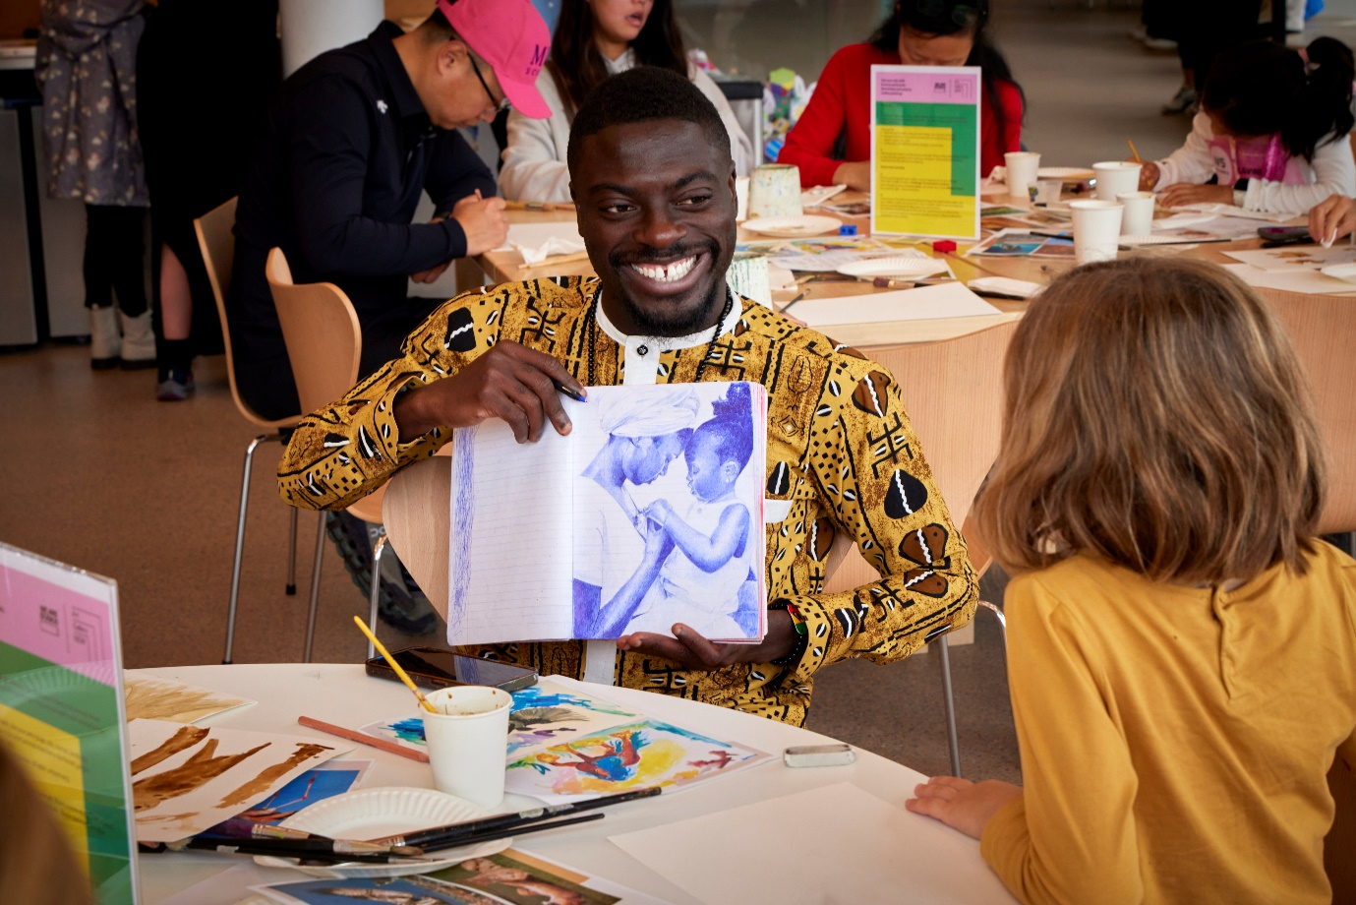
Artist Emmanuel Asante from We Are Studios leading a coffee-painting workshop, ‘Tell your tale’, during Make it May – a series of community-minded events highlighting connection and imagination at the Art Gallery in May 2024

Contacts, publishing information and credits
The Art Gallery of New South Wales values community feedback on our progress in meeting the goals outlined in the Disability Inclusion Action Plan 2025–28. We encourage individuals and community organisations to share their thoughts and experiences to ensure our continued improvement. Please contact us at artmail@ag.nsw.gov.au or on 02 9225 1700.
Published by Art Gallery of New South Wales
on Gadigal Country
Art Gallery Road, The Domain
Sydney NSW 2000, Australia
artgallery.nsw.gov.au
© Art Gallery of New South Wales 2025. All rights reserved. No part of this publication may be reproduced or transmitted in any form or by any means, electronic or mechanical, including photocopying, recording or any other information storage and retrieval system, without prior permission in writing from the publisher.
All artworks included in this publication in copyright are © the artist or their estate unless noted otherwise. The Art Gallery thanks the copyright owners for granting permission to reproduce works in this publication. Every effort has been made to contact the copyright owners and credit them accurately. Any omissions or errors will be corrected in future editions providing the publisher has been notified in writing.
Photos © Art Gallery of New South Wales
Photography by Diana Panuccio (cover, pages 2, 4–5, 11, 12 left, 13, 15–20), Anna Kucera (page 3), Felicity Jenkins (page 8), Felipe Olivares (page 9) and Cecilia Tsai (page 12 right)
Compiled by Olivia Arnold, Georgia Connolly, Danielle Gullotta and Cecilia Tsai
Text editing and proofreading by Melissa Ratliff
PDF version designed by George Hatton (Studio Thomas Hatton)
The Art Gallery of New South Wales is a statutory body of the NSW State Government.
The Gadigal are the traditional custodians of the Country on which the Art Gallery of New South Wales stands.
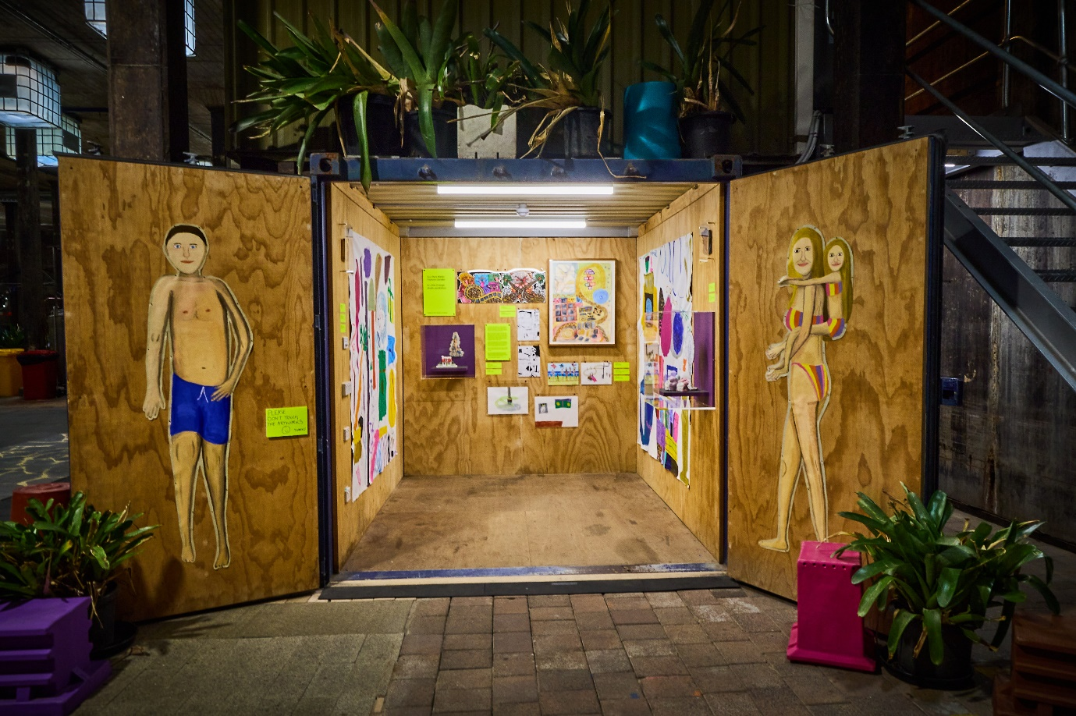
Fun Park Water Feature Garden, an exhibition by artists from Campbelltown Arts Centre’s Little Orange studio in Bobby’s container, 3 December 2025 – 30 January 2026. The exhibition space is part of Mike Hewson: The Key’s Under the Mat, Art Gallery of New South Wales, 4 October 2025 – 2026, artworks © the artists

