EAR RESHAPING (OTOPLASTY) INSTRUCTION

GETTING READY FOR YOUR OTOPLASTY PROCEDURE
- If possible, avoid medications and supplements that may thin your blood. This includes aspirin, ibuprofen, naproxen, Vitamin E, and fish oil for 2 weeks before surgery.
- Do not smoke for 2 weeks prior to and 2 weeks after surgery. Nicotine and tobacco smoke delay healing and can result in scarring or infection.
- You will be given prescription medications on the day of surgery. These typically include a pain medication and an antibiotic.
- Stock up on easy to prepare meals and snacks. You may resume a normal diet after surgery.
- You should plan to take 1 week off work/school.
- Arrange to have someone drive you home from the procedure if you are having any oral or IV sedation. If you are having local anesthesia or numbing you will not need a driver.

Shopping List
- Stool softener (docusate). Constipation is common with use of pain medications and surgical recovery.
- Tylenol (acetaminophen)
- Baby shampoo
- Head band with ear flaps
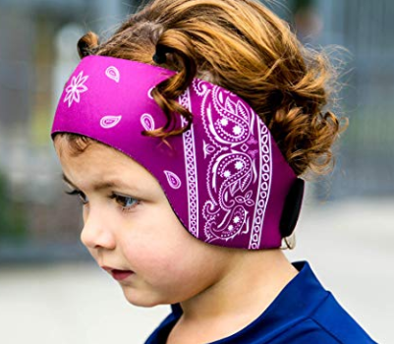
THE DAY OF SURGERY
- If IV or general anesthesia are planned, do not have anything to eat or drink (even water) after midnight the night before your surgery. Essential medications may be taken with a small sip of water the morning of your procedure.
- Wear comfortable, loose-fitting clothes that button or zip. Avoid slipover clothing.
- Leave your valuables at home; do not wear jewelry or piercings.
- Avoid all make-up, hairspray, and nail polish.
- Bring your ID to the surgery center.

POST-OPERATIVE CARE
- You will have a dressing on after the procedure. This will be removed the next day at follow up.
- Keep the incisions dry for 24 hours. Wash your face with a washcloth, do not wash/scrub around the ears. Do not apply any ointments or conditioners.
- There may be surgical glue behind the ears. It is ok to let water run over them after 24 hours, but do not apply lotions or ointments to the area.
- You should wear a head wrap or band for the first week after surgery, only take it off for showering. After week 1, wear the head wrap at night for 2 more weeks.
- Keep your head elevated for the first 48 hours. A recliner is best. Sleeping with extra pillows work as well. This will minimize swelling and help avoid rolling during sleep.
- All patients are placed on antibiotics for a short time after surgery to prevent an infection. Please complete the entire course of medication as written on the bottle.
- There will be mild bruising and swelling over the first week but improves quickly after.
- There will be some numbness to your ears following surgery, that may take several weeks to resolve.
- Avoid hair coloring or permanents for 1 month after surgery.
- Do not wear glasses for 2 weeks after surgery.
- After surgery, it is important to have a bowel movement within a day or two. If you do not, you may take over-the-counter stool softener to encourage your bowels to move.
- Sunscreen should be applied to the external scars starting 2-3 weeks after surgery. It is important to protect your scars for AT LEAST 1 year to prevent discoloration from the sun. Sunscreen with SPF 30 and above is always recommended to prevent skin cancer and signs of aging/sun damage.
- Resuming physical activities:
  - Light activity (preparing meals, walking around the house) is encouraged immediately to prevent blood clots but no heavy lifting greater than 10 pounds, bending over, or straining until cleared by Dr. Harbison.
  - Driving: once you are no longer taking pain medications
  - Sports: 6 weeks
  - Swimming, sauna, hot tub: 3-4 weeks or as directed by Dr. Harbison
  - Scuba diving: 12 weeks

Please call our office at any time with questions or concerns. After hours, you may call our office and follow the prompts to speak to the on call nurse. If you are experiencing a life-threating emergency, please go to the nearest emergency department.

