Jackson-Pratt (JP) Drain Home Care Instructions

## What is a Jackson-Pratt Drain?

Depending on your surgery, your doctor may send you home with one or more drains. These drains help prevent blood and fluid buildup at the surgical site, reducing the risk of complications such as infection or delayed healing.

The most common type is the Jackson-Pratt (JP) drain, which has a bulb-shaped container at the end of a plastic tube. The drain is stitched to your body to minimize accidental removal. When the bulb is squeezed, it creates gentle suction to draw out fluid.

**How long will the drain stay in?**

The drain may remain in place for several days to a few weeks, depending on the amount of fluid being collected and how quickly your body heals. Your surgeon will determine when the drain can be safely removed, usually when the output is less than 20 mL per day for 24 hours.

## How to Care for Your JP Drain

To help your surgeon determine when the drain can be safely removed, it's important to **measure and record the output** regularly.

* The collection bulb should always be **collapsed (flat)** to maintain continuous suction.
* The bulb should be emptied when it's filled with fluid or no longer under suction.
* Avoid collapsing the bulb by pushing in the bottom end, as this does not create suction.
* You can pin the bulb to your clothing with a safety pin to prevent it from being dislodged (remember to unpin it when undressing).

## Emptying the Drains

You will need a **measuring cup, which will be** provided by us.

1. **Wash your hands** thoroughly with soap and water.
2. **Uncap the drain** and carefully empty the fluid into the measuring cup.
   * **Note the amount** (in mL or cc; these are the same).
   * Make sure the spout of the bulb does not touch the measuring container to prevent the spread of germs onto or into the drain.
3. **Squeeze the center of the bulb** and recap it securely before releasing the bulb.
4. **Record the time**, the amount of fluid (in mL), and the drain number (e.g., drain #1 or right breast) on the provided flow sheet.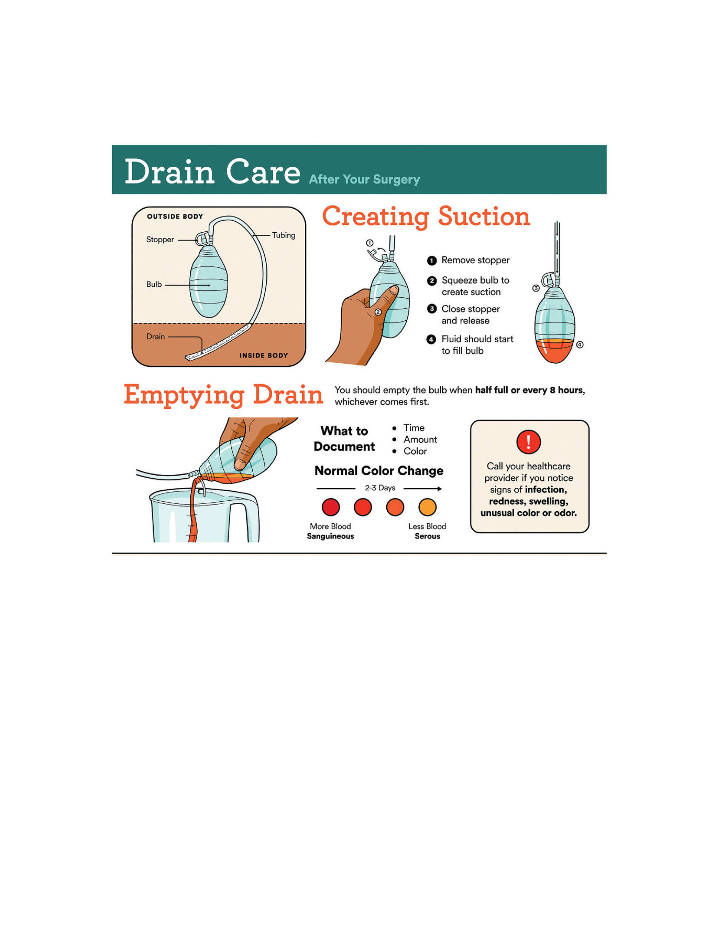
5. **Discard the fluid** into the toilet.
6. Repeat for all drains, **recording each drain separately**. Do not add the outputs together.

Bring your recorded drain outputs to each visit. The practice typically removes the drains when they put out **less than 20 mL/day for 24 hours**.

## **JP Drain Troubleshooting**

| **Problem** | **What to do?** |
| --- | --- |
| Drain is not holding suction | Make sure the cap is securely in place and the bulb completely  compressed. Check the drain site near the skin, if a black dot is visible or the channels of the drain are visible outside the skin, call the office. |
| Drain is pulled out or falls out | Do NOT attempt to replace. This is very common and nothing to worry about! Place a bandaid over the skin opening and notify the office during business hours. |
| Drain site is red and/or painful | Some discomfort and redness are to be expected around the immediate drain site. If redness is larger than the size of a quarter and swelling/heat present, call the office during business hours. |
| Drain site is leaking fluid | Sometimes the drain is clogged or insufficient to remove the fluid  building up. Reinforce the dressing around the drain and change when saturated. If frequent dressing changes are noted, notify the office. |
| Drain output slows or stops | If nothing comes out, there may be nothing to drain. If the surgical site is enlarged or painful, notify the office. |
| Drain and bulb have “clots” or solid material | You may notice some thick or solid clot or whitish material in the  drain tubing or bulb, especially after a few days. This is normal. Continue to record drain output. |

* **Drain issues are rarely emergencies**, even if the drain falls out.
* **The most important thing to monitor is** any change at the surgery site, such as swelling, pain, or a noticeable increase in size, which could indicate a clogged drain.

Jackson-Pratt (JP) Drain Output Tracking Form

* **Date and Time**: Record the date and time you empty the drains.
* **Drain Outputs**: Measure the amount of fluid from each drain in milliliters (mL & cc are the same thing) and record it in the corresponding column.
* **Site Location and Laterality**: Write down the specific location of the drain (e.g., breast, abdomen) and circle the laterality (Left/Right) for each drain.
* **Comments**: Note any unusual changes in the fluid (e.g., color, thickness, clots) for each drain, if applicable.

***Bring this form to each visit*** *with your surgeon so they can track your progress and determine when the drains can be safely removed. Please call us @* (808) 585-8855 OR *email us at* [*clinicalrn@drshimching.com*](mailto:clinicalrn@drshimching.com) *when your output is less than 24 mL for 24 hours.*

| Date & Time | Drain #1 Output (mL/cc)  ____________  Left / Right | Drain #2 Output (mL/cc)  ____________  Left / Right | Drain #3 Output (mL/cc)  ____________  Left / Right | Drain #4 Output (mL/cc)  ____________  Left / Right | Comments (e.g., color, consistency) |
| --- | --- | --- | --- | --- | --- |
|  | —--------------  (mL/cc) | —--------------  (mL/cc) | —--------------  (mL/cc) | —--------------  (mL/cc) |  |
|  | —--------------  (mL/cc) | —--------------  (mL/cc) | —--------------  (mL/cc) | —--------------  (mL/cc) |  |
|  | —--------------  (mL/cc) | —--------------  (mL/cc) | —--------------  (mL/cc) | —--------------  (mL/cc) |  |
| Date & Time | Drain #1 Output (mL/cc)  ____________  Left / Right | Drain #2 Output (mL/cc)  ____________  Left / Right | Drain #3 Output (mL/cc)  ____________  Left / Right | Drain #4 Output (mL/cc)  ____________  Left / Right | Comments (e.g., color, consistency) |
|  | —--------------  (mL/cc) | —--------------  (mL/cc) | —--------------  (mL/cc) | —--------------  (mL/cc) |  |
|  | —--------------  (mL/cc) | —--------------  (mL/cc) | —--------------  (mL/cc) | —--------------  (mL/cc) |  |
|  | —--------------  (mL/cc) | —--------------  (mL/cc) | —--------------  (mL/cc) | —--------------  (mL/cc) |  |
|  | —--------------  (mL/cc) | —--------------  (mL/cc) | —--------------  (mL/cc) | —--------------  (mL/cc) |  |
|  | —--------------  (mL/cc) | —--------------  (mL/cc) | —--------------  (mL/cc) | —--------------  (mL/cc) |  |
|  | —--------------  (mL/cc) | —--------------  (mL/cc) | —--------------  (mL/cc) | —--------------  (mL/cc) |  |
|  | —--------------  (mL/cc) | —--------------  (mL/cc) | —--------------  (mL/cc) | —--------------  (mL/cc) |  |

| Date & Time | Drain #1 Output (mL/cc)  ____________  Left / Right | Drain #2 Output (mL/cc)  ____________  Left / Right | Drain #3 Output (mL/cc)  ____________  Left / Right | Drain #4 Output (mL/cc)  ____________  Left / Right | Comments (e.g., color, consistency) |
| --- | --- | --- | --- | --- | --- |
|  | —--------------  (mL/cc) | —--------------  (mL/cc) | —--------------  (mL/cc) | —--------------  (mL/cc) |  |
|  | —--------------  (mL/cc) | —--------------  (mL/cc) | —--------------  (mL/cc) | —--------------  (mL/cc) |  |
|  | —--------------  (mL/cc) | —--------------  (mL/cc) | —--------------  (mL/cc) | —--------------  (mL/cc) |  |
|  | —--------------  (mL/cc) | —--------------  (mL/cc) | —--------------  (mL/cc) | —--------------  (mL/cc) |  |
|  | —--------------  (mL/cc) | —--------------  (mL/cc) | —--------------  (mL/cc) | —--------------  (mL/cc) |  |
|  | —--------------  (mL/cc) | —--------------  (mL/cc) | —--------------  (mL/cc) | —--------------  (mL/cc) |  |
|  | —--------------  (mL/cc) | —--------------  (mL/cc) | —--------------  (mL/cc) | —--------------  (mL/cc) |  |

| Date & Time | Drain #1 Output (mL/cc)  ____________  Left / Right | Drain #2 Output (mL/cc)  ____________  Left / Right | Drain #3 Output (mL/cc)  ____________  Left / Right | Drain #4 Output (mL/cc)  ____________  Left / Right | Comments (e.g., color, consistency) |
| --- | --- | --- | --- | --- | --- |
|  | —--------------  (mL/cc) | —--------------  (mL/cc) | —--------------  (mL/cc) | —--------------  (mL/cc) |  |
|  | —--------------  (mL/cc) | —--------------  (mL/cc) | —--------------  (mL/cc) | —--------------  (mL/cc) |  |
|  | —--------------  (mL/cc) | —--------------  (mL/cc) | —--------------  (mL/cc) | —--------------  (mL/cc) |  |
|  | —--------------  (mL/cc) | —--------------  (mL/cc) | —--------------  (mL/cc) | —--------------  (mL/cc) |  |
|  | —--------------  (mL/cc) | —--------------  (mL/cc) | —--------------  (mL/cc) | —--------------  (mL/cc) |  |
|  | —--------------  (mL/cc) | —--------------  (mL/cc) | —--------------  (mL/cc) | —--------------  (mL/cc) |  |
|  | —--------------  (mL/cc) | —--------------  (mL/cc) | —--------------  (mL/cc) | —--------------  (mL/cc) |  |