Emergency Action Plan

(Plan is mandatory for employers with 11 or more employees)

Name of the Facility
Address

According to OSHA’s 29 CFR 1910.157, a very simple plan will suffice in offices, small retail shops, and small manufacturing settings where there are few or no hazardous materials or processes, and employees evacuate when alarms sound or when notified by public address systems. More complex plans are required in workplaces containing hazardous materials or workplaces where employees fight fires, perform rescue and medical tasks, or delay evacuation after alarms sound to shut down critical equipment.

Plan
In the event of an emergency, employees are alerted by check the boxes that apply):
☐ The sounding of an alarm
☐ Public Address Announcement
☐ Verbal Announcement
☐ Shout
☐ Siren
☐ Other
___________________________________________________________________
___________________________________________________________________
___________________________________________________________________
___________________________________________________________________
Identify the emergency signal for each emergency situation, i.e. earthquake, fire, general evacuation. (Enter description of employee alerts for each emergency situation)

- Fire _________________________________________________________________
- Earthquake _________________________________________________________________
- General Evacuation _________________________________________________________________
Fire Emergency (check whichever is appropriate)
☐ In the event of fire or other emergency, all employees shall evacuate immediately.
☐ In the event of an emergency, employees shall evacuate by means of the nearest available marked exit.

☐ In the event of an emergency, employees shall evacuate:
________________________________________________________________________________________________________________________________________________________________________________________________________________________________________________________________________________________________
(Enter a statement or diagram describing Means of Evacuation and Evacuation Routes)
☐ The policy of this establishment in the event of fire or another emergency is to (Enter a more detailed policy statement):
________________________________________________________________________________________________________________________________________________________________________________________________________________________________________________________________________________________________

Use of fire extinguishers in an emergency (check as appropriate)
☐ Portable fire extinguishers are provided in the workplace for employee use. In the event of fire, any employee may use extinguishers to attempt to extinguish the fire before evacuating.
☐ Employees are not authorized to use any portable fire extinguisher that may be present to fight fires. In the event of fire, employees are to evacuate immediately.
☐ In the event of a fire, the following individuals are authorized to use portable fire extinguishers to attempt to extinguish fires before evacuating (Enter a statement describing employees (by name or job) who are designated to use fire extinguishers):

_______________________________________________________________________________________________________________________________________________________________________________________________________________________________________________________________________________________________

Supervisory, Medical and Rescue Duties
☐ In the event of an emergency, the following employees are to remain in the workplace to supervise operations before they evacuate (Enter a statement describing employees (by name or job) who are designated to remain):
________________________________________________________________________________________________________________________________________________________________________________________________________________________

☐ Critical operations shutdown procedures are not required, because no employees are authorized to delay evacuation for this purpose.
☐ The following employees are to perform rescue or medical duties during an emergency (Enter a statement describing employees (by name or job) who are responsible for rescue and medical assistance):

________________________________________________________________________________________________________________________________________________________________________________________________________________________

☐ No employees are assigned to perform medical or rescue duties during emergency evacuation situations

After an emergency evacuation, employees are to gather in the following location(s) (Enter name and description of the location):

_________________________________________________________________________________________________________________________________________________________________________________________________________________________________________

After an emergency evacuation, the procedure for accounting for all employees is (Enter description of accounting procedure here):
________________________________________________________________________________________________________________________________________________________________________________________________________________________________________________________________________________________________________________________
For further assistance with emergency evacuation procedures, the following individuals may be contacted (Enter contact information here):
____________________________________________________________________________________________________________________________________________________________________________________________________________________________________________________________________________________________________________________________________________________________________________________________________________________________________________________________________________________

This page intentionally left blank

Fire Prevention Plan

(Plan is mandatory for employers with 11 or more employees)

Facility Name ______________________________________________________

Address ____________________________.________________________...

Name of Fire Safety Officer
____________________________________________________________________________

This plan is located at________________________________________________ and is accessible to all employees. All employees must review this plan ten days within taking up an assignment at our facility and ________. months thereafter.

Purpose
The purpose of the fire prevention plan is to prevent a fire from occurring in our facility.

Plan
A list of all major fire hazards, proper handling and storage procedures for hazardous materials, potential ignition sources and their control, and the type of fire protection equipment necessary to control each major hazard are mentioned below.

Major fire hazards at our facility are:
☐ Electrical Outlets
☐ Flammable Materials
☐ Ignitable Materials
☐ Hazardous Materials
☐ Other
___________________________________________________________________
___________________________________________________________________
___________________________________________________________________
___________________________________________________________________
___________________________________________________________________
___________________________________________________________________

Potential Ignition Sources at our facility are:
☐ Electro Surgical Units
☐ Open Flame
☐ Other
___________________________________________________________________
___________________________________________________________________
___________________________________________________________________
___________________________________________________________________

Following preventive tasks/procedures are done at our facility to control ignition sources:
___________________________________________________________________
___________________________________________________________________
___________________________________________________________________
___________________________________________________________________
(Describe different procedures implemented at the facility)

Fire Protection Equipment available at our facility are:
☐ Automatic Sprinkler System
☐ Total Flooding System
☐ Dry Chemical System
☐ Water Spray and Foam System
☐ Gaseous Agent System
☐ Other
___________________________________________________________________
___________________________________________________________________
___________________________________________________________________
___________________________________________________________________
___________________________________________________________________
___________________________________________________________________
___________________________________________________________________
___________________________________________________________________
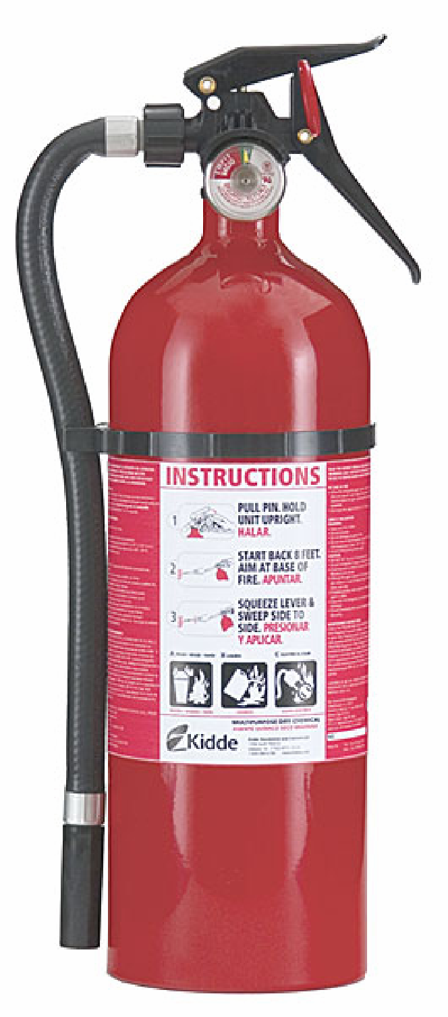
Fire Extinguishers (check as appropriate)
- ☐ Portable Fire Extinguishers are available at our facility. Employees have been trained in the operations of portable fire extinguishers. Employees will use fire extinguishers only if they recognize that the fire is:
  - Small and manageable
  - Trained and comfortable using the extinguisher
  - Know where the exits and escape routes are
- ☐ Portable Extinguishers are not available at our facility. Total evacuation is carried out upon sounding the fire alarm.

Fire Alerts (check as appropriate)
Employees will be alerted of incidents of fire using the following procedures:
- ☐ Smoke Detectors
- ☐ Audible Communication
- ☐ Fire Alarm

The following flammable and combustible waste materials are kept at our facility:
___________________________________________________________________
___________________________________________________________________
___________________________________________________________________
___________________________________________________________________
___________________________________________________________________
Procedures to control accumulations of flammable and combustible waste materials are:
___________________________________________________________________
___________________________________________________________________
___________________________________________________________________
___________________________________________________________________
___________________________________________________________________
(Detail procedures to control accumulations such as using alternative, safer materials, storing materials in fire proof containers, etc.)

The following heat-producing Equipment are present at our facility:
___________________________________________________________________
___________________________________________________________________
___________________________________________________________________
___________________________________________________________________
___________________________________________________________________

Procedures for regular maintenance and/ or safeguards installed on heat-producing equipment to prevent the accidental ignition of combustible materials are:
___________________________________________________________________
___________________________________________________________________
___________________________________________________________________
___________________________________________________________________
___________________________________________________________________
(Detail different procedures or maintenance undertaken on the heat-producing equipment)

___________________________________________________________________
(Name or job title of designated person) is responsible for maintaining equipment to prevent or control sources of ignition or fires at our facility.

____________________________________________________________ (Name or job title of designated person) is responsible for the control of fuel source hazards at our facility.

Employees at our facility have been trained and briefed about the various sources of fire. Each employee is aware of his or her duties.

