Laser Safety Plan

Methods of Implementation and Control

(Non-mandatory: Fill out this plan only if you utilize lasers)

Name of the Facility
Address

Overview
Laser hazards are addressed in the following specific OSHA standards for General Industry:

- 29 CFR 1910 Subpart I, Personal Protective Equipment
  - 1910.142, General Requirements
  - 1910,133, Eye and Face Protection

Much of the content of this chapter is not specific OSHA regulation, but does provide guidance from other regulatory bodies related to worker protection.

There are four basic categories of controls useful in laser environments. These are:
- engineering controls
- personal protective equipment
- administrative and procedural controls
- special controls

The controls to be reviewed here are based upon the recommendations of the ANSI Z 136.1 standard, NIOSH, IEC, ISO and FDA.

Designating and authority of Laser Safety Officer (LSO)
The LSO has the authority to monitor and enforce the control of laser hazards and effect the knowledgeable evaluation and control of laser hazards. The LSO administers the overall laser safety program where the duties include, but are not limited to, items such as confirming the classification of lasers, assuring that the proper control measures are in place and approving substitute controls, approving standard operating procedures (SOP's), recommending and/or approving eye wear and other protective equipment, specifying appropriate signs and labels, approving overall facility controls, providing the proper laser safety training as needed, conducting medical surveillance, and designating the laser and incidental personnel categories.

The LSO should knowledgeable on laser fundamentals, laser bioeffects, exposure limits, classifications, control measures (including area controls, eye wear, barriers, etc.), and medical surveillance requirements.

The Laser Safety Officer of this facility is (can be the OSHA Compliance Manager):

Name
Contact Information

Authorized Users of Lasers
The LSO shall determine which employees are authorized to operate a laser under his/her control. The LSO may grant temporary permission to use the laser, if system-specific laser safety training and documentation are provided before use and approval gained.

Accidents and Injuries
The LSO will assist in obtaining appropriate medical attention for any employee involved in the laser accident. The LSO shall perform an investigation and implement recommendations to prevent a recurrence. A written incident report of any actual injury shall be prepared by the LSO as soon as possible in accordance with the Reporting Requirements.

Operating Procedures
For Class 3b and 4 laser systems, the LSO shall ensure standard operating procedures (SOPs) are available in order to prevent the operation of a laser if exposure to employees or the general public could exceed the maximum permissible exposure (MPE).

Standard Operating Procedures (SOPs) are necessary for alignment, maintenance, service and emergency response.

Responsibility of Employees Working with or Near Lasers

Authorization
An employee shall not operate a class 3b or 4 laser system unless authorized to do so by the LSO. The LSO may give system specific laser safety training and grant temporary permission to use the laser.

Compliance
All employees shall comply with the safety rules and regulations prescribed by the LSO. Employees shall know the operating procedures applicable to their work.

Accident Reporting
All injuries and accidents involving lasers and laser systems shall be reported to the LSO. However, the treatment of injured personnel and the preservation of property shall be the first priority.

Training Programs
Training shall be provided to each employee routinely operating a Class 3b or 4 laser or laser system or working in an area where such a laser is in operation. Additional laser-specific training programs are encouraged.

Introduction to Laser Safety

Laser Classes and Hazards
Class FDA | Class IEC | Laser Product Hazard | Product Example
I | 1, 1M | Considered non-hazardous. Hazard increases if viewed with optical aids, including magnifiers, binoculars, or telescopes. | - laser printers  - CD players  - DVD players
IIa, II | 2, 2M | Hazard increases when viewed directly for long periods of time. Hazard increases if viewed with optical aids. | - bar code scanners
IIa, II | 2, 2M | Hazard increases when viewed directly for long periods of time. Hazard increases if viewed with optical aids. | - bar code scanners
IIIa | 3R | Depending on power and beam area, can be momentarily hazardous when directly viewed or when staring directly at the beam with an unaided eye. Risk of injury increases when viewed with optical aids. | - laser pointers
IIIb | 3B | Immediate skin hazard from direct beam and immediate eye hazard when viewed directly. | - industrial lasers  - research lasers
IV | 4 | Immediate skin hazard and eye hazard from exposure to either the direct or reflected beam; may also present a fire hazard. | - industrial lasers  - research lasers  - lasers for treatments and procedures

Precautions
- Follow the safety procedures for the facility and the laser being used.
- Wear approved laser safety goggles with the proper optical density for the specific wavelength(es) of the laser. Even with goggles, direct exposure to a laser beam is hazardous. Laser safety goggles are meant to protect for short exposures.
- Keep the beam horizontal and at waist level so the eyes of personnel standing in the facility are well above the beam plane.
- Keep reflective surfaces out of the beam line as specular reflections present a hazard.
- Question practices which appear unsafe:
  - Are they necessary or outdated?
  - Can the same function be performed in a manner which is less dangerous?
  - Can the unsafe practices be replaced by some other safer practice?
  - Are work practices designed for expediency at the expense of safety?

Operating Procedures
- Operating procedures must be developed for each class 3b or 4 laser and any IPL device. They are recommended for all other lasers.

Control Measures

Introduction
Control measures for Class 3b and 4 lasers are designed to reduce the possibility of eye and skin exposure to hazardous levels of radiation and to other hazards associated with the laser systems.

Engineering Controls
Engineering controls for Class 3b and 4 lasers as required by regulation are listed below. All Class 3b and 4 lasers at this facility are covered by this policy, and should have the listed design features unless otherwise approved by the LSO.
- A protective housing shall be provided for each laser system. The protective housing shall be interlocked such that removal of the protective housing will prevent exposure to laser radiation. Interlocks shall not be defeated or overridden during normal operation of the laser.
- Service access panels that allow access to the beam during operation shall be interlocked and have an appropriate warning label.
- A Class 3b or class 4 laser shall have a key-controlled or computer-actuated master switch. The authority for access to the key shall be vested in the LSO.
- All viewing portals, display screens, and collecting optics shall be designed to prevent exposure to the laser beam above the applicable MPE for all conditions of operation and maintenance.
- A laser control area shall be designated for all unenclosed beam paths. The laser control area is defined as the area where laser radiation is in excess of the MPE. The appropriate control measures must be implemented in the laser-controlled area.
- A Class 3b laser should be provided with a remote interlock connector. A Class 4 laser shall have a remote interlock connector. The remote interlock connector will decrease the laser beam power to safe levels when activated. Exceptions must be approved by the LSO and LSO.
- The LSO will follow the recommendations and requirements as set forth by ANSI Z136.1 and ANSI Z136.8 in regard to interlocks for class 3b and 4 lasers. The LSO have the authority to require more stringent entry controls based on a case by case analysis.
- A Class 3b laser should have a permanent beam stop in place. A Class 4 laser shall have a permanent beam stop in place.
- An alarm (for example, an audible sound such as a bell or chime), a warning light (visible through protective eyewear), or a verbal “countdown” command should be used at start-up of a Class 3b laser, and shall be used with Class 4 lasers. For Class 4 laser systems, the warning should allow sufficient time to take appropriate actions to avoid exposure to the laser beam.
- Whenever possible, Class 4 lasers should be operated and fired from a remote location.

Work Practice Controls
- Standard written operating procedures, with safety controls, shall be provided to all laser users and be readily available for operation of the laser system. Refer to the laser application for a guide to assist in the development of SOPs. The instructions shall include clear warnings and precautions to avoid possible exposure to laser and collateral radiation in excess of the MPE. Operating procedures are to be maintained for inspection for the duration of the life of a laser.
- Each laser operator shall have the education and training level commensurate with degree of hazard and responsibility.
- Alignment procedures shall be developed to ensure that eye exposure to the primary beam or to a diffuse or specular reflection does not exceed the MPE.
- The laser facility shall be designed in such a way to limit spectator access to the laser-controlled area.
- Service personnel must comply with appropriate control procedures for the laser system and have education and training commensurate with the laser system.
- Proper eye protection devices, specifically designed for the laser radiation, shall be worn when engineering or other administrative and procedural controls are inadequate to eliminate exposures above the MPE.
- Utilize the “universal precautions” control measures as required by the Bloodborne Pathogen Standard.

Class 3b and 4 Laser Control Area
- The area designated as the control area for Class 3b laser facilities shall have the following adequate control measures.
  - Operation only by qualified and authorized personnel.
  - Appropriate warning signs at all entryways and within the area.
  - Limited spectator access.
  - Appropriate beam stops for terminating potentially dangerous beams.
  - Only diffuse-reflective surfaces on non-optical structures in or near the beam path.
  - Appropriate eye protection for all personnel within the area.
  - Laser beam positioned well above or below eye level.
  - All windows, doorways, and open portals covered to prevent the laser radiation above the applicable MPE outside the laser facility.
  - Secured storage of laser equipment.
- In addition to the above control measures for Class 3b laser facilities, the controlled area for Class 4 laser facilities (Figure 2) shall have the following control measures:
  - All entryway controls designed to allow rapid egress.
  - A “Panic Button” shall be clearly marked and readily accessible to the laser personnel. When activated, the “Panic Button” will reduce the output power of the laser to levels below the MPE. The following are acceptable examples of “Panic Buttons”.
    - Key switches to deactivate the laser.
    - Master switch on power source to turn off power.
    - Red mushroom-type button on control panel or other readily accessible location within the area.
  - Limited Access Entryway. The LSO shall implement one of the following mechanisms to protect personnel.
    - Non-Defeatable (non-override) Entryway Safety Controls
      - Non-defeatable entryway controls will reduce the output power of the laser to levels below the MPE when the door is opened unexpectedly.
    - Defeatable Entryway Safety Controls
      - Controls with an override for safety latches and/or interlocks, may be used if it is clear that there is no laser radiation hazard at the point of entry. Only trained and authorized personnel may operate the overrides to enter the facility.
    - Procedural Entryway Safety Controls
      - All authorized personnel shall be trained, and personal protective equipment (PPE) shall be available at entry.
      - A secondary barrier (laser curtain) shall be used to block the laser radiation at the entryway, screening the entrance from the room.
      - At the entryway there should be a visible or audible indication that the laser is in operation.
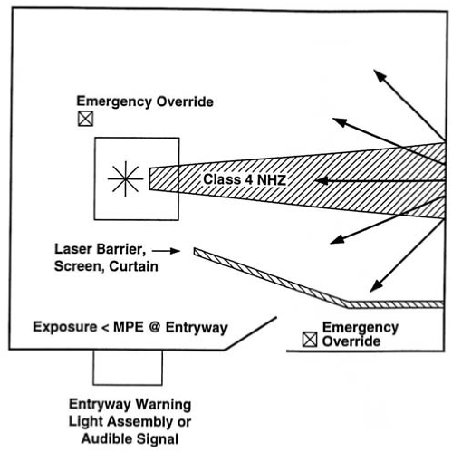
Figure 1: Class 4 Laser Controlled Area

Equipment Labels
All lasers (except Class 1) shall have appropriate warning labels with the laser sunburst logo and the appropriate cautionary statement (Figure 2). The labels shall be affixed to both the control panel and the laser housing.
Ancillary hazards shall also be appropriately labeled.

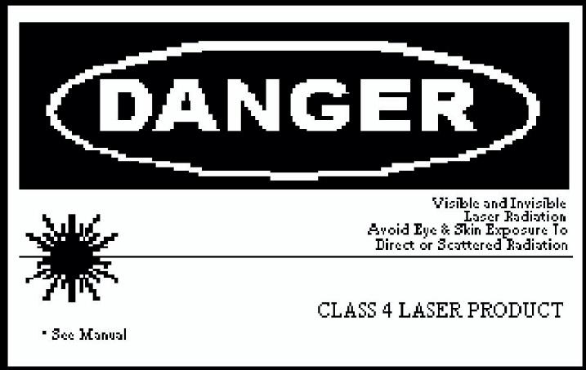
Figure 2: Laser Identification Label

Area Posting Signs
Areas which contain Class 2 or 3a laser systems should be posted with appropriate area postings as described in Figure 3. Areas which contain Class 3b or 4 laser systems shall be posted with appropriate area postings as described in Figure 4. Also, the laser-controlled area should be indicated with the appropriate warning sign.

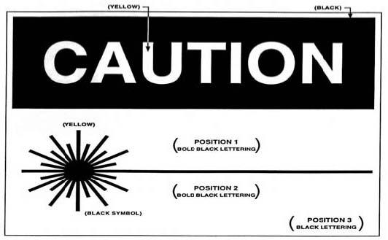
Figure 3: Area Posting for Class 2 and 3a Lasers

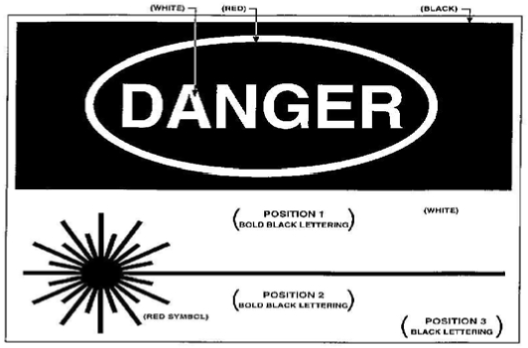
Figure 4: Area Posting for Class 3b and 4 Lasers

Personal Protective Equipment (PPE)
Performance oriented PPE must be used when operating with and around lasers. See PPE section of the Documentation Kit for more information.

In this facility, we utilize the following laser safety PPE:
- ☐ Laser safety googles
- ☐ Laser safety face shields
- ☐ Eyewear with laser filter materials/reflective coatings
- ☐ Face masks
- ☐ Gloves
- ☐ Covers for forearms
- ☐ Other: ………………………………………………………………………….
- ☐ Other: ………………………………………………………………………….
- ☐ Other: ………………………………………………………………………….

Control of Smoke from Laser/Electric Surgical Procedures
Research has shown airborne contaminants generated by surgical devices can cause ocular and upper respiratory tract irritation in health care personnel, and creates visual problems for the surgeon. Two types of control are recommended: ventilation and work practice.

Ventilation
In this facility, the following ventilation controls are implemented:

- ☐ General room ventilation
- ☐ Local exhaust ventilation
- ☐ Portable smoke evacuators
- ☐ Room suction systems
- ☐ High Efficiency Particulate Air (HEPA) filters
- ☐ Other: ……………………………………………………………………………
- ☐ Other: ……………………………………………………………………………
- ☐ Other: ……………………………………………………………………………

Work Practices
- The smoke evacuator or room suction hose nozzle inlet must be kept within 2 inches of the surgical site to effectively capture airborne contaminants generated by these surgical devices.
- The smoke evacuator should be ON (activated) at all times when airborne particles are produced during all surgical or other procedures.
- At the completion of the procedure all tubing, filters, and absorbers must be considered infectious waste and be disposed appropriately.
- New filters and tubing should be installed on the smoke evacuator for each procedure.
- All LEV systems must be regularly inspected and maintained to prevent possible leaks.
- Users shall also utilize control measures such as "universal precautions," as required by the Bloodborne Pathogen standard.

Appendices
FDA/CDRH Federal Product Performance Standard Evaluation Outline

Instructions: Utilize this form when evaluating the performance of laser equipment in the facility.

Laser Description:

Classification Designation
☐ Class I | ☐ Class IIIA
☐ Class II | ☐ Class IIIB
☐ Class IIA | ☐ Class IV

Requirement | Class | Yes | No
Performance Requirements
Protective Housing [1040.10(f)(1)] | All | ☐ | ☐
Safety Interlocks [1040.10(f)(2)] | All | ☐ | ☐
Remote Interlock Connector [1040.10(f)(3)] | IIIB, IV | ☐ | ☐
Key Control Classes [1040.10(f)(4)] | IIIB, IV | ☐ | ☐
Emission Indicator [1040.10(f)(5)]  No delay [1040.10(f)(5)(i)]  With delay [1040.10(f)(5)(ii)]  Indicators on laser and controls, if separated by more than 2 meters.  NOTE: Class IIA is exempt. | II, III, IV | ☐ | ☐
 | II, IIIA | ☐ | ☐
 | III, IV | ☐ | ☐
Beam Attenuator [1040.10(f)(6)] | II, III, IV | ☐ | ☐
Location of Controls [1040.10(f)(7)] | II, IIA, III, IV | ☐ | ☐
Viewing Optics [1040.10(f)(8)] | All | ☐ | ☐
Scanning Safeguard [1040.10(f)(9)] | All | ☐ | ☐
Manual Reset Mechanism [1040.10(f)(10)] | IV | ☐ | ☐
Label Requirements
Certification Label [1010.2] | All | ☐ | ☐
Identification Label [1010.3] | All | ☐ | ☐
Class Designation and Warning Label [1040.10(g)(1,2,& 3)] | II, IIA, III, IV | ☐ | ☐

Requirement | Class | Yes | No
Radiation Output Information (Position 2 on label)  [1040.10(g)(4]  NOTE: Class IIA is exempt. | II, III, IV | ☐ | ☐
Aperture Label [1040.10(g)(5)]  NOTE: Class IIA is exempt. | II, III, IV | ☐ | ☐
Non-interlocked Protective Housing Labels (i.e. service panels)  [1040.10(g)(6)] | II, III, IV | ☐ | ☐
Defeatably Interlocked Protective Housing Labels [1040.10(g)(7)] | All | ☐ | ☐
Warning for Invisible Radiation (wherever applicable - all labels) [1040.10(g)(8)] | All | ☐ | ☐
Positioning of Labels [1040.10(g)(9)] | All | ☐ | ☐
Label Specifications [1040.10(g)(10)] | All | ☐ | ☐
Information Requirements
User Information [1040.10(h)(1)] | All | ☐ | ☐
Operator & Maintenance Instructions [(h)(1)(i)] | All | ☐ | ☐
Statement of Parameters [(h)(1)(ii)] | All | ☐ | ☐
Label Reproductions [(h)(1)(iii)] | All | ☐ | ☐
Listing of Controls, Adjustments, and Procedures, including Warnings [(h)(1)(iv)] | All | ☐ | ☐
Service Information [1040.10(h)(2)(ii)] | All | ☐ | ☐

Maximum Permissible Exposure Limits (ANSI Z 136.1)
Wavelength | MPE level (W/cm²)
Laser type | (μm) | 0.25 s | 10 s | 600 s | 30,000 s
CO2 (CW) | 10.6 | --- | 100.0 × 10⁻³ | --- | 100.0 × 10⁻³
Nd: YAG (CW) | 1.33 | --- | 5.1 × 10⁻³ | --- | 1.6 × 10⁻³
Nd: YAG (CW) | 1.064 | --- | 5.1 × 10⁻³ | --- | 1.6 × 10⁻³
Nd: YAG (Q-switched) | 1.064 | --- | 17.0 × 10⁻⁶ | --- | 2.3 × 10⁻⁶
GaAs (Diode/CW) | 0.840 | --- | 1.9 × 10⁻³ | --- | 610.0 × 10⁻⁶
HeNe (CW) | 0.633 | 2.5 × 10⁻³ | --- | 293.0 × 10⁻⁶ | 17.6 × 10⁻⁶
Krypton (CW) | 0.647  0.568  0.530 | 2.5 × 10⁻³  31.0 × 10⁻⁶  16.7 × 10⁻⁶ | --- | 364.0 × 10⁻⁶  2.5 × 10⁻³  2.5 × 10⁻³ | 28.5 × 10⁻⁶  18.6 × 10⁻⁶  1.0 × 10⁻⁶
Argon (CW) | 0.514 | 2.5 × 10⁻³ | --- | 16.7 × 10⁻⁶ | 1.0 × 10⁻⁶
XeFl (Excimer/ CW) | 0.351 | --- | --- | --- | 33.3 × 10⁻⁶
XeCl (Excimer/ CW) | 0.308 | --- | --- | --- | 1.3 × 10⁻⁶

