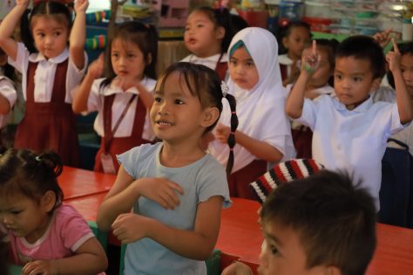

BARMM:
ECD 6: ©UNICEF Philippines/2023/Resa Salvador
Caption: Children in an early childhood development center in the Bangsamoro Region, Philippines engage in a playful dance exercise.

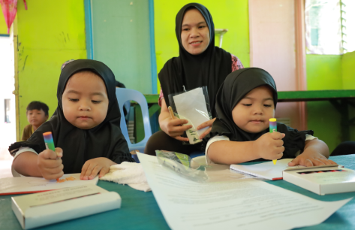

BARMM
ECD 3 : ©UNICEF Philippines/2023/Resa Salvador
Caption: Young learners in the Bangsamoro Region, Philippines concentrate on their coloring activity using the learning materials provided to them.

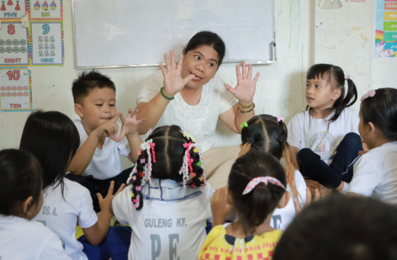
BARMM
Teacher 1: ©UNICEF Philippines/2023/Resa Salvador
Caption: Young learners gather around their teacher in the Bangsamoro Region for a lively exercise designed to spark curiosity.

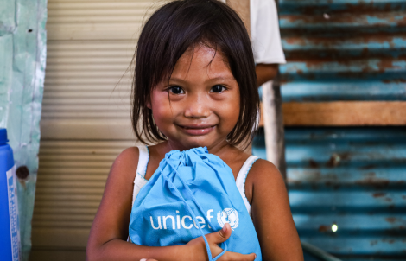

Caraga
San Ricardo-June 16 2022-ACDimatatac-35: ©UNICEF/2022/AcDimatatac
Caption: A student in San Ricardo, Caraga Region clutches her school materials, ready to embrace the promise of learning despite the challenges around her.

