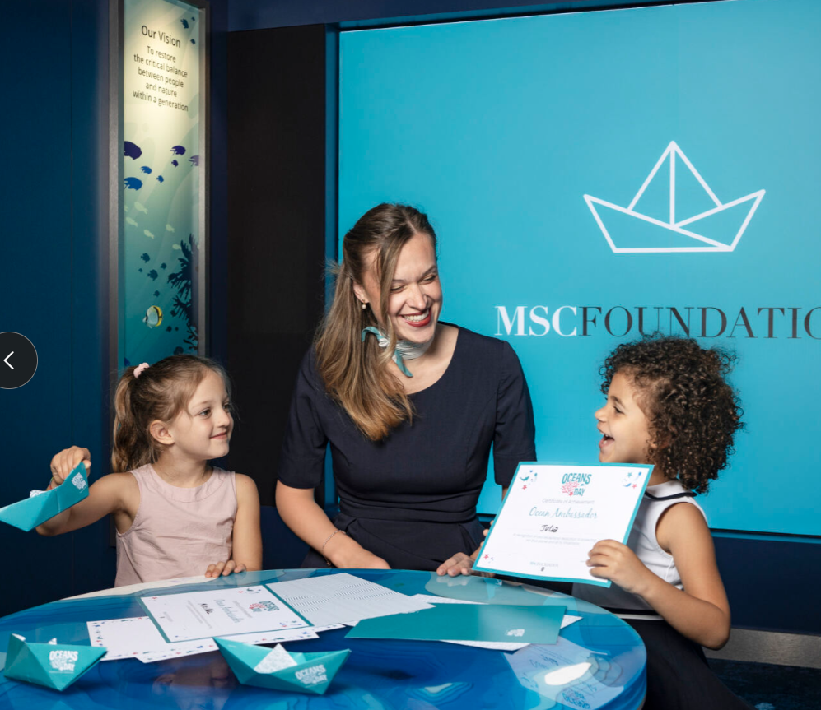 | Smiles, certificates and ocean inspiration at Oceans Day powered by MSC Foundation.  @giuliopiscitelli
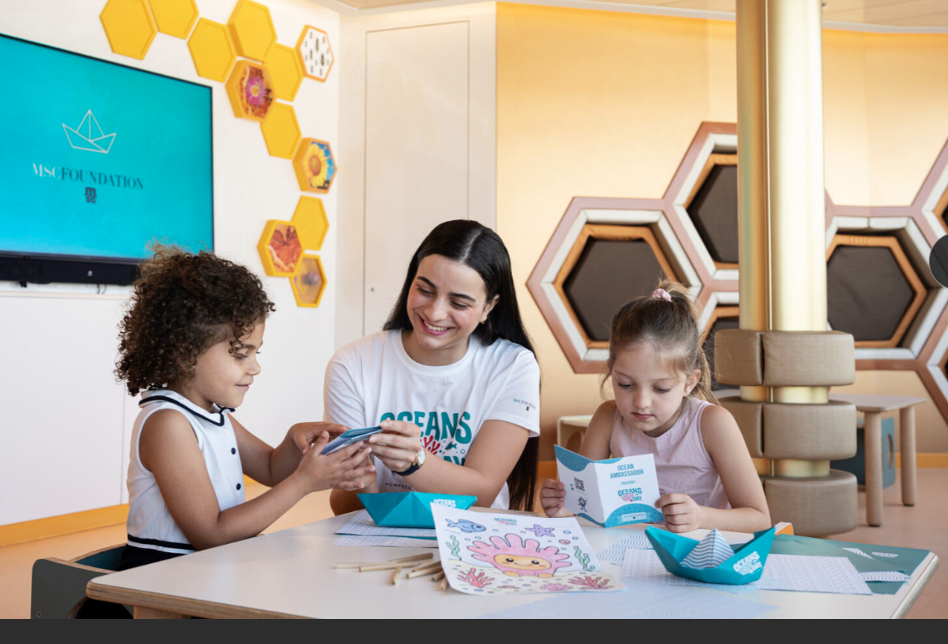 | Ocean-themed activities supported by MSC Cruises Entertainment as part of Oceans Day powered by MSC Foundation. @giuliopiscitelli
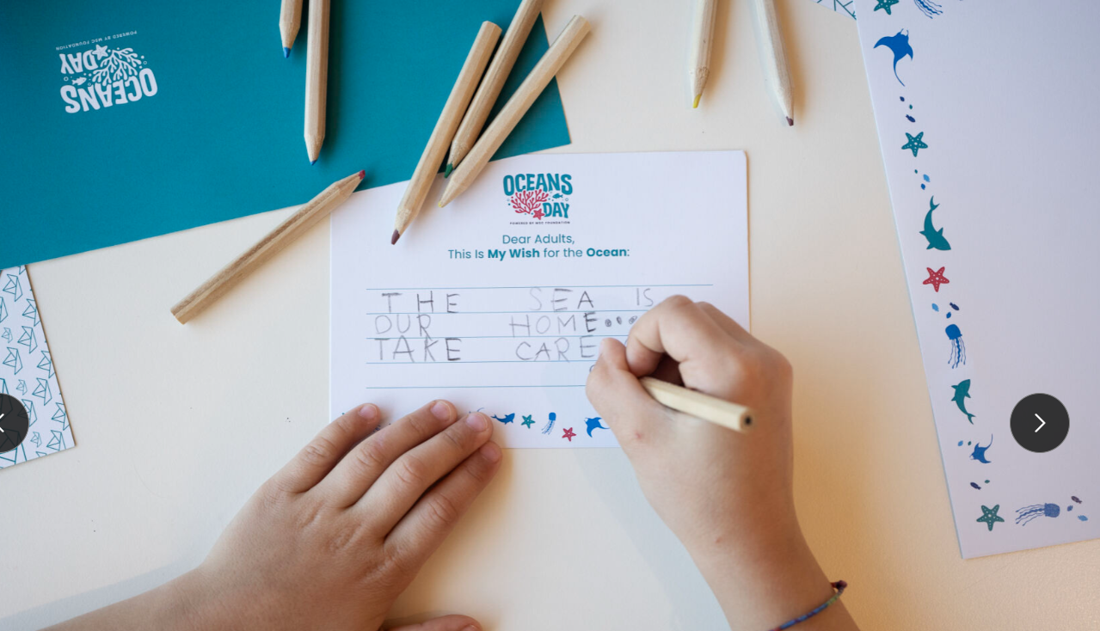 | The “My Wish for the Ocean” activity invites children to reflect on caring for the ocean. @giuliopiscitelli
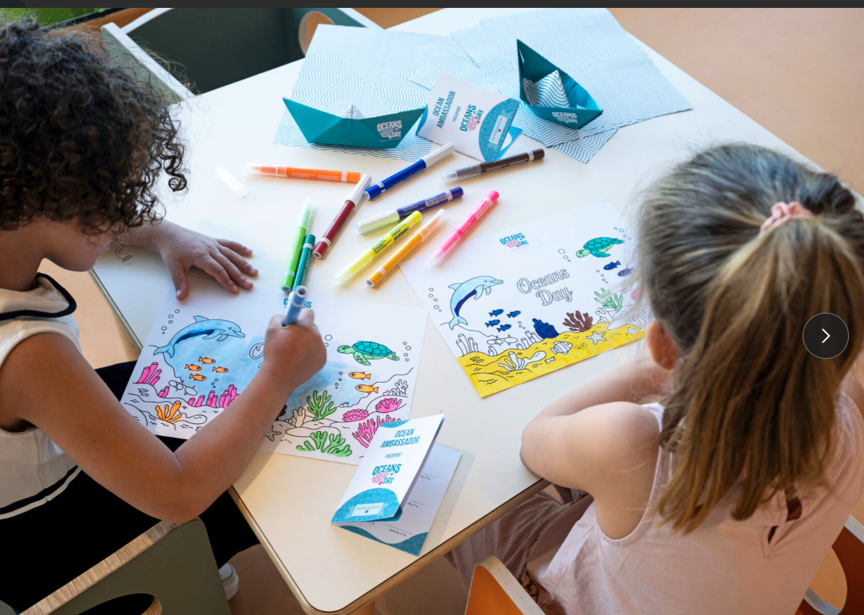 | Ocean-themed creative activities designed to encourage curiosity and learning during Oceans Day. @giuliopiscitelli

