Photos and captions for SCTLD press release
Photo | Caption
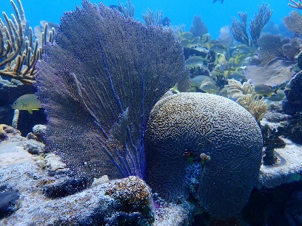 | A Caribbean stony coral on a healthy reef.  (Photo credit: MSC Foundation).
Marine Scientist recording coral health during a ‘Rapid Ecological Assessment’ dive.
(Photo credit: Simone Piccoli)
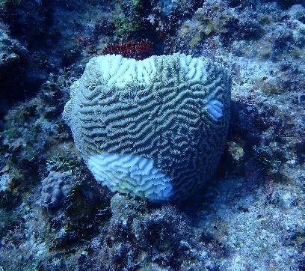 | Before treatment.  Coral beginning to be infected by Stony Coral Tissue Loss Disease (SCTLD). The diseased areas are white and are spreading across the living parts of the coral.  (Photo credit: MSC Foundation)
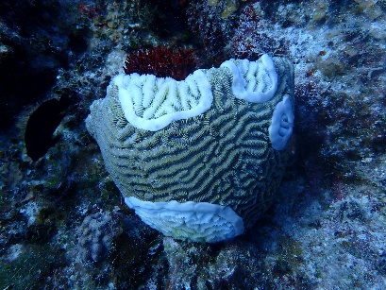 | After treatment.  An antibiotic paste is applied around edge of the disease to prevent the infection from spreading further across the coral.  (Photo credit: MSC Foundation)

