Assets to accompany the GCRMN Press Release

Photo | Caption
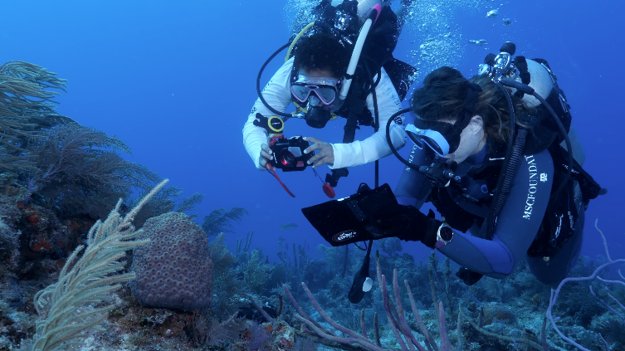 | MSC Foundation divers monitoring and photographing the state of coral reefs in The Bahamas.  (Credit: Simone Piccoli)
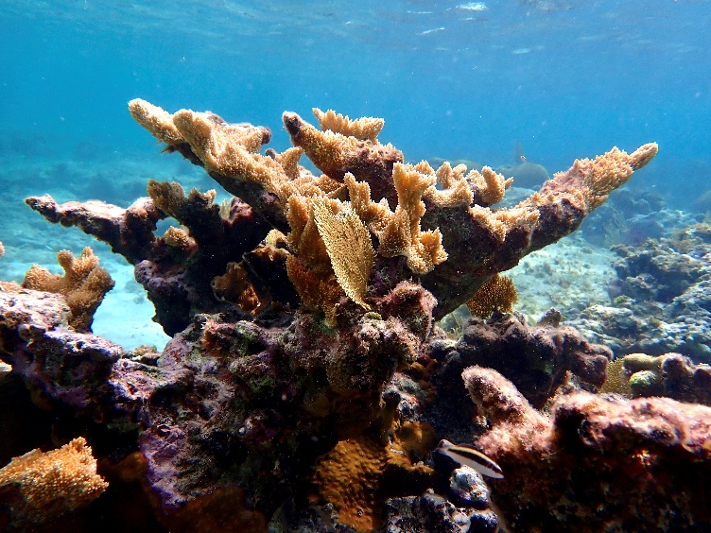 | Elkhorn Coral in The Bahamas  (Credit: MSC Foundation)
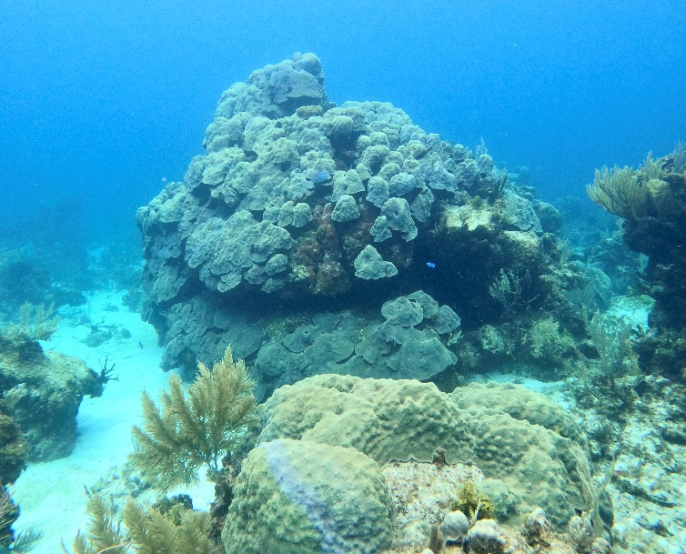 | Stony coral in The Bahamas  (Credit: MSC Foundation)
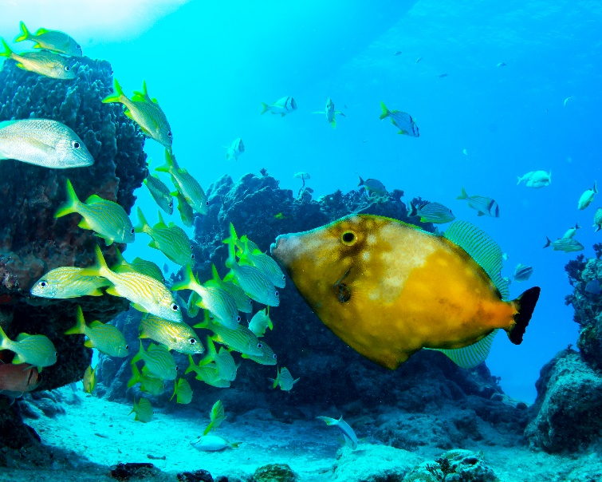 | Thriving marine life in The Bahamas  (Credit: MSC Foundation)
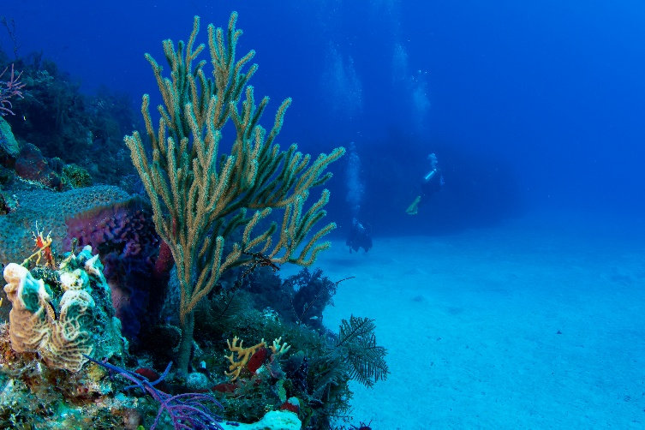 | Soft tissue coral in The Bahamas.  (Credit: MSC Foundation)
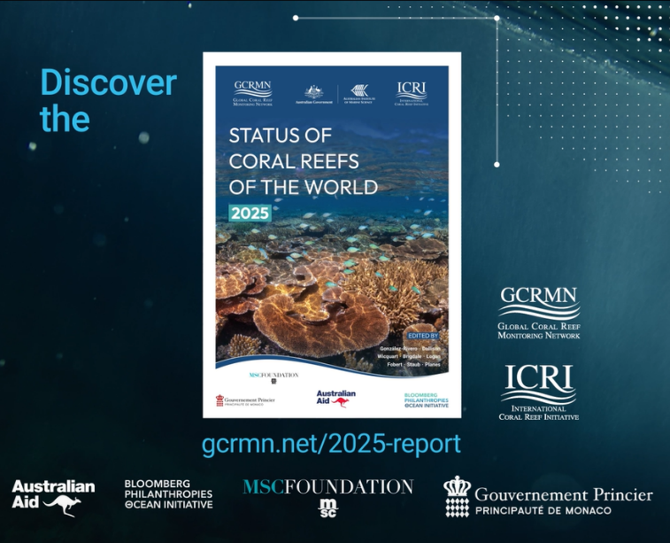 | GCRMN Report title card page.  (Credit: GCRMN)

