2021 Chris Arnost ‘Stay Focussed’ & ‘Encouragement’ Scholarships – Application Form

SECTION 1 ‐ To be completed by Student/Teacher Nominator (please also complete Section 3)

Please tick ONE scholarship from the table below:
Scholarship Title | Eligibility | Value (Up to) | Application Closing Date | Tick
Chris Arnost ‘Stay Focussed’ Memorial Scholarship | 1st Year Certificate III Electrotechnology | $ 1500 | 22 May 2021
Chris Arnost ‘Stay Focussed’ Memorial Scholarship | 2nd Year Certificate III Electrotechnology | $ 1500
Chris Arnost ‘Encouragement’ Memorial Scholarship | Electrotechnology Pre‐apprenticeship | $ 500

Student Details:

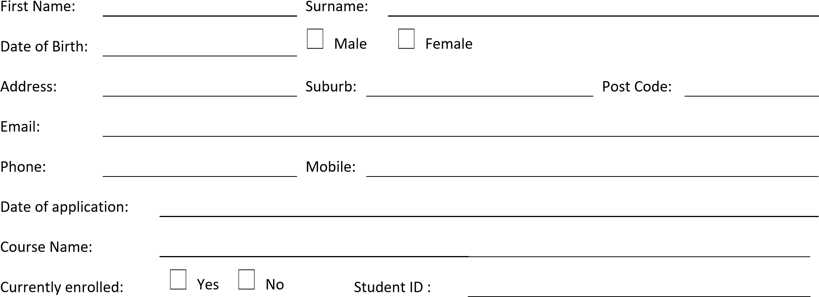

Faculty Endorsement:

Name:

Email:

Phone:

Date:

Faculty Nominator Support for Student Application (dot points)

SECTION 2 ‐ To be completed by the Student (please also complete Section 3)

Please provide a TYPED statement below as to how this scholarship will assist you with your academic achievements. This should include information on your background, your aspirations, long‐term goals, your intentions after graduating from Box Hill Institute and what receiving this scholarship will mean to you. Please include second page if needed.

STUDENT PLEDGE:

In accepting a scholarship, I agree to:

- Maintain satisfactory progress in my chosen studies;
- Complete the study in which I am current enrolled;
- Act as a positive ambassador for Box Hill Institute;
- Attend the Annual Sponsors Recognition Function;
- Be available for media interviews and photo sessions and provide permission for subsequent promotion regarding my achievement;
- Allow my contact details to be given to scholarship donor on request as part of application process.
- You must demonstrate a need, passion and commitment to your studies and to the fulfilment of all course requirements

I understand that if I fail to fulfil the Student Pledge above, I will be required to repay Box Hill Institute up to the value of the scholarship.

Student Name: Signature: Date:

Please ensure ALL documents listed below are attached to your application form.

Financial Hardship or Personal Challenges
Photo copy of Health Care Card (if available)
Current Resume

SECTION 3 ‐ To be completed by Teacher & Student

Faculty Nominator:

I declare that I have sighted all the documentation provided by the Student.

Signed: Date:

Student:

I confirm and declare that the information contained in this application and supporting documentation is true and correct.
I have read and understood the Student Pledge regarding acceptance of this scholarship and promotional requirements by Box Hill Institute. I understand that I can only receive one scholarship from Box Hill Institute per calendar year.

Student Name: Signature: Date:

Please return your completed application to:

scholarships@boxhill.edu.au

or

Student Mobility and Scholarship Coordinator
Building 3, Level 3, Elgar Campus
465 Elgar Road
Box Hill VIC 3128

Phone enquiries: 9286 9601

FOR OFFICE USE ONLY
Date Received
Date Processed
Name of Processing Officer:
Application Outcome :

