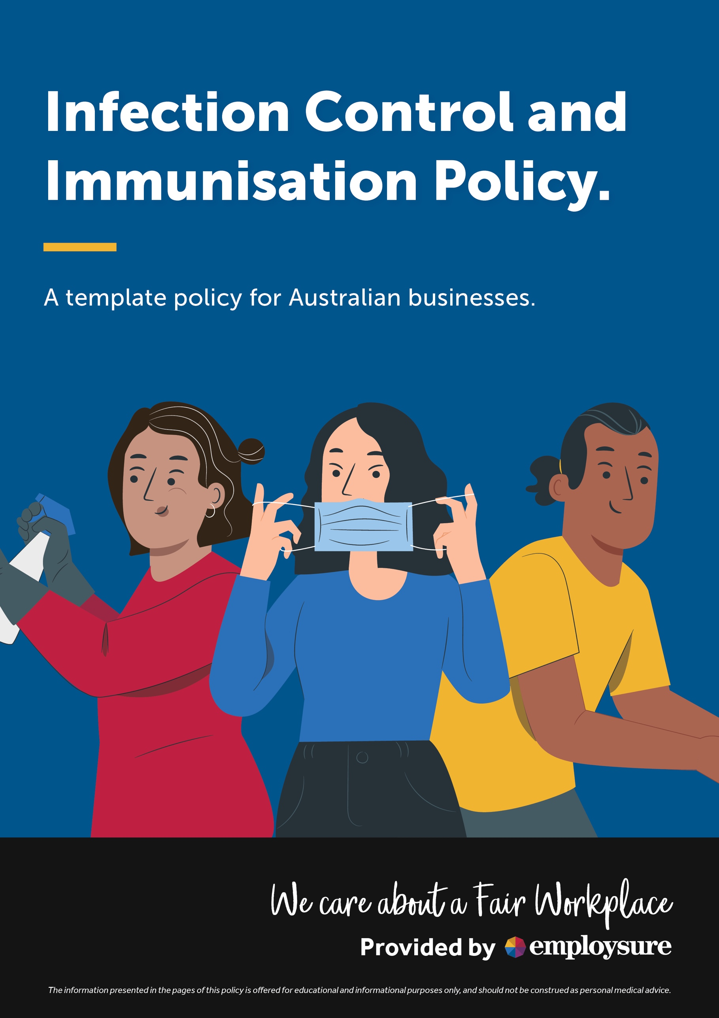

Infection control IN THE WORKPLACE

INTRODUCTION
The broad definition of infection is the invasion of tissue by pathogenic organisms. Infections generally result from a combination of factors, including:
- the presence of micro-organisms
- a compromised or weakened status of the host and
- the chain of transmission of the micro-organism.
Bacteria, viruses and other organisms, which can cause disease in humans, may be found wherever people live and work.
This policy is designed to be consistent with the Organisation’s health and safety framework. Its objective is to identify the requirements of infection prevention and control, and the development of safe work practices based upon risk management procedures. Therefore, the risks associated with infections in the workplace will be addressed via a risk management approach.
However, this policy is also designed to support any advice or directions from government health authorities. Therefore, no part of this policy either stated or implied, is designed to compromise any public health advice or directions that may be issued from time to time and which may require additional controls to be implemented.

Identifying infection transmission hazards
Micro-organisms are transmitted by various routes and the same infective agent may be transmitted by more than one route. There are several main routes of transmission:
- blood borne transmission through such things as sharp tools or contact with cuts or scratches
- direct contact through person to person contact or via contaminated articles or equipment
- droplet transmission such as through sneezing, coughing or talking
- airborne transmission through microscopic droplets or dust particles
- gastrointestinal infection through contaminated food or fluid or via an infected food handler and/or
- vector borne infections transmitted by carrier insects or animals such as mosquitoes, flies or rats.
The source of infection may be clients/customers, staff or visitors and the person may either be acutely ill or in the incubation (window) period of a disease. They may be a chronic carrier or colonised with the infective agent but have no apparent disease.
Contaminated items in the environment, including surfaces, equipment or food are other possible sources of infection.
The ability to resist infection varies depending upon age and underlying medical conditions. Other factors such as nutritional status or drug therapy may also reduce a person's immunity, making them more susceptible to infection.
Persons who have been recently exposed to trauma or who have recently undergone surgery, or invasive therapeutic and/or diagnostic procedures will also have an increased susceptibility to infection.

ASSESSING INFECTION TRANSMISSION HAZARDS
As part of the risk management approach, the Organisation has an obligation to ensure that persons and visitors to the workplace are not exposed to any infections, as far as is reasonably practicable.
Given the nature of our work, it is safe to assume that any infection brought into the workplace will pose a risk of injury to persons at the workplace. When approaching a task or duty, consideration must be given to the potential pathological agents involved, the transmission paths of the agents and who may potentially be at risk. The overall risk can then be analysed and assessed based on:
- what are the aspects of the task or procedure that facilitates transmission of infection
- what existing controls are in place
- what is the likelihood of transmission
- what are the likely consequences of transmission and
- what factors will increase or decrease the risk of transmission.

CONTROLLING INFECTION TRANSMISSION HAZARDS
The Organisation will ensure, as far as reasonably practicable, that the risks associated with infections in the workplace are controlled. The process of controlling exposure to infection transmission risks will be determined in consultation with all personnel in the workplace who are required to carry out the task and will include:
- the development of infection control principles
- the development of administrative requirements designed to minimise the risk of infection transmission
- the development of effective work practices and procedures
- the implementation of an immunisation program
- ensuring that all staff required to undertake a task that may potentially expose them to infection through their work have enough training, skills, knowledge, level of competence and education and/or qualifications to undertake the task and
- a regular review of our policies and procedures.
If exposure to infections within the workplace have been assessed as a risk, consistent with national and international requirements, the Organisation will adopt a three-level approach to infection control precautions.
The three-level approach involves:
- Level 1 – General: infection control procedures for the prevention or minimisation of transmission for all persons at a workplace

- Level 2 – Standard: infection control procedures for persons who may come into contact with blood and/or bodily fluids such as first aid persons and

- Level 3 – Transmission-based precautions: provides a high level of protection to all persons at the workplace following identification of a positive transmission and assumes that Level 1 and Level 2 controls are in place

Level 1 Controls – General
Infectious agents can be spread in a variety of ways, including:
- breathing in airborne germs – coughs and sneezes release airborne pathogens, which is then inhaled by others

- touching contaminated objects or eating contaminated food

- skin-to-skin contact – transfer of some pathogens can occur through touch or by sharing objects and

- contact with body fluids – pathogens in saliva, urine, faeces or blood can be passed on via cuts or through the mucus membranes of the mouth and eyes.

The first level relates to general procedures designed to eliminate or minimise the risk of infection transmission. These infection control procedures will involve good personal and environmental hygiene, including:
- regular hand hygiene such as handwashing or handrubbing at all times – washing hands with water and soap for at least 20 seconds, or using alcohol based hand sanitiser can prevent the spread of many pathogens, especially after visiting the toilet, before and after preparing food, and after touching clients/customers or equipment. Wet hands will be dried with a single use paper towel

- routine environmental cleaning and disinfection, including high contact points such as door handles, lift buttons and telephone equipment as well as high traffic areas such as reception areas

- promotion of respiratory hygiene and cough etiquette, such as covering the nose and mouth with the crook of the elbow or with a tissue when coughing or sneezing, and dispose of tissue in a closed bin

- any cuts or open wounds will be appropriately treated and covered with a waterproof dressing

- appropriate waste bins will be provided to dispose of contaminated tissues and other dirty items and

- appropriate use of PPE such as gloves when undertaking cleaning and disinfection procedures. PPE and training on its use will be provided to all personnel in the workplace in accordance with manufacturer’s guidelines and Australian and New Zealand Standards. PPE will be removed before leaving the work areas where the cleaning and disinfection is taking place.

Level 2 Controls – Standard health procedures
The second level of control is referred to as ‘standard precautions’ and will be applied to all persons at the workplace, clients/customers or visitors regardless of their diagnosis or presumed infection status wherever there is potential contact with:
- blood
- body fluids, secretions and excretions (except sweat)
- non-intact skin or
- mucous membranes, including eyes.
Standard precautions will involve the use of safe work practices and protective barriers, including:
- hand hygiene
- routine environmental cleaning
- managing spills
- waste management
- the safe use and disposal of sharps
- decontamination of equipment
- appropriate use of gloves
- appropriate use of facial protection/masks
- use of protective clothing
- appropriate device handling
- appropriate handling of any laundry items and/or protective clothing and
- incorporation of respiratory hygiene and cough etiquette.

Level 3 Controls – Transmission based precautions
Additional control measures will be initiated where persons are known or suspected to be infected with pathogens. These precautions are in addition to the general and standard precautions and are referred to as Level 3, or ‘transmission-based precautions’ (TBPs).
Transmission-based precautions (TBPs) are used in addition to standard precautions when standard precautions alone may be insufficient to prevent transmission of infection.
The three types of additional precautions are:
- airborne precautions which must be applied where the infected patient is known or suspected to be infected with pathogens that can be transmitted by an airborne route for eg Aspergillus, Legionella, Pulmonary tuberculosis, Chickenpox, Measles and Coronaviruses. These will include isolation of the infected person and in the case of a Coronavirus exposure, use of a type P2 or N95 mask that meets the requirements of Australian and New Zealand Standard, AS/NZS 1716:2012 Respiratory Protection Devices
- droplet precautions which must be applied where the person is known or suspected of being infected with pathogens that can be transmitted by droplet route for eg Influenza, Bordetella pertussis (whooping cough), Rubella, Listeria, E. coli, Salmonella and Coronaviruses. These will include isolation of the infected person, maintaining a separation distance of at least one and a half metres, the use of protective gloves and eyewear and the initiation of room cleaning protocols and
- contact precautions designed to reduce the risk of transmission of micro-organisms by direct or indirect contact for eg viral Gastroenteritis, Clostridium difficile, Methicillin-resistant Staphylococcus aureus (also known as MRSA or staph) and Coronaviruses. These will include additional precautions to eliminate contamination of environmental surfaces and equipment through the use of protective gloves and the implementation of additional room cleaning protocols.
TBPs, including cleaning protocols and procedures must be tailored to the infectious agent involved and the mode of transmission. To minimise the exposure time of other people in office/retail based setting or more industrial environment, people identified as at risk of transmitting droplet or airborne diseases (for example, a person with suspected Coronavirus exposure) should be attended to immediately and placed into appropriate transmission-based precautions to prevent further spread of the disease.

IMMUNISATION PROGRAM
To help ensure the Organisation meets its health and safety obligations to minimise the workplace risks to workers, particularly those in relation to the risk of exposure to vaccine preventable diseases in the workplace, the Organisation will develop and implement an appropriate immunisation program.
According to health authorities, immunisation is one of the safest ways to protect people against harmful infections before they come into contact with them by using the body’s natural defences to build resistance to specific infections.
Therefore, to the extent that is permissable under law and where it is determined as necessary through the application of a risk management approach and in accordance with relevant medical advice, the Organisation may make the requirement for immunisation against any particular disease or infection, a condition of employment or engagement with the Organisation.
Where such a program is implemented, the Organisation will take the responsibility for all real costs involved and will, where possible, implement the program during work hours. The Organisation will also retain records of the vaccination program, sufficient to identify who has been vaccinated but in compliance with the Organisation’s requirements for the confidentiality of medical and health records.
Prior to the implementation of an immunisation program, the Organisation will:
- seek appropriate and independent medical advice to ensure the recommended program meets all Government and health authority guidelines as well as the requirements of the National Immunisation Program and its related immunisation schedules
- encourage workers to seek their own independent medical advice regarding the program
- provide information to all workers on the immunisation programs currently recommended by health authorities for the Organisation’s business sector and
- ensure its infection control policy and program is fully implemented so as to minimise transmission and risks of infectious diseases being transmitted in the workplace.
Where an immunisation program is not possible or a worker is unable to be vaccinated for any reason, the Organisation will implement sufficient and appropriate alternative control measures to eliminate or reduce the risk of disease transmission at the workplace.
The implementation of the immunisation program will be overseen by an authorised medical practitioner and will be delivered by an authorised vaccination provider. An annual review of the immunisation status of workers will be conducted and records will be updated accordingly.

SAFE HANDLING, USE AND DISPOSAL OF SHARPS
A sharp is any object that can inflict a penetrating injury and includes needles, broken glass and any other sharp object or tools designed to perform penetrating procedures. The potential for the transmission of blood borne viruses is greatest when devices such as needles or knives are used. As such, the Organisation will develop a policy and procedures for the safe handling, use and disposal of sharps.

ENVIRONMENTAL CLEANING
Environmental cleaning refers to the appropriate cleaning of surfaces found in the workplace. Deposits of dust, soil and microbes on surfaces are a potential source of associated infections. The following basic principles should be followed:
- written cleaning protocols should be prepared, including methods and frequency of cleaning
- cleaning procedures must be commensurate with the level of risk and tailored accordingly
- standard precautions (including wearing of personal protective equipment (PPE), as applicable) must be implemented when cleaning surfaces and facilities
- cleaning methods should avoid generation of aerosols
- all cleaning items should be changed after each use and cleaned and dried before being used again. They should also be changed immediately following the cleaning of blood or body fluid/substance spills. Single-use cleaning items are preferred, where possible, such as lint-free cleaning cloths
- sprays should not be used, because they can become contaminated and are difficult to clean. Sprays are not effective, as they do not touch all parts of the surface to be cleaned
- detergents should not be mixed with other chemicals and
- all cleaning solutions should be prepared fresh before use.
The Organisation will ensure that a person is identified and nominated as being responsible for the implementation, management and evaluation of the cleaning service provided.

MANAGING SPILLS OF BLOOD, BODY FLUIDS AND SUBSTANCES
The Organisation will ensure there are procedures in place for dealing with blood, bodily fluids and substance spills. Cleaning protocols should be included alongside safe work procedures and emphasised in ongoing training.
The basic principles of blood and body fluid/substance spills management are:
- standard precautions should apply, including the use of PPE, as applicable
- spills should be cleared up before the area is cleaned (adding cleaning liquids to spills increases the size of the spill and should be avoided) and
- generation of aerosols from spilled material should be avoided.
The management of spills should be flexible enough to cope with different types of spills whilst also considering the following factors:
- the nature (type) of the spill for example chemical substances, sputum, vomit, faeces, urine or blood
- the pathogens most likely to be involved in these different types of spills – for example, stool samples may contain viruses, bacteria or protozoan pathogens, whereas sputum may contain Mycobacterium tuberculosis
- the size of the spill – for example, spot (few drops), small (<10cm) or large (>10cm)
- the type of surface – for example, carpet or impervious flooring
- the location involved – that is, whether the spill occurs in a contained area (such as office), in a public location or within a community premises and
- whether there is any likelihood of bare skin contact with the soiled (contaminated) surface.
          - Cleaning spills – equipment
Standard cleaning equipment, including a mop, cleaning bucket and cleaning agents, should be readily available for spills management. It should also be stored in an area known to all staff.
To help manage spills in areas where cleaning materials may not be readily available, a disposable ‘spills kit’ could be used, containing a large (20 L) reusable plastic container or bucket with fitted lid, containing the following items:
- appropriate leak-proof biohazard bags and containers for disposal of waste material
- a designated, sturdy scraper and pan for spills
- absorbent mats and paper
- approximately five sachets of a granular formulation containing 10,000ppm available chlorine or equivalent (each sachet should contain sufficient granules to cover a 10cm diameter spill)
- disposable rubber gloves suitable for cleaning
- eye protection (disposable or reusable)
- plastic apron and
- a respiratory protection device, for protection against inhalation of powder from the disinfectant granules or aerosols (which may be generated from high-risk spills during the cleaning process).
Single-use items in the spills kit should be replaced after each use of the spills kit. With all spill management protocols, it is essential that the affected area is left clean and dry before use of the area.
          - Cleaning spills – procedures
Care should be taken to thoroughly clean and dry areas where there is any possibility of bare skin contact with the surface.
PPE should be used for all cleaning procedures and disposed of or sent for cleaning after use. Hands should be washed and dried after cleaning.
Where a spill occurs on a carpet, shampoo as soon as possible. Do not use disinfectant. Steam cleaning may be used instead.
Wash hands thoroughly after cleaning is completed.
          - Cleaning spots or small spills
Spots or drops of substances or other small spills (up to 10cm) can easily be managed by wiping the area immediately with paper towels, and then cleaning with warm water and detergent, followed by rinsing and drying the area. Dry the area, as wet areas attract contaminants.
          - Cleaning large spills
Where large spills (more than 10cm) have occurred in a ‘wet’ area, such as a bathroom or toilet area, the spill should be carefully washed off into the sewerage system using copious amounts of water and the area flushed with warm water and detergent.
Large spills that have occurred in ‘dry’ areas should be contained and generation of aerosols should be avoided.
Granular formulations that produce high available chlorine concentrations can contain the spilled material and are useful for preventing aerosols. A scraper and pan should be used to remove the absorbed material. The area of the spill should then be cleaned with a mop, and a bucket of warm water and detergent. The bucket and mop should be thoroughly cleaned after use and stored dry.

WASTE DISPOSAL
The Organisation will ensure that procedures are in place for the correct management of all waste generated and that they are compliant with regulations and guidelines administered by other Government agencies eg Environmental Protection Agencies and Local Government Ordinances.
All waste should be stored in secure areas until collected. Waste should be removed from workplace areas each day and more frequently as needed, such as from specialised areas. Waste bags should be tied before removing from the area.
          - General waste disposal
Place in general waste bin for removal.
          - Biohazard waste disposal
Place in biohazard bags as soon as possible. Biohazard bags have a biohazard symbol and are currently coloured yellow.

MEDICAL/OTHER CONDITIONS
Due to the potential hazards associated with this workplace such as possible exposure to pathogens and infection, persons working at the workplace are required to disclose any medical condition or disability, which may affect their capacity to participate in specific work activities that may impact upon their health and safety or the health and safety of others.
If a worker becomes aware of any condition, disability or impairment (temporary or otherwise), which may potentially affect their capacity to participate safely in work activities, or activities related to their work, they should immediately advise management as soon as practicable so that a suitable and applicable risk assessment can be undertaken.
All such discussions will be considered strictly confidential in accordance with the Organisation’s privacy policy. Any medical information disclosed will be used only for the purpose for which it was collected and will not be disclosed to other parties unless permitted by law, without the consent of the person making the disclosure.

DEALING WITH COVID-19 IN THE WORKPLACE
COVID-19 spreads through respiratory droplets produced when an infected person coughs or sneezes. A person can acquire the virus by touching a surface or object that has the virus on it and then touching their own mouth, nose or eyes.
          - Cleaning and disinfection
The best way to protect all persons in the workplace from the risk of exposure to COVID-19 is by implementing appropriate cleaning and disinfecting measures for the workplace. Combined regiment of cleaning and disinfection will be the most effective method in eliminating or spread of the COVID-19 virus in the workplace.
Workplace should be cleaned at least once a day. More frequent cleaning may be required in some circumstances. If equipment is shared between persons, it should be cleaned between uses, where practicable.
Cleaning is to be performed using detergent and water and once cleaned surfaces should be disinfected. This would include any time there has been an instance or suspected case of COVID-19 in the workplace or where any persons in the workplace are likely to touch a surface.
          - Hygiene
Good hygiene is necessary to stop the spread, therefore each worker must:
- frequently wash their hands with soap for at least 20 seconds or use a hand sanitiser with greater than 60% ethanol or 70% isopropanol before and after eating and going to the toilets
- limit contact with others, including shaking hands
- stop touching their eyes, nose and face when their hands are not washed
- cover their mouth while coughing and sneezing with a clean tissue or elbow and
- put used tissues straight into the bin.
The Organisation will ensure that adequate supply of hand washing soap dispensers, sanitisers and tissue paper is readily available to all persons in the workplace.
          - Self isolation
If a worker suspects that they have contracted COVID-19 or if they have been in the presence of someone infected by the COVID-19, they must isolate themselves (self-quarantine) and advise their manager immediately. This is to be followed by contacting their doctor or a nearest hospital until more thorough examination has taken place.

WORKER RESPONSIBILITIES
To ensure the overall success in controlling the risks related to infections at this workplace, persons working in the Organisation must be able to implement the established infection control measures and follow the protocols that have been developed. To this end, the Organisation will ensure that they:
- have been trained and deemed competent by the Organisation in the infection control protocols of this workplace before undertaking any work where they may come into direct contact with clients/customers or members of public, waste from their respective tasks and equipment, instruments or apparatus used
- have enough training, skills, knowledge, level of competence and qualifications required to undertake any task that may potentially expose them to the risk of infection at work or undertaking work related activities
- have enough skills and training in the effective use of all PPE required by the Organisation to eliminate or minimise the risk of infection to themselves or others at work
- follow any reasonable instruction given to them by the Organisation designed to eliminate or minimise the risk of infection to themselves or others at work, including the mandatory use of PPE when and where required
- actively participate in the development and review of the Organisation’s infection control protocols and procedures
- actively participate in the development and review of the Organisation’s administrative requirements designed to minimise the risk of infection transmission at work
- will advise management immediately when they become aware of any potential exposure to infection to themselves or others at work during their work
- do not undertake any activity, action or inaction that may knowingly place themselves or others at work at risk of exposure to an infection
- will advise management immediately when they become aware of contracting any illness or disease or having become aware of any condition, disability or impairment (temporary or otherwise), that may potentially affect their capacity to participate in specific work activities or where specific work activities may further impact upon their health, safety or welfare or the health and safety of others at work
- subject to medical advice or other defined reasons, actively participate in any recognised immunisation program recommended for the Organisation by an authorised health authority, accepting that such immunisation may be a condition of employment or engagement by the Organisation and
- will inform management if they are not immunised against that disease, should an outbreak of a vaccine preventable disease occur at the workplace. The worker will be directed to consult with their own doctor as soon as possible and may be directed not to attend work during the outbreak.

