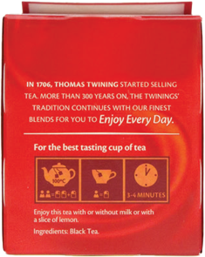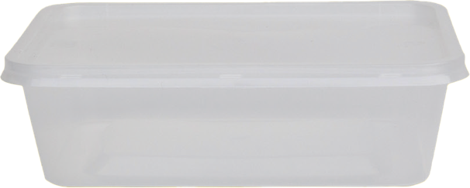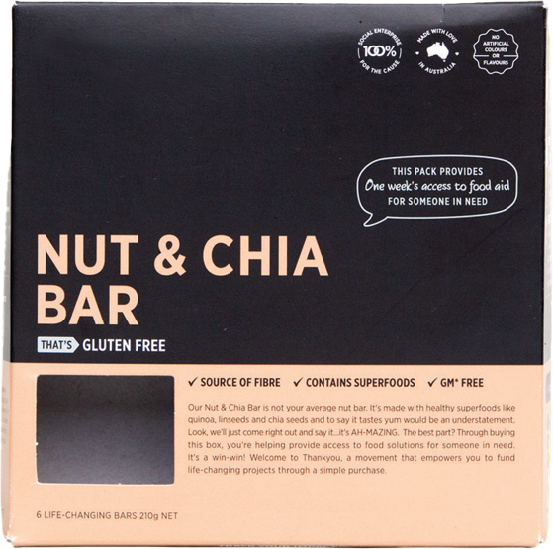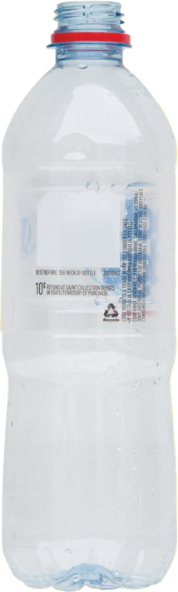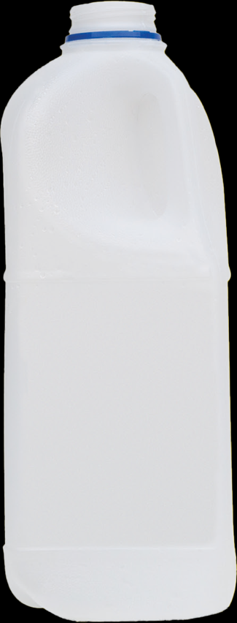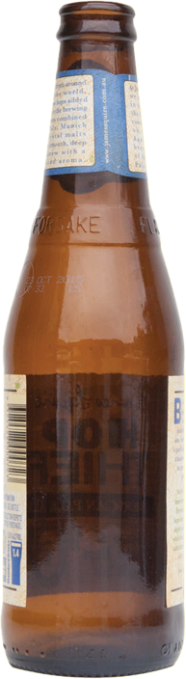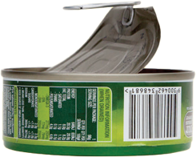

**MIXED**

**RECYCLING**

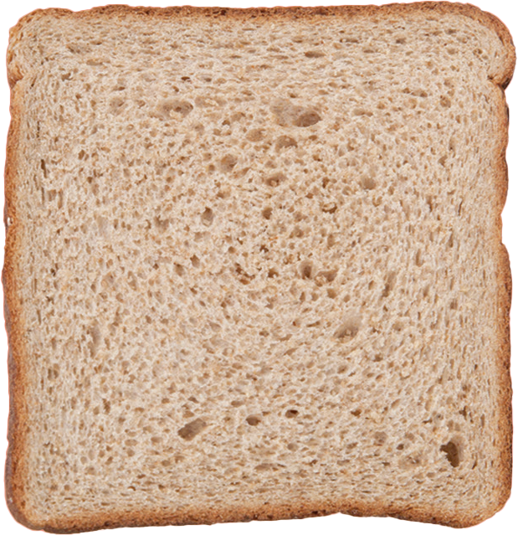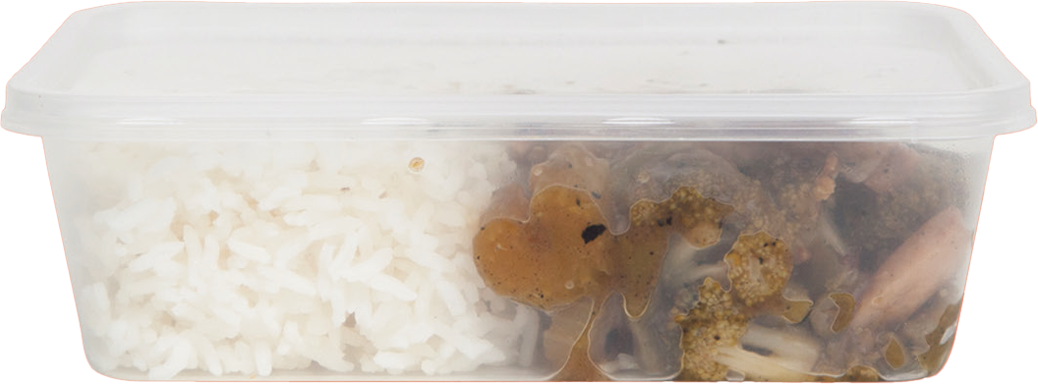

**Plastic and glass bottles**

**Aluminium cans**

**Steel and tin cans and containers**

**Take-away containers (empty)**

**Small quantities of paper**

**(envelopes, post-it notes etc.)**

**Bioplastics or compostable plastic packaging, Coffee cups, Paper hand towels, Food and liquid, Disposable cutlery, Unwanted/broken IT equipment, Plastic bags, Containers with food**

**PLASTIC & GLASS BOTTLES**

**ALUMINIUM CANS**

**STEEL CONTAINERS (1-7)**

**STEEL CANS & TINS**

**TAKE-AWAY CONTAINERS (CLEAN)**

**SMALL QUANTITIES OF PAPER**

**(ENVELOPS, POST-IT NOTES ETC)**