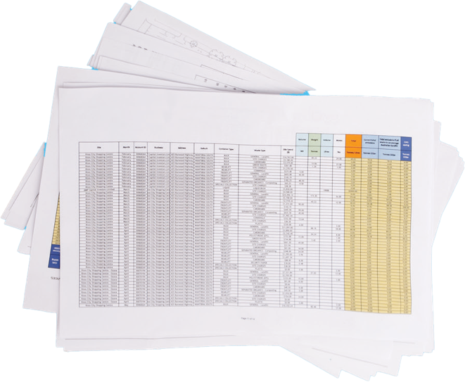

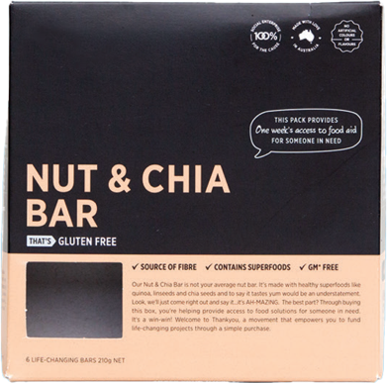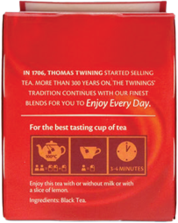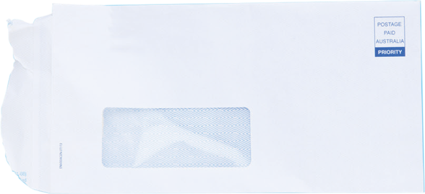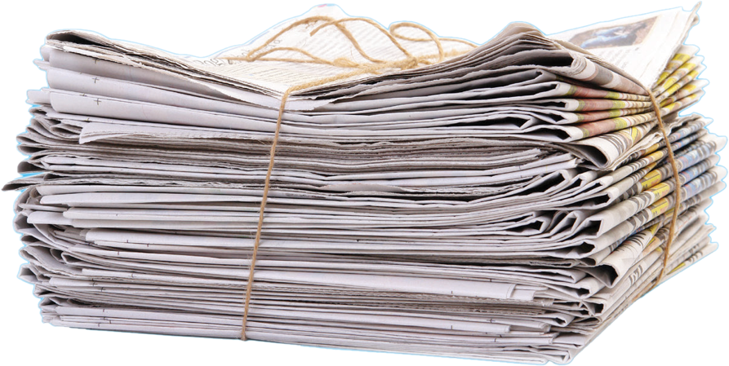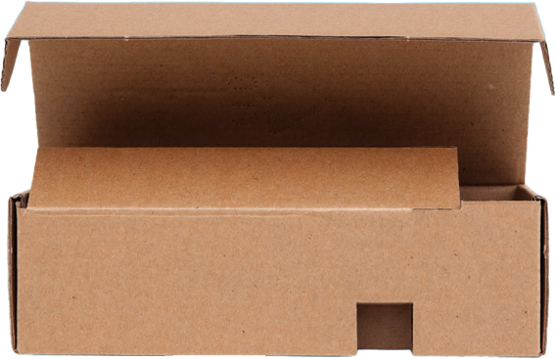

**PAPER**

**CARDBOARD**

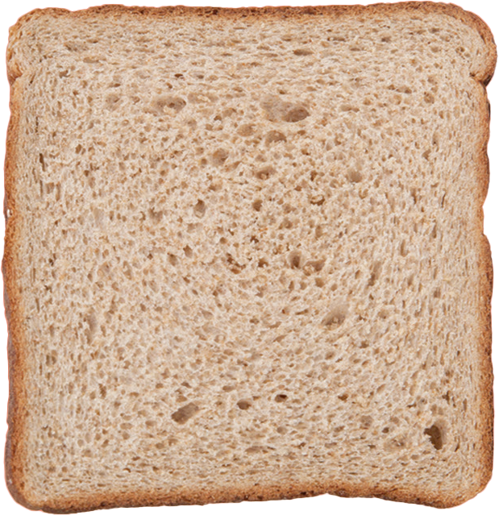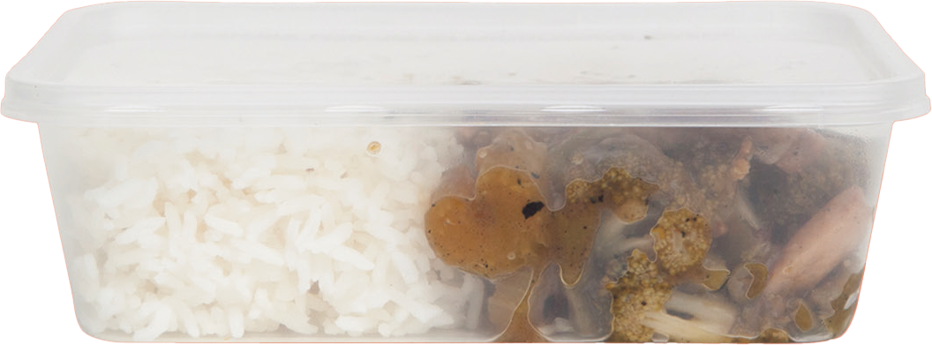

**Office paper  
Magazines  
Newspaper  
Envelopes  
Note books  
Post-it notes  
Cardboard boxes  
staples are ok**

**Coffee cups, Food and liquid, Chocolate and potato chip packaging, Plastic wrappers, Plastic strapping, Polystyrene, Soft plastics, Wooden stirrers, Paper hand towels, Tissues**