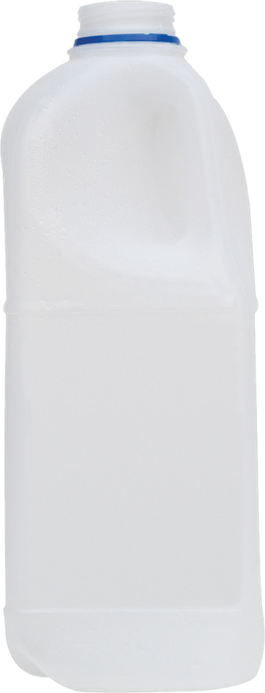

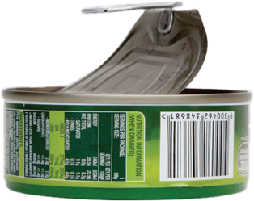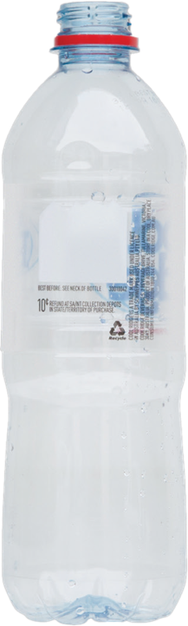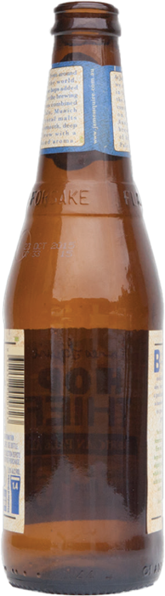

**10¢**

**REFUNDABLES**

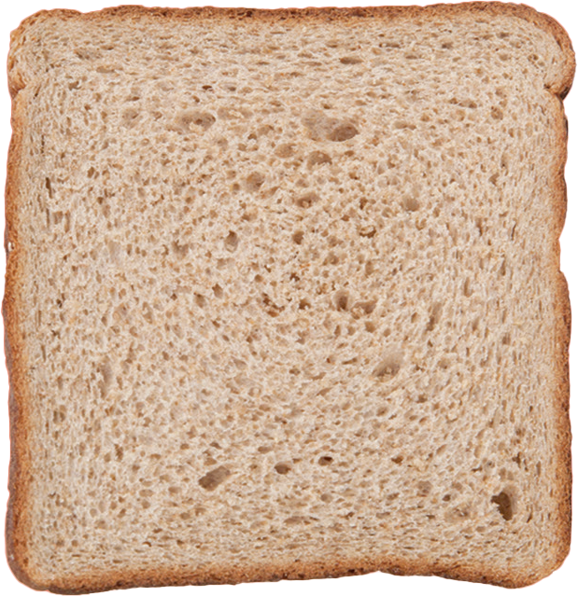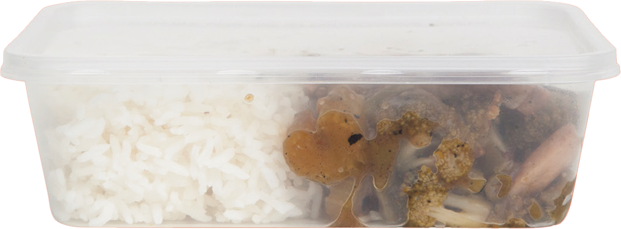

**All items  
with a 10¢ refundable  
logo including:**

**Plastic bottles**

**Glass bottles**

**Aluminium cans**

**Everything else**