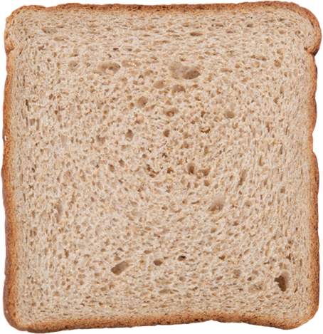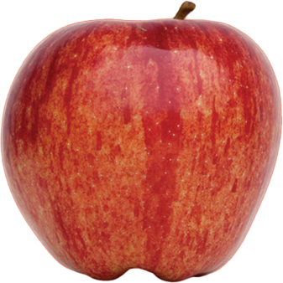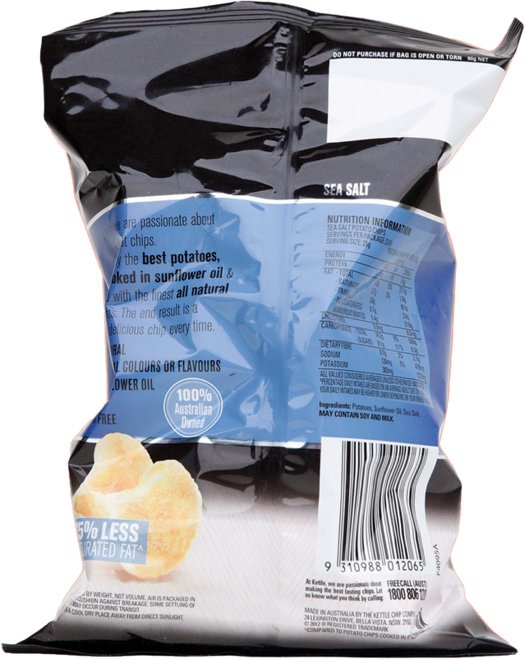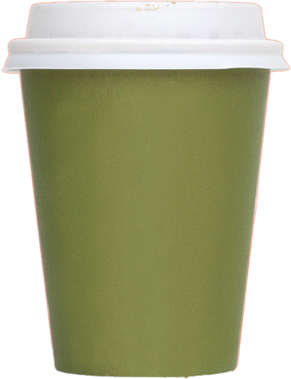

**Liquid / Paper / Plastic and glass bottles / Cans /  
IT equipment / Clean plastic containers**

**Coffee cups**

**Uneaten food**

**Tea bags**

**Paper towel**

**Take-away containers**

**Chocolate and chip packaging**

**Disposable cutlery**

**Broken stationery**

**WASTE**

**GENERAL**