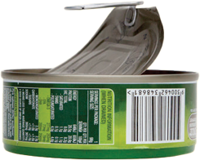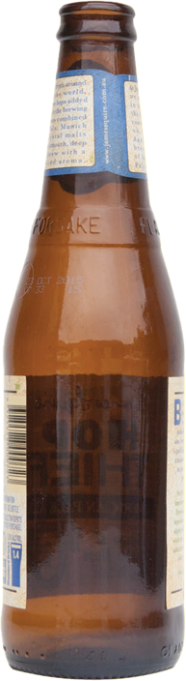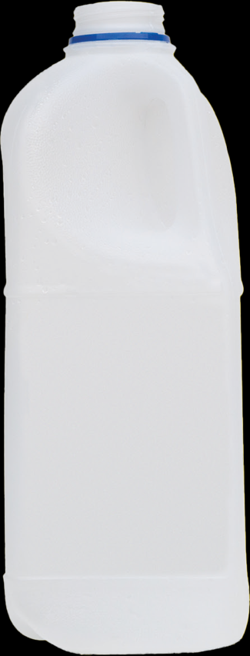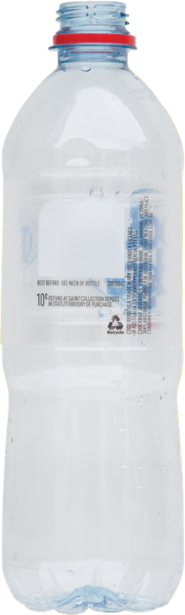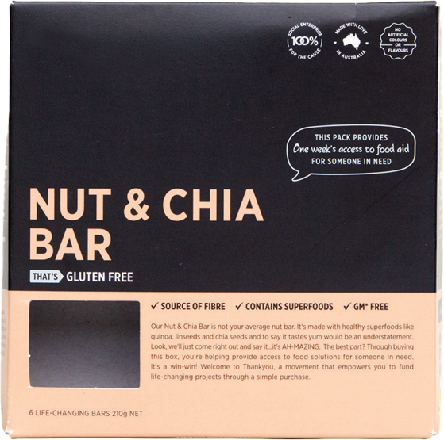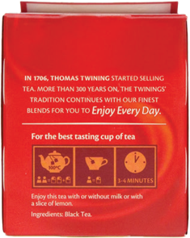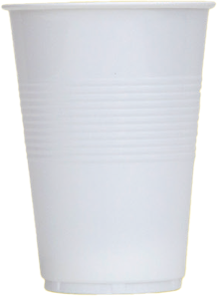

**Bioplastics or compostable plastic packaging, Coffee cups, Paper hand towels, Food and liquid, Disposable cutlery, Unwanted/broken IT equipment, Plastic bags, Containers with food**

**Plastic and glass bottles**

**Aluminium cans**

**Steel and tin cans and containers**

**Take-away containers (empty)**

**Small quantities of paper**

**(envelopes, post-it notes etc.)**

**RECYCLING**

**MIXED**