SAFETY SHARE

Log Intrusion – John Deere Forestry Forwarder

Incident

In April 2018, a 20-30cm/6m, 400kg log log broke through the 12 mm polycarbonate front and rear screens of a forwarder operated by a customer of CablePrice in the lower North Island.

CIRCUMSTANCES
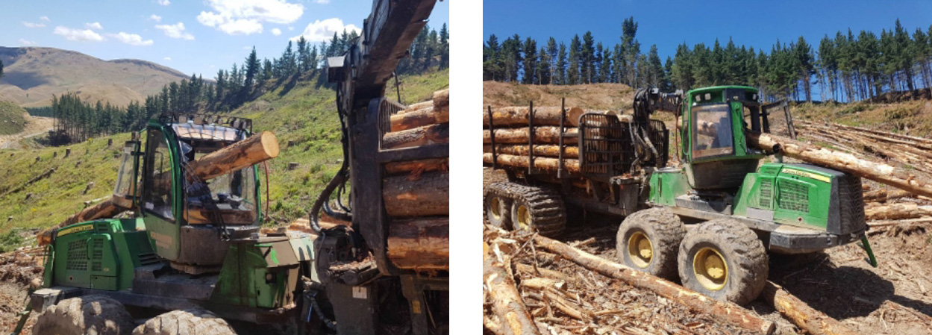

In April 2018 a 20-30cm, 6m, 400kg log smashed though the 12mm polycarbonate front and rear screens of a forwarder in the lower North Island.

INVESTIGATION

While there were many contributing factors to this incident, the safety of the machines we supply and the health and safety of our people and our customers is the number one priority at CablePrice. The polycarbonate met the current requirements for Operator Protective Structures (OPS) from WorkSafe NZ and meet the ISO 12117 and ISO 8084 which are the International Organisation of Standards requirements for Forestry Machinery.

RECOMMENDATIONS
- Ensure you are using the right machinery for the job. This includes providing suppliers and certifiers with an accurate understanding of the task and situation you will be putting the machinery to use in.
- Ensure that all manufacturer’s instructions and recommendations are being followed.
- Ensure staff are trained and have a good understanding of the risks and safe operating of the machinery they are using.
- Do not load bunk higher than the cab protection barrier (headboard).
- Install additional cab protection. CablePrice can assist with the supply and install of this protection.

